20170117
Hranice
http://www.openstreetmap.org/note/157043#map=17/49.76400/15.69060&layers=N
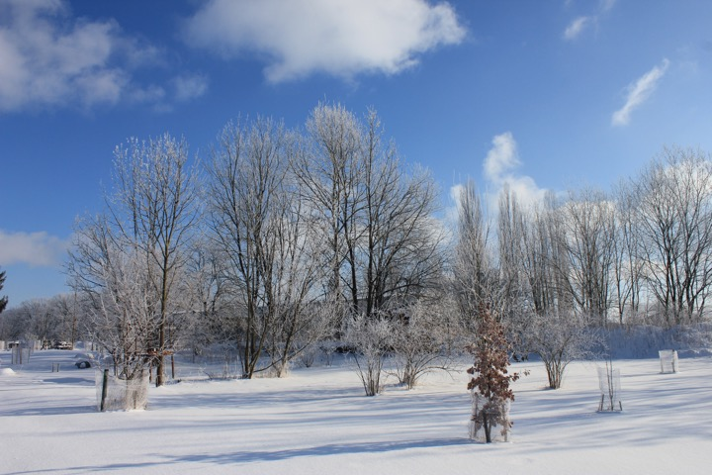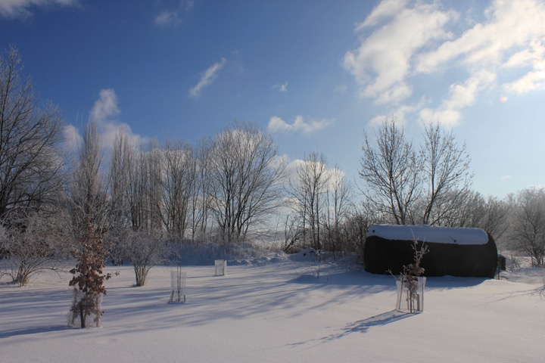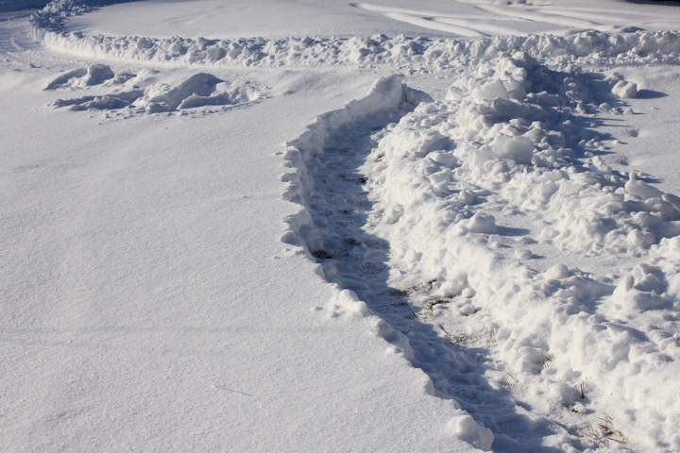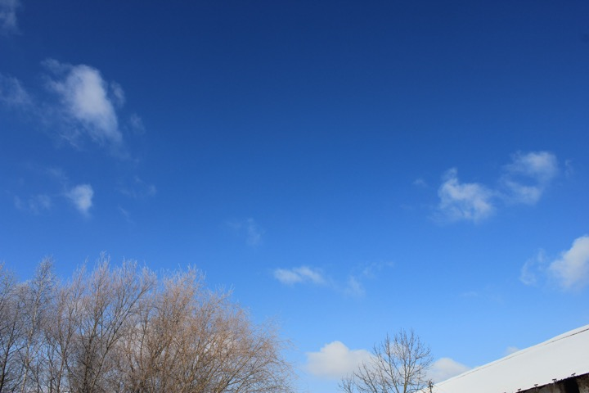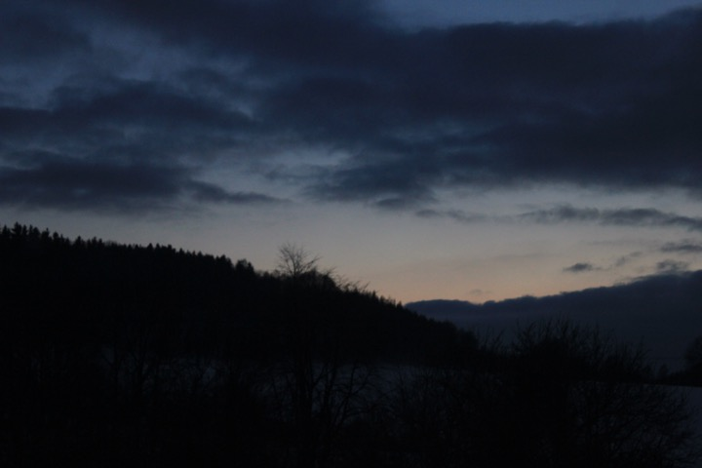
Rostock
http://www.openstreetmap.org/search?query=54.0794%2C12.1261#map=11/54.0791/12.1262


