20170202
Hranice
http://www.openstreetmap.org/note/157043#map=17/49.76400/15.69060&layers=N
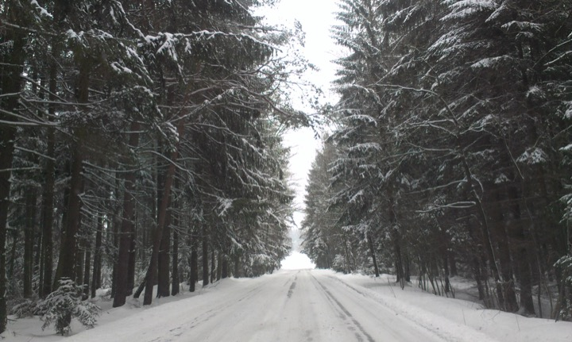
Apparently there are some changes in the weather at hand. This morning woke up and heard a knocking sound tapping in rhythmical waves. It proved to be a black and white patterned woodpecker (strakapoud maly or dendrocopos minor) widening a hole in the wall, presumably making a nest there. It is hard to make a picture but will try to record its interesting rhythm as soon as it is coming about again.
It is interesting to see all these advertisements for phones, and how they are getting better by the day. Testing them for sound recording, even with high quality, uncompressed settings, they sound horrible. It might be due to the built-in microphones. A pity. They all concentrate on the camera. But what is a movie with a bad sound?

