20170207
Hranice
http://www.openstreetmap.org/note/157043#map=17/49.76400/15.69060&layers=N
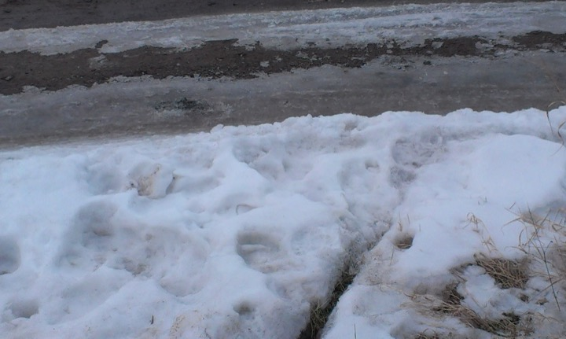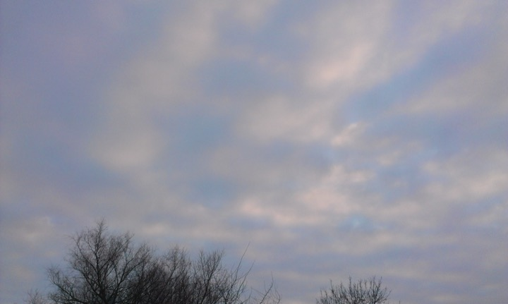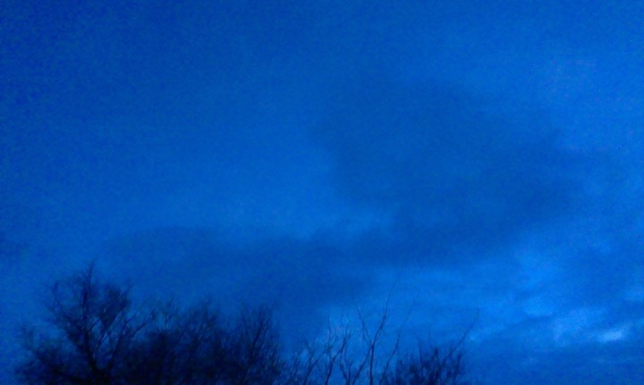
The same upgoing temperatures, slowly degree by degree. The same pattern, dark misty mornings and then a brilliant afternoon, an open sky at night, millions of stars, make us feel smaller and smaller. The snow is now a massive ice layer, one can walk on it without sinking into it. At the same time the process of gradually melting off during the daytime and freezing again at night creates these strange shapes on the ground.


