20170215
Hranice
http://www.openstreetmap.org/note/157043#map=17/49.76400/15.69060&layers=N
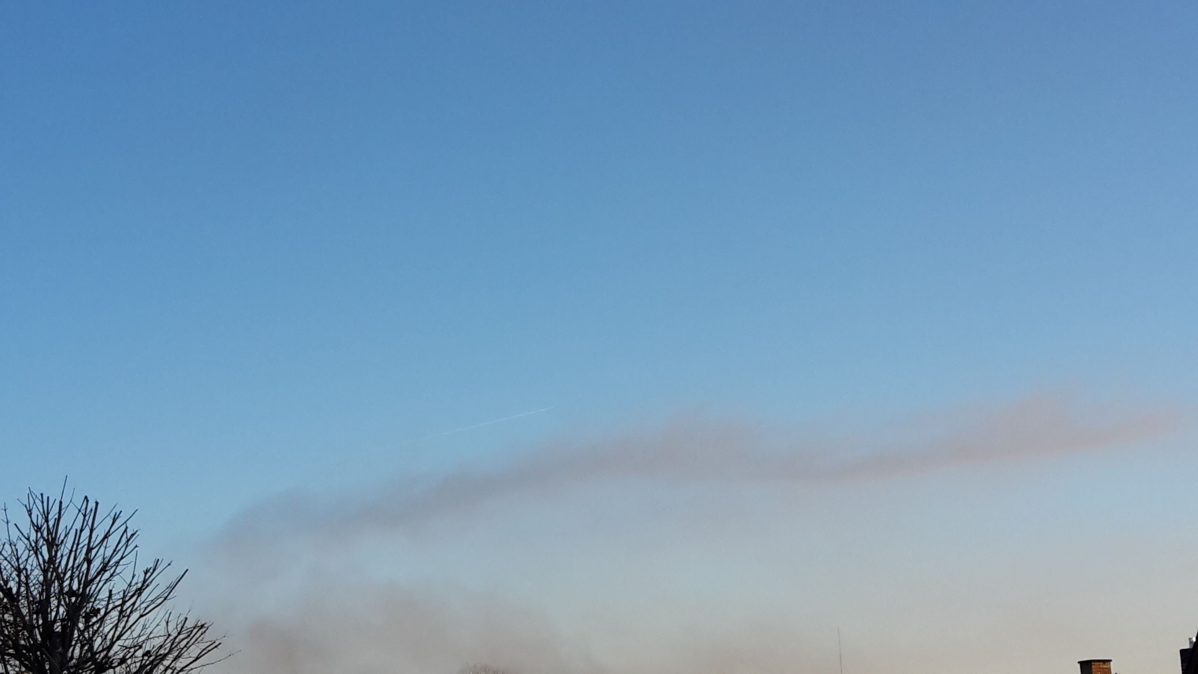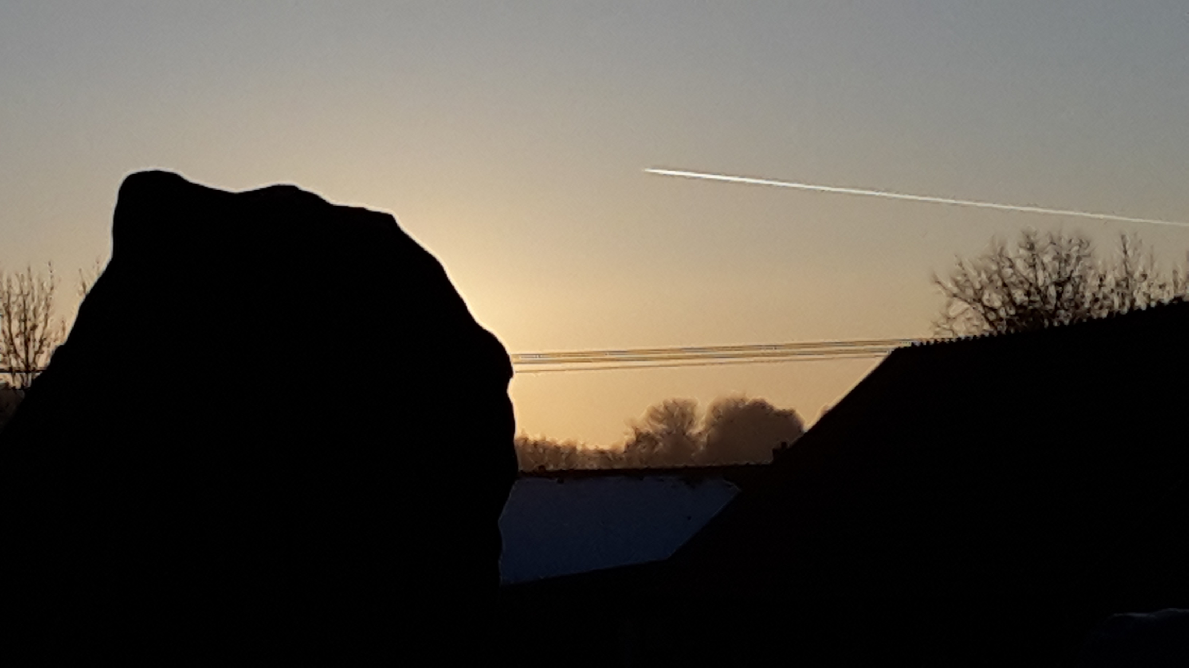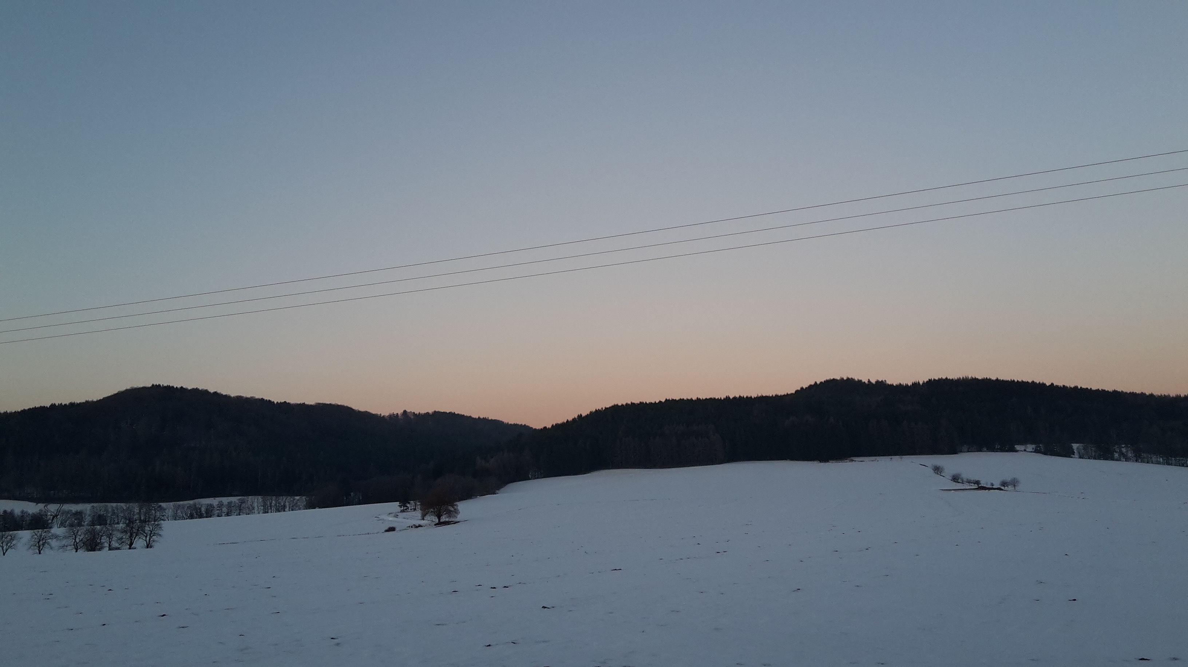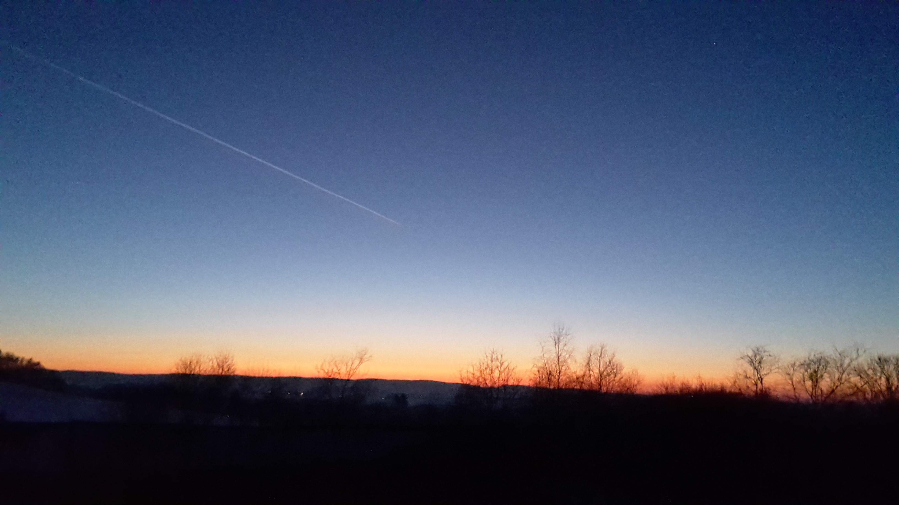
Immaculate skies. Near the playground in Libice, there is a weather station and was observing the wind. First it was quiet and nothing seemed to move but after half an hour a cold wind was blowing from the West. There are big differences in temperature during day and night: from + 7 to - 10.

