20170414
Praha to Hranice
http://www.openstreetmap.org/note/157043#map=17/49.76400/15.69060&layers=N
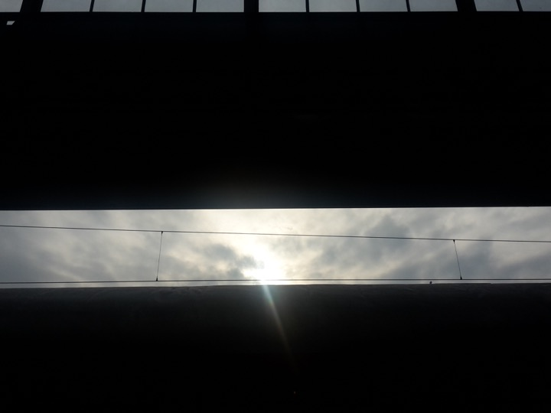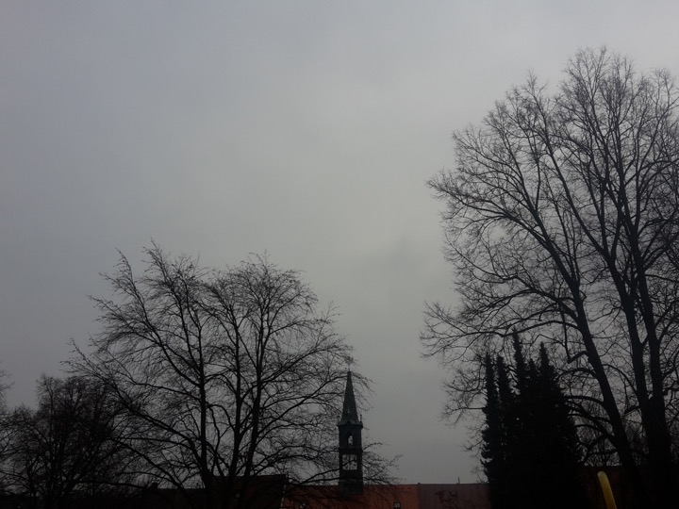
From Praha hlavní nádraží to Chotěboř, from open sunny weather into a thick mist.

