20170315
Hranice
http://www.openstreetmap.org/note/157043#map=17/49.76400/15.69060&layers=N
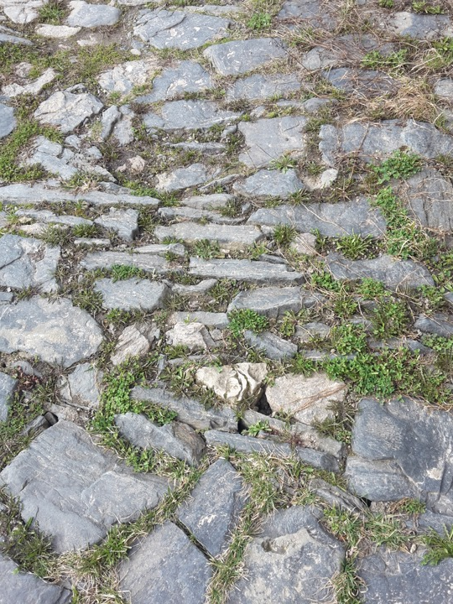
The first rays of warm sunshine, glad to be home, walking around opening doors and windows to air the house and cowshed, which has been locked all winter. The ground is dry.

