20170320
Hranice
http://www.openstreetmap.org/note/157043#map=17/49.76400/15.69060&layers=N
20170320-1800.wav
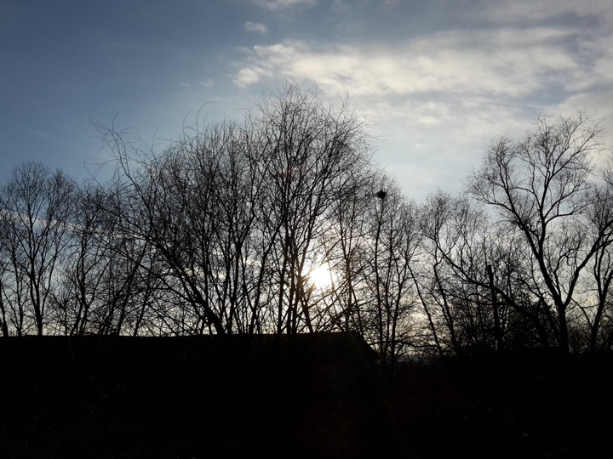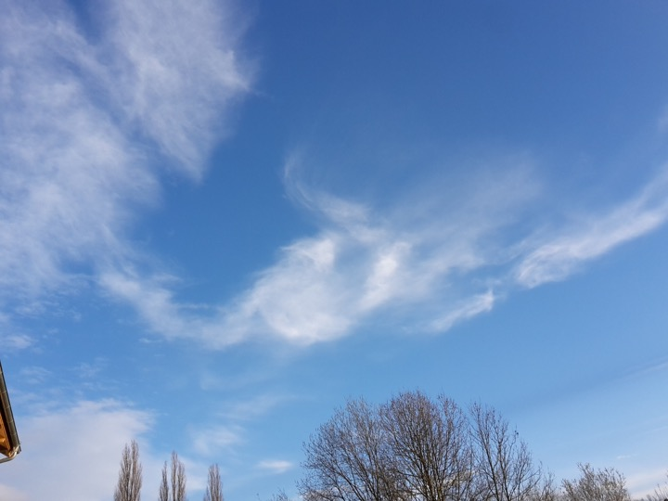
Almost springtime, nicely building up. The first blossoms on the willows, and all plants start to push up.

