20170323
Hranice
http://www.openstreetmap.org/note/157043#map=17/49.76400/15.69060&layers=N
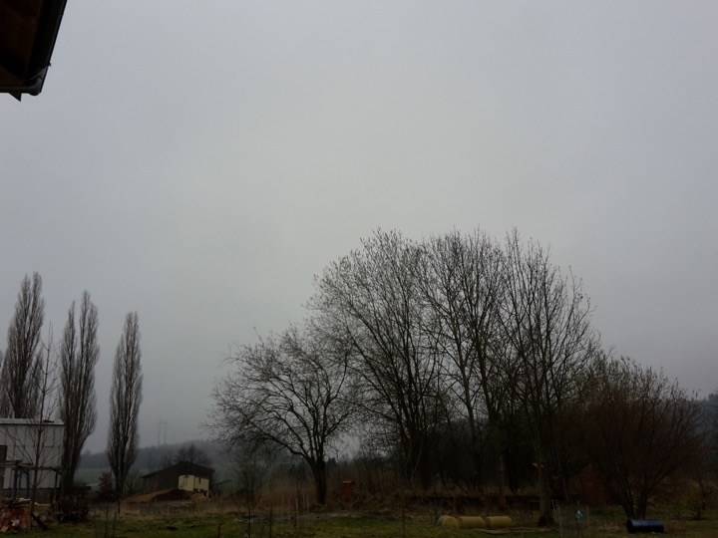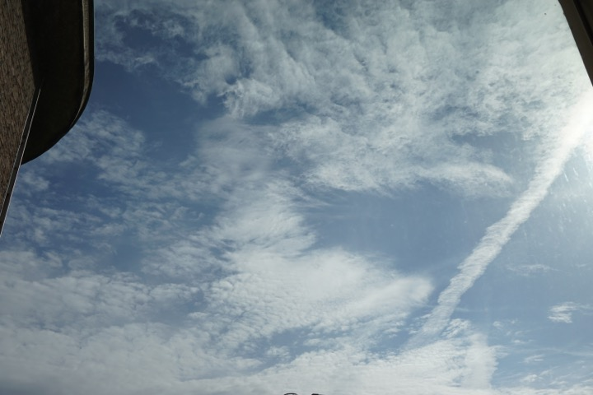
There are more and more birds singing. Found some pictures from Gent, but lost date and time. So here they are as well.

