20170325
Hranice
http://www.openstreetmap.org/note/157043#map=17/49.76400/15.69060&layers=N
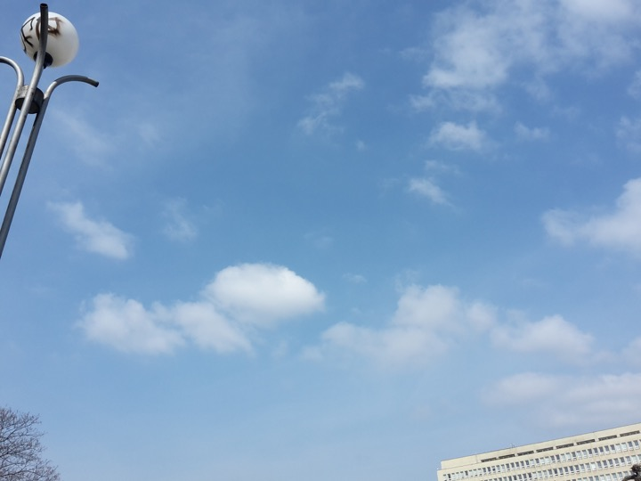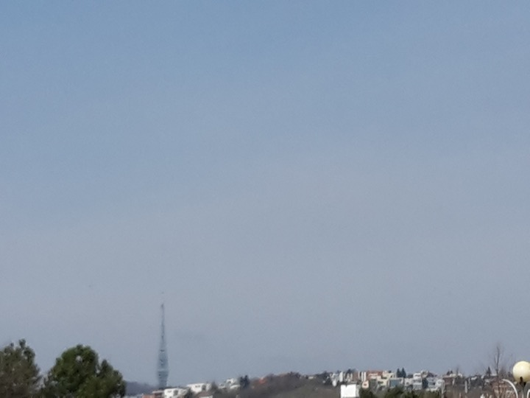
There are more and more birds singing. Found pictures from Bratislava from tomorrow. A flash forward it seems. The sun is back.

