20170327
Weimar http://www.openstreetmap.org/search?query=50.97966%2C11.32405#map=18/50.97966/11.32405
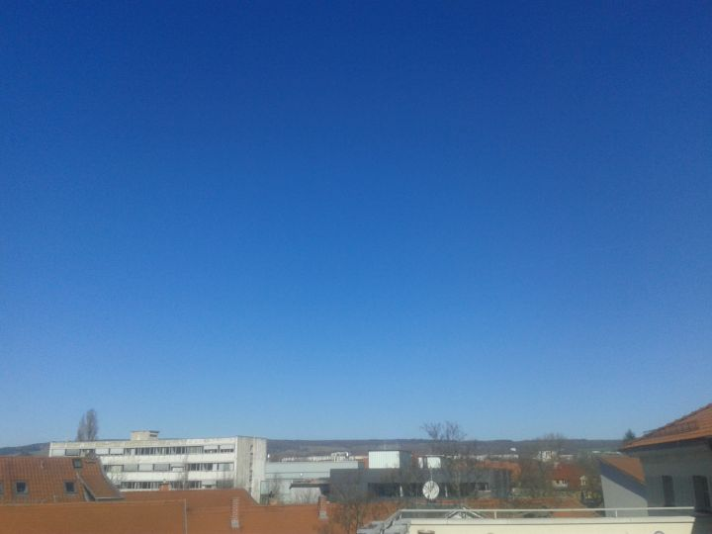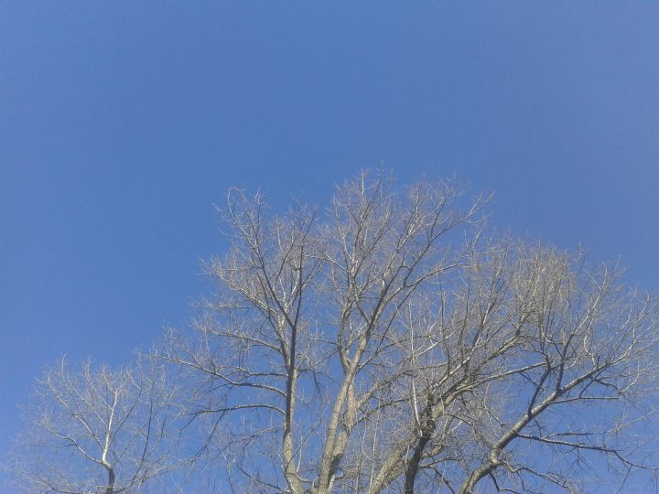
During lunch break I enjoyed the clear sky and the warm sun rays.

