20170329
Hranice
http://www.openstreetmap.org/note/157043#map=17/49.76400/15.69060&layers=N
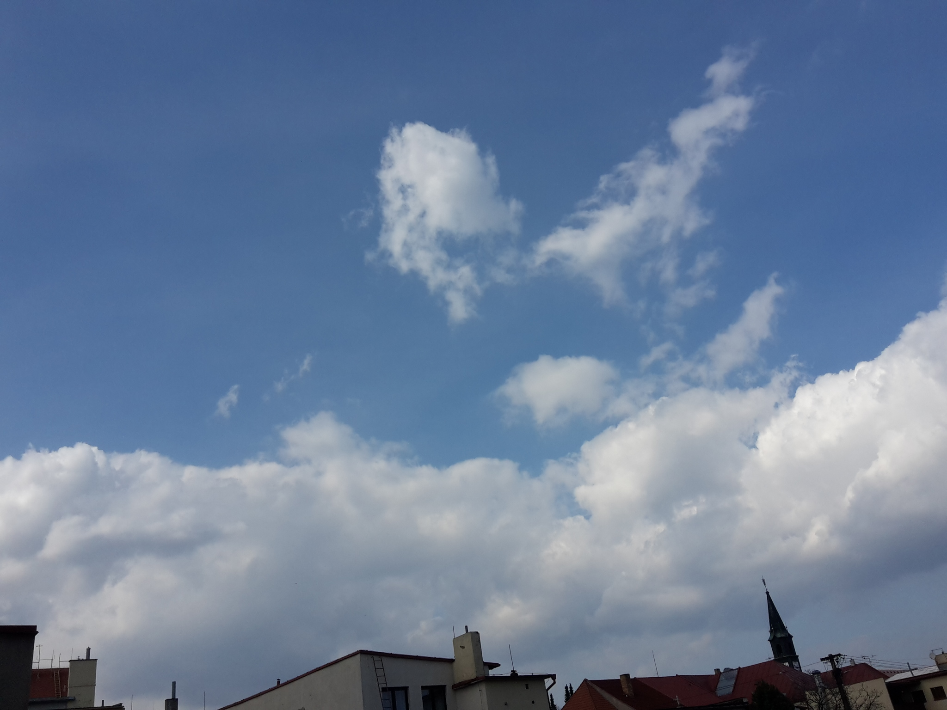
Back home. Stable weather, warm, not so much wind. It could be spring forever.

