20170401
Hranice
http://www.openstreetmap.org/note/157043#map=17/49.76400/15.69060&layers=N
20170401-1930-birds_dog_wings.wav
20170401-1930-birds_wind.wav
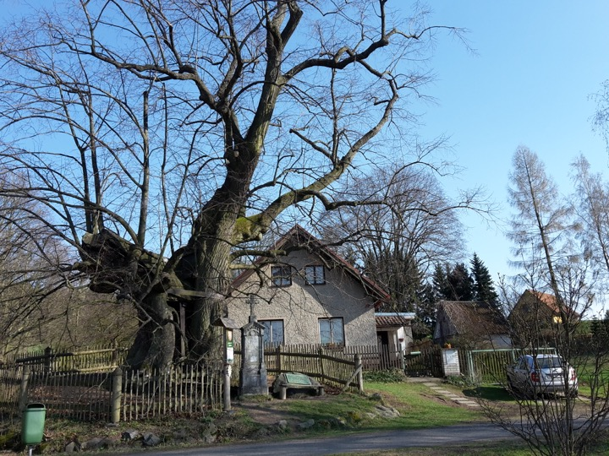
A one-thousand old tree (Lipa). Birds. So many birds suddenly.

