20170409
Hranice
http://www.openstreetmap.org/note/157043#map=17/49.76400/15.69060&layers=N
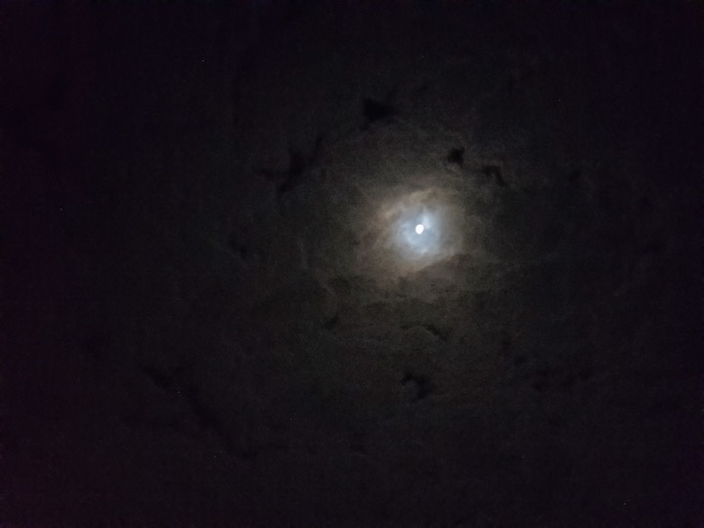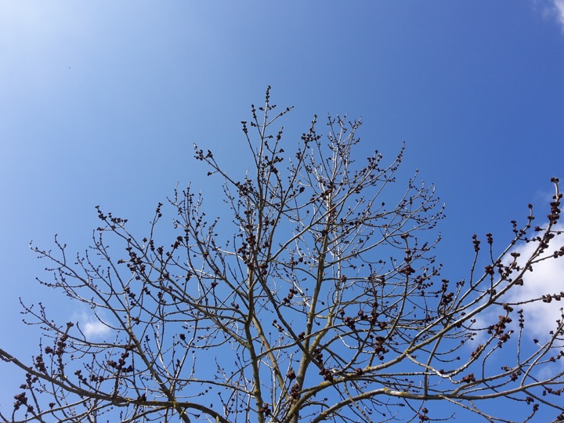
getting home again, a change of weather, food, people, sound, view

