20170410
Hranice
http://www.openstreetmap.org/note/157043#map=17/49.76400/15.69060&layers=N
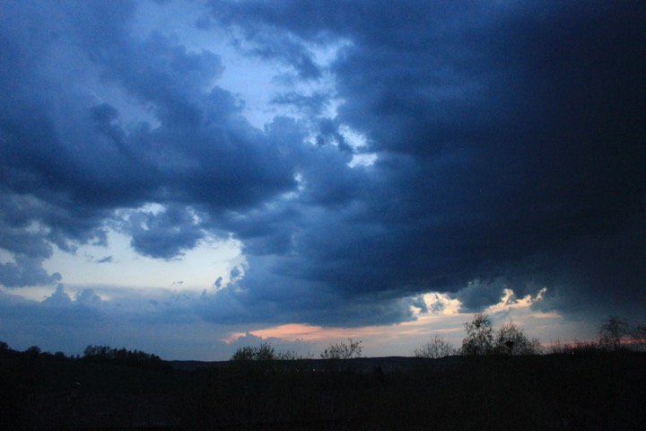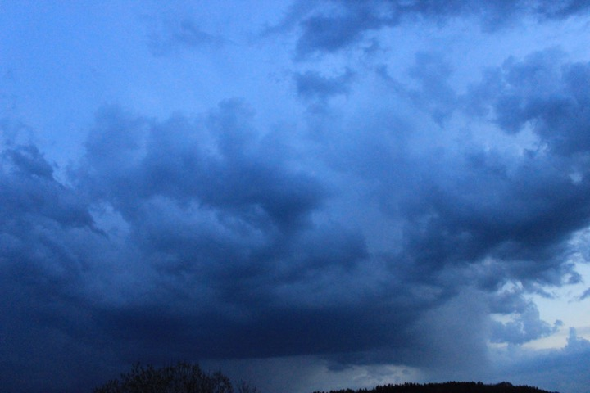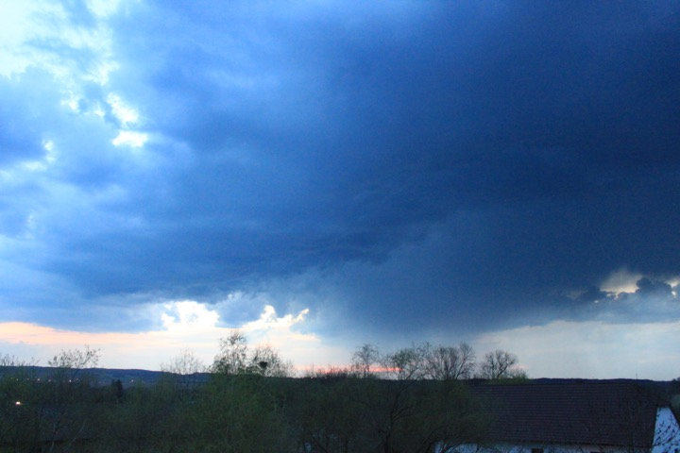
A storm rising in the west, rumbling from a distance in the growing darkness.

