20170425
Gent http://www.openstreetmap.org/search?query=gent%20muinkkaai#map=16/51.0443/3.7291
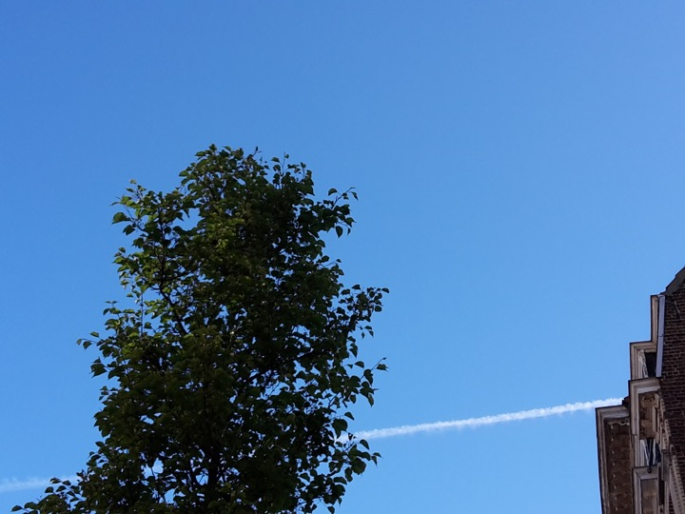
Walking next to the Leie river, running in a canal.

