20170427
Gent http://www.openstreetmap.org/search?query=brussels%20midi%20station#map=15/50.8357/4.3362
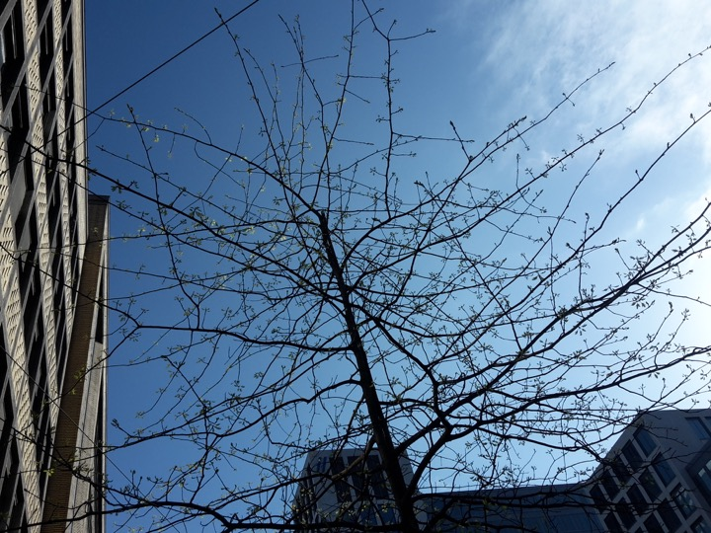
Brussels around MIDI station.
Schmalkalden (Thuringia) http://www.openstreetmap.org/search?query=50.72305%2C10.45533#map=18/50.72305/10.45533
Schloss Wilhelmsburg with view over the parade ground. variable weather by moderate temperature.

