20170430
Stekene, Sint-Niklaas http://www.openstreetmap.org/search?query=51.22676,%204.05359#map=19/51.22676/4.05359
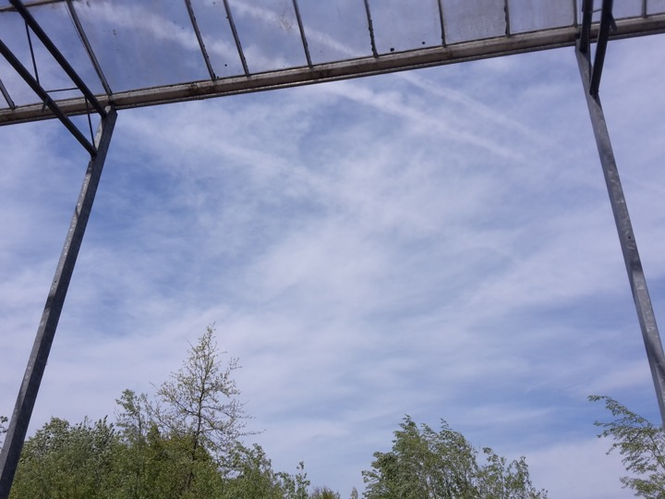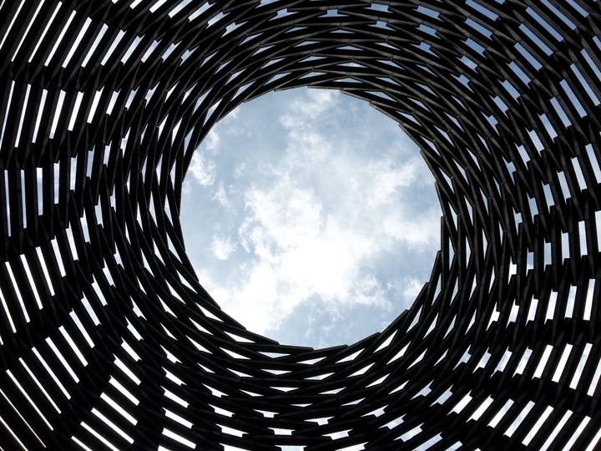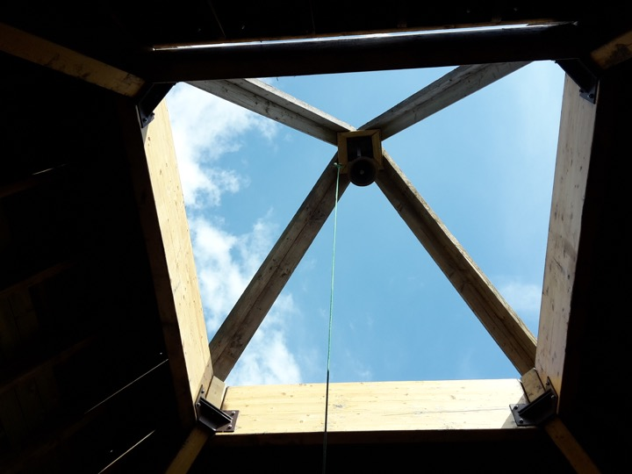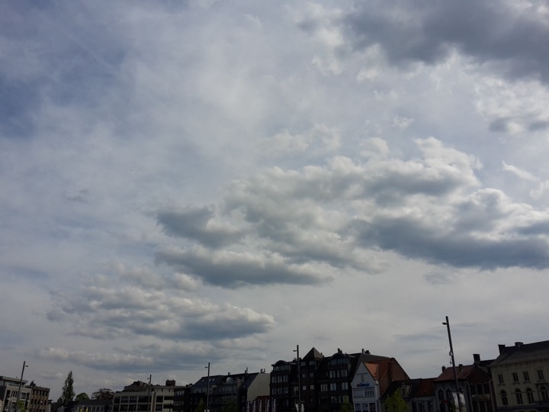
Visiting the summer exhibition at Verbeke Foundation, 100% Flemish countryside, contemporary ecological art.

