20170504
Brussels Midi station
http://www.openstreetmap.org/search?query=50.8364%2C4.3367#map=15/50.8364/4.3367 Hranice
http://www.openstreetmap.org/note/157043#map=17/49.76400/15.69060&layers=N
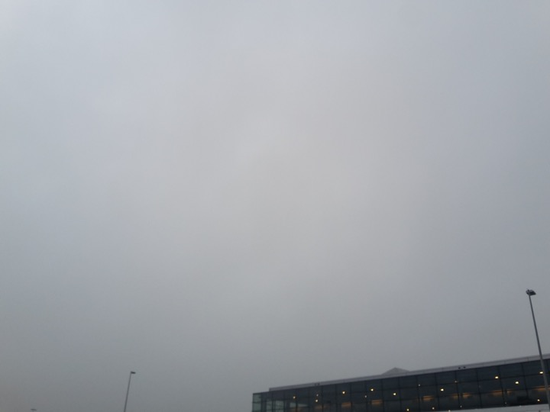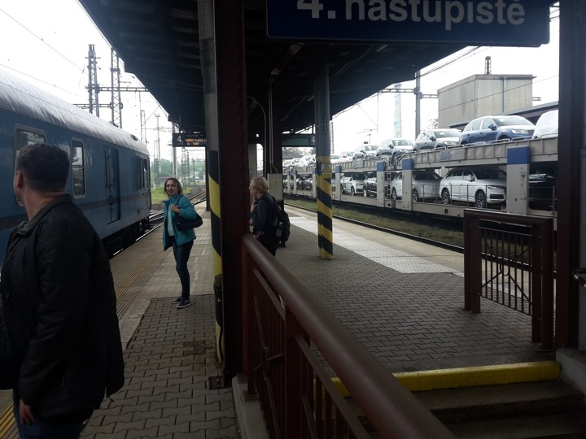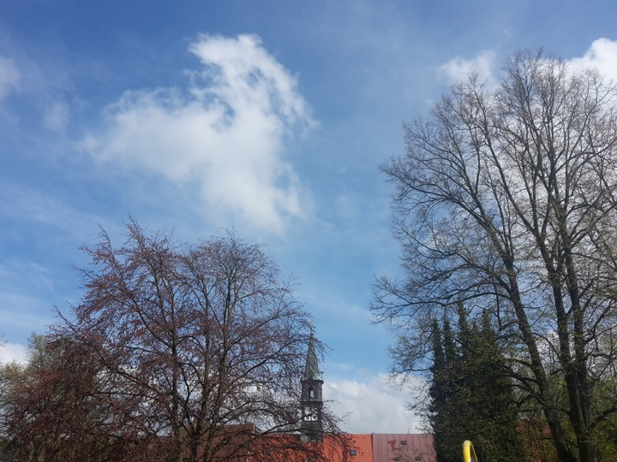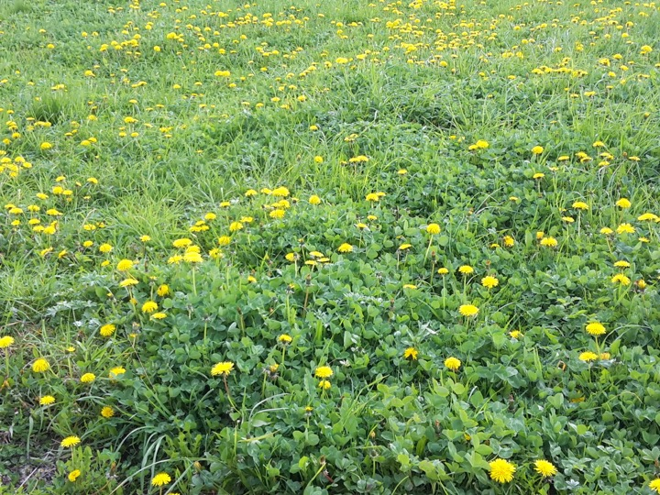
From Brussels to Home.

