20170515
Kalte Sophie
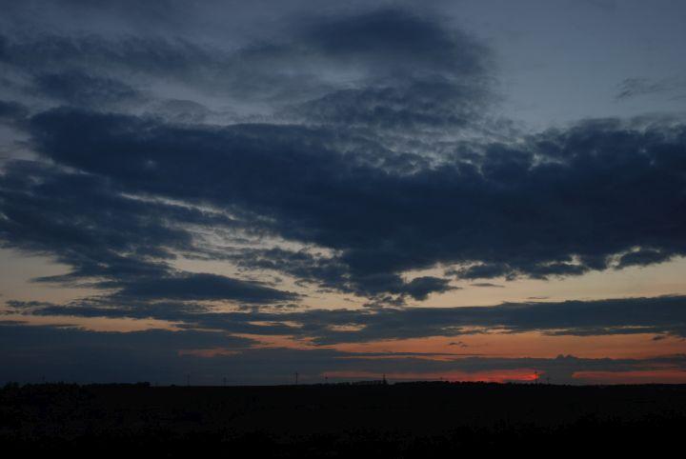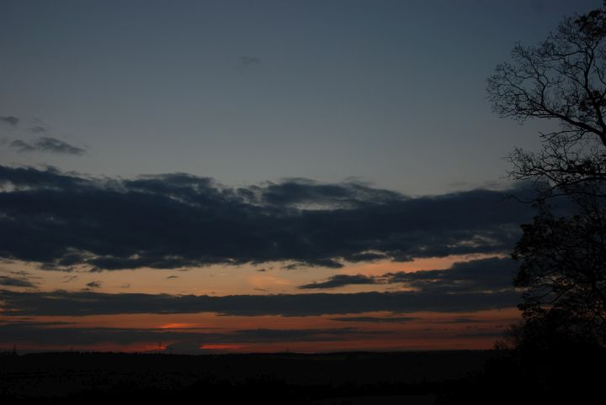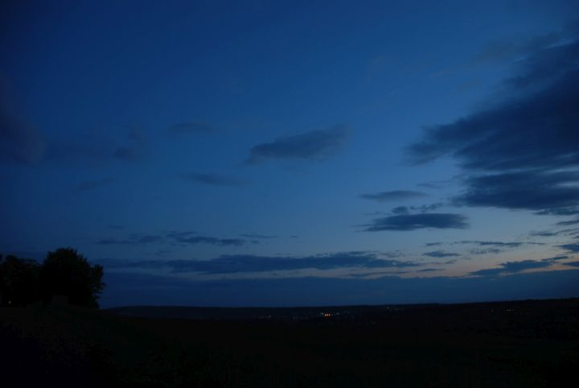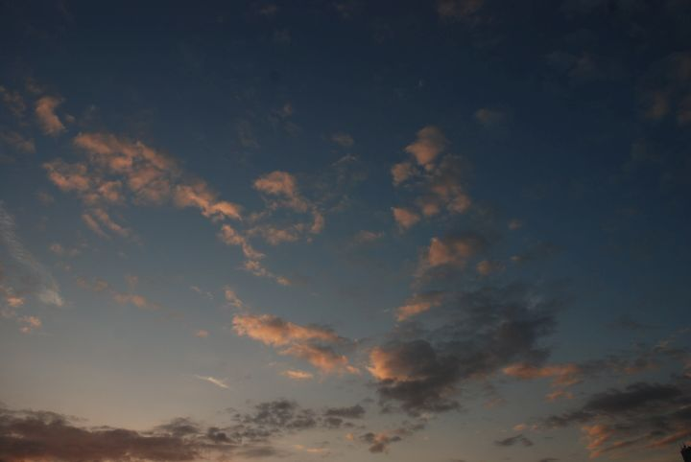
Weimar (Belvedere), http://www.openstreetmap.org/search?query=50.9496%2C11.3501#map=13/50.9496/11.3501

