20170519
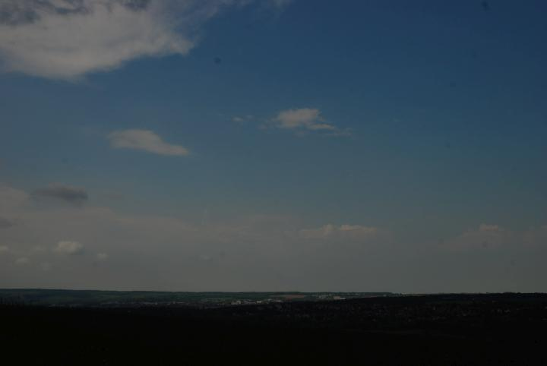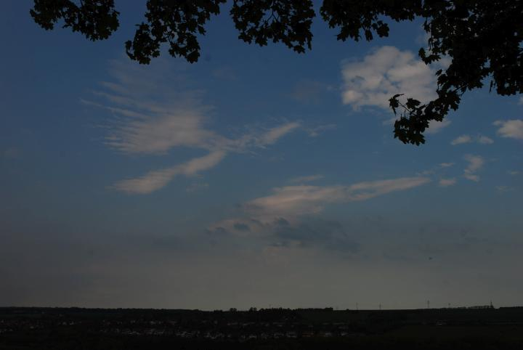
Weimar, Friday 2017/05/19 - 02:30 p.m. - Between + 21° and + 22° degree Celsius at Schloss Belvedere in Weimar. While waiting for the tempest (forecasted 03:00 p.m.), doing some recordings of bumblebees and wind in the trees. A lot of Blackbirds were singing there, too (and also the highway).
Until 03:00 p.m. the sun was shining, afterwards it was cloudy and sometimes the sun came through. Two hours later it was windy and heavily overcast at constant temperature. After the big rain (5 p.m.) at night the temperature went down.
Weimar, http://www.openstreetmap.org/search?query=50.9487%2C11.3539#map=15/50.9487/11.3539
Meantime on the road from Hranice to Brno and finally to Bratislava...


