20170529
Hranice
http://www.openstreetmap.org/note/157043#map=17/49.76400/15.69060&layers=N
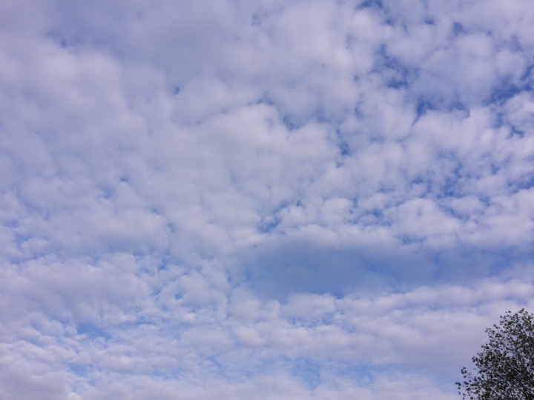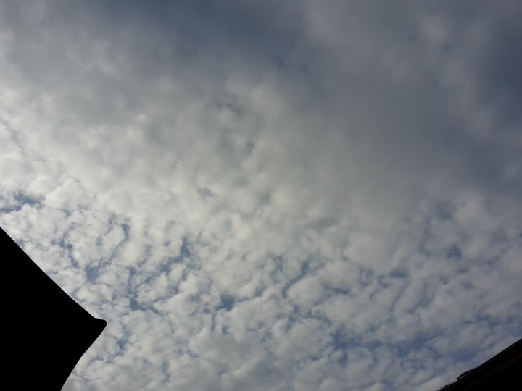
Weimar
http://www.openstreetmap.org/search?query=weimar#map=12/50.9803/11.3290


