20170530
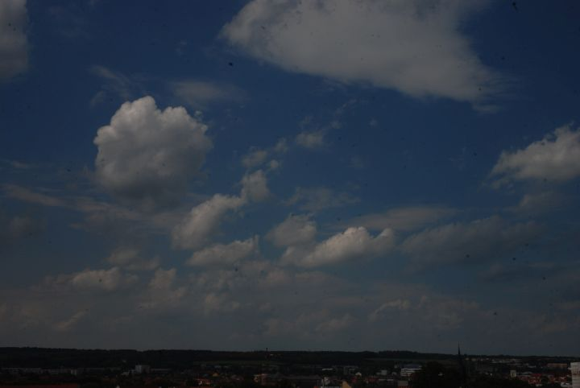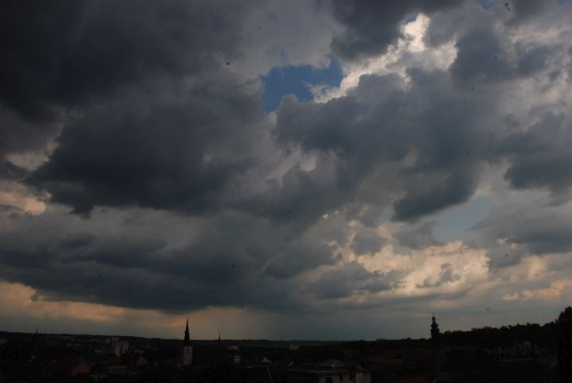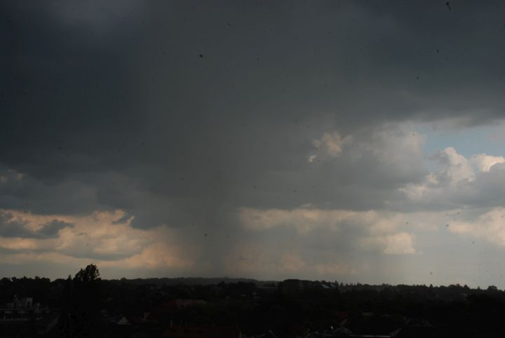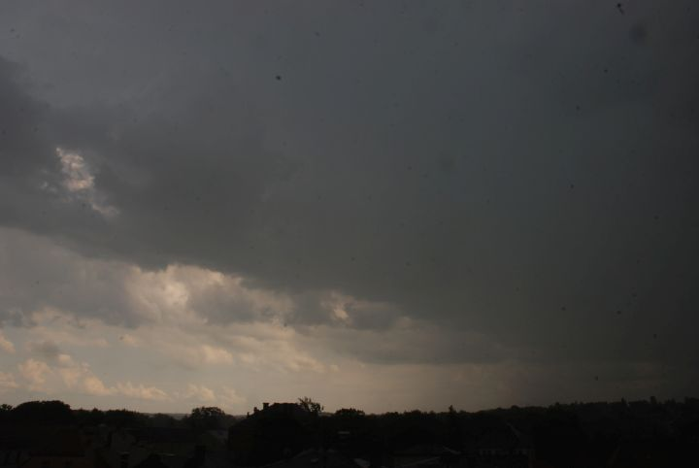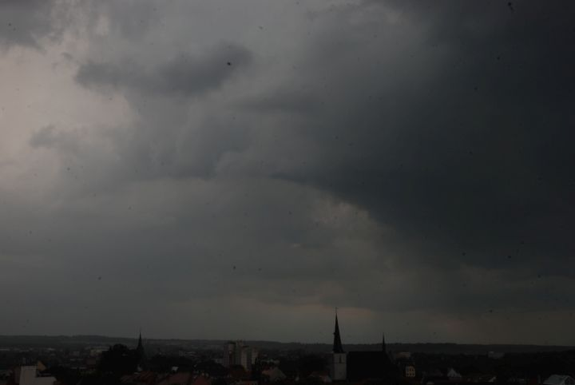
Limona (attic), 16:30 p.m.
A heat thunderstorm with a lot of rain was coming up. The recording was taken at a window in the attic of the former brewery.
20170540-1615-rain-on-window.wav
Weimar, http://www.openstreetmap.org/search?query=50.97750%2C11.32683#map=16/50.9775/11.3268

