20170531
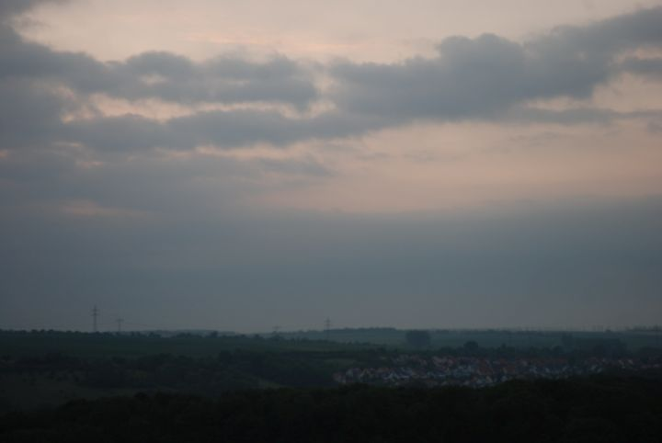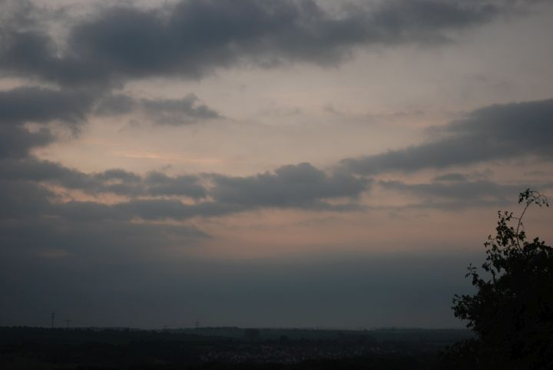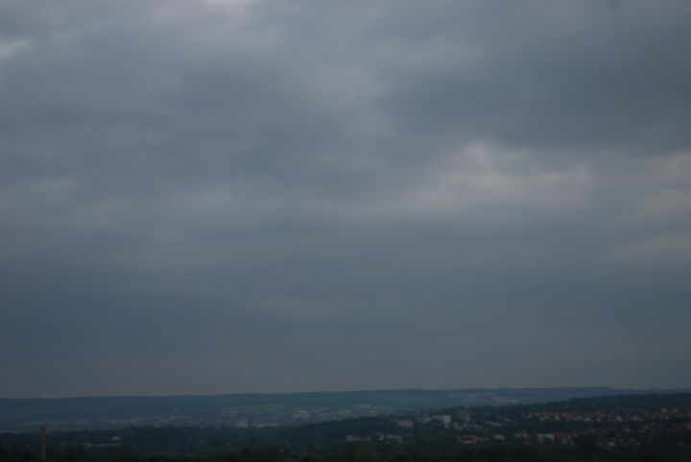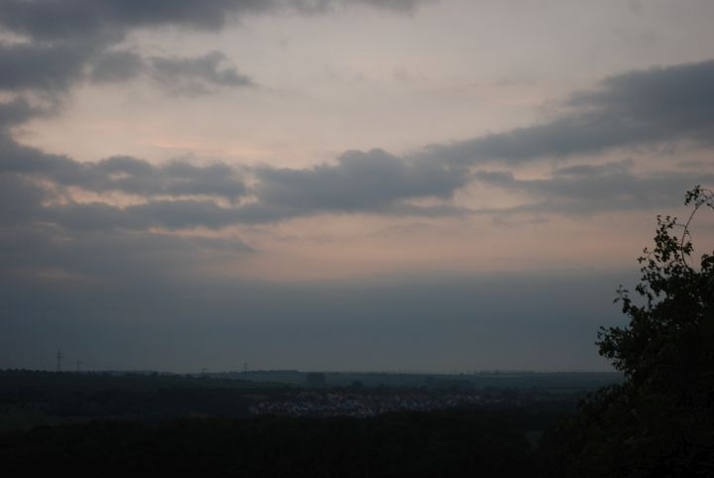
Schloss Belvedere, 03:18 a.m.
+ 14°C, cloudy, light breeze, high humidity, gently mist, wet ground (because of the thunderstorm in the afternoon before). The male frogs at the ponds croak all night long to attract the females. The birds began to sing at around four o'clock.
Weimar, http://www.openstreetmap.org/search?query=50.9496%2C11.3501#map=13/50.9496/11.3501

