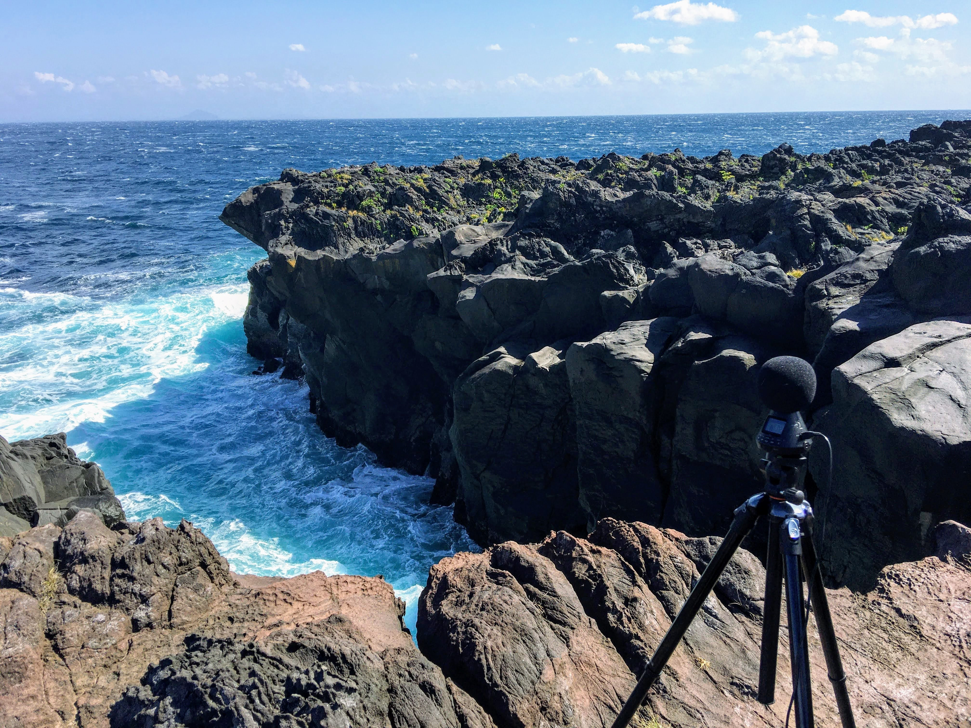
Akihiro Kubota is currently the professor of Art and Media Course in the Information Design Department at Tama Art University, Tokyo, JAPAN. His interdisciplinary hybrid projects include the ARTSAT Project which launches personal art satellites into space, bioart, and sound performances by live coding and handmade instruments.
- http://artsat.jp
- http://soundcloud.com/hemokosa
- http://hemokosa.com (archive)
- A History of Japanese Hacking and DIY music (by ADACHI Tomomi)


