Bosch's Butt Song
It is a known fact that in The Garden of Earthly Delights, by Hieronymus Bosch, on the right panel depicting hell, there is a piece of music painted on someone's butt (on the panel you can see in the middle on the left, but in between the lute/harp and hurdy-gurdy, a naked man with a score on his ass). For more information on the painting which Bosch painted between 1490 and 1510, see here.
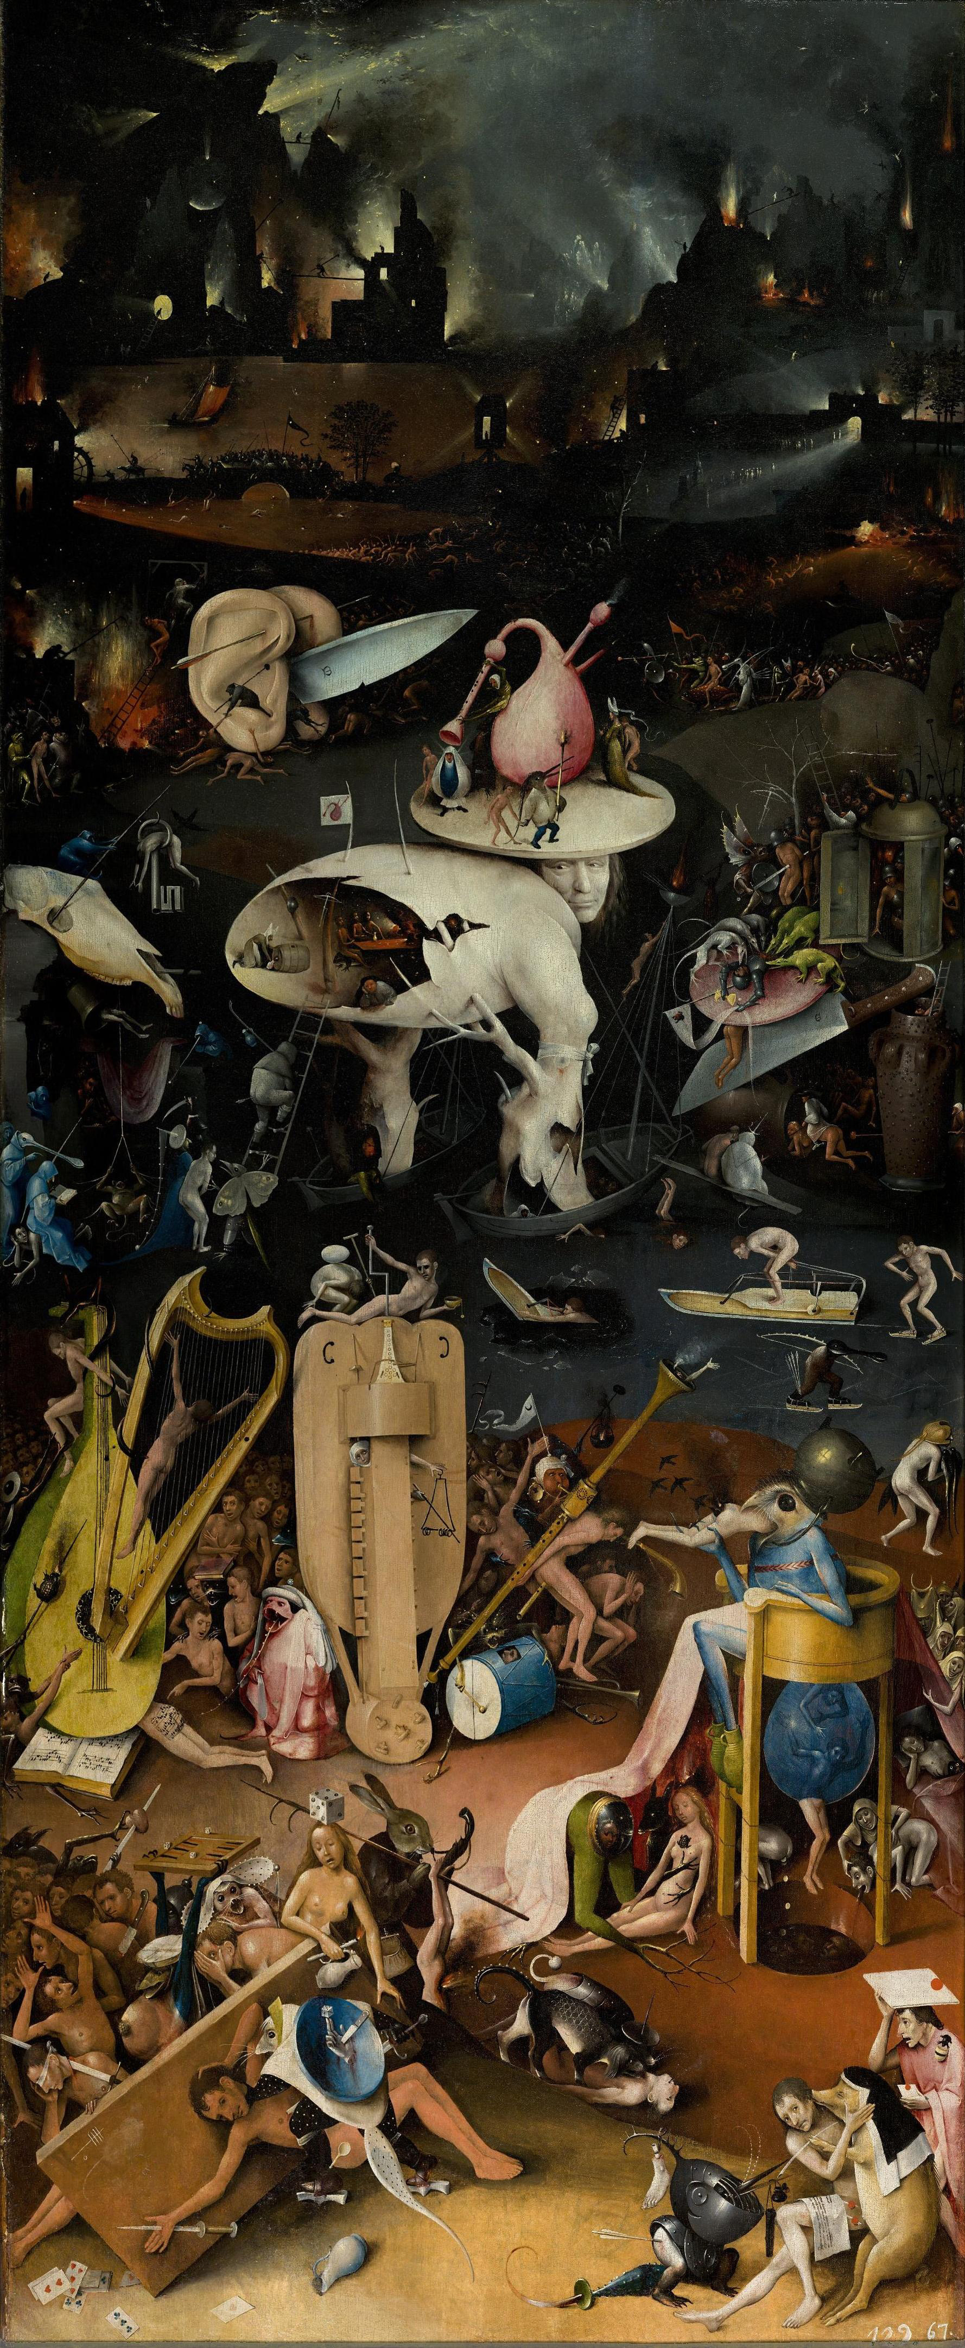
Recently there were some interesting interpretations of the music on the poor man's butt. A certain Amalia made a transcript and there were some twitter musical moves with new interpretations of the score. What is interesting as well is that the depicted instruments were the folk instruments that were not very well appreciated by church. This is similar to the destruction of western instruments after the Ayatola revolution in Iran (I vividly remember on the news some footage of bulldozers driving over piles of drums and guitars in one of the main streets of Teheran). Definitely the very straight and religious Hieronymous wanted to depict the horrible folk music of his time. This is just before Luther's actions, and the haydays of the popular Franco-Flemish Polyphonists, at least in Europe, while Gregorian chant (unaccompanied) was the required orthodox way for singing in church. All the rest was leading to immoral behaviour and pointing to hell after life.
Here some recent links one might enjoy...
https://www.pri.org/stories/2014-02-14/hieronymus-bosch-painted-sheet-music-mans-butt-and-now-you-can-hear-it
https://news.artnet.com/art-world/bosch-butt-song-from-hell-309732
https://www.youtube.com/watch?v=OnrICy3Bc2U
https://www.youtube.com/watch?v=Br3SunLc8zU
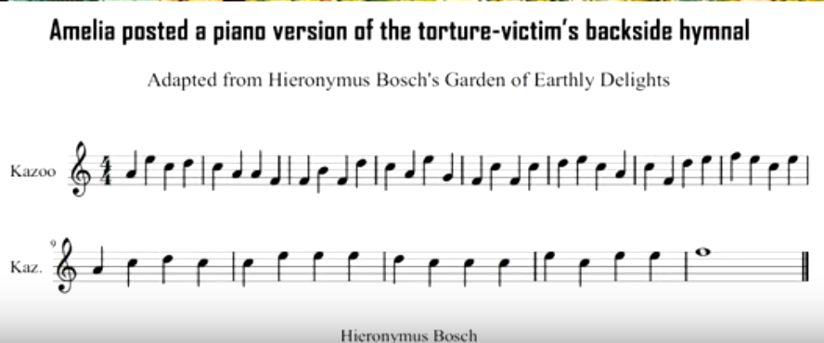
Nigel Horne published an interesting and short guide on how to transcribe this medieval notation: The Written Notation of Medieval Music

