Skupina: recording the singularity in plural.
This page contains additional material for the I WAS 17 piece for His Voice.

O
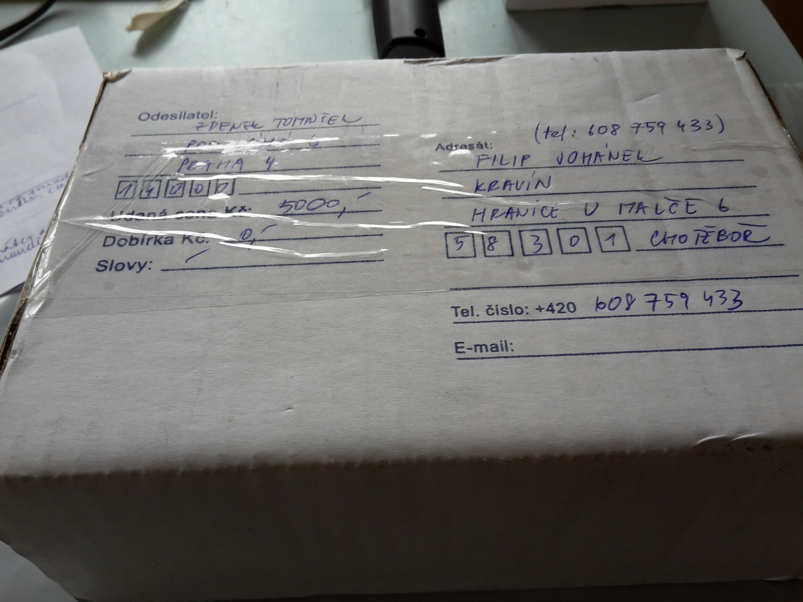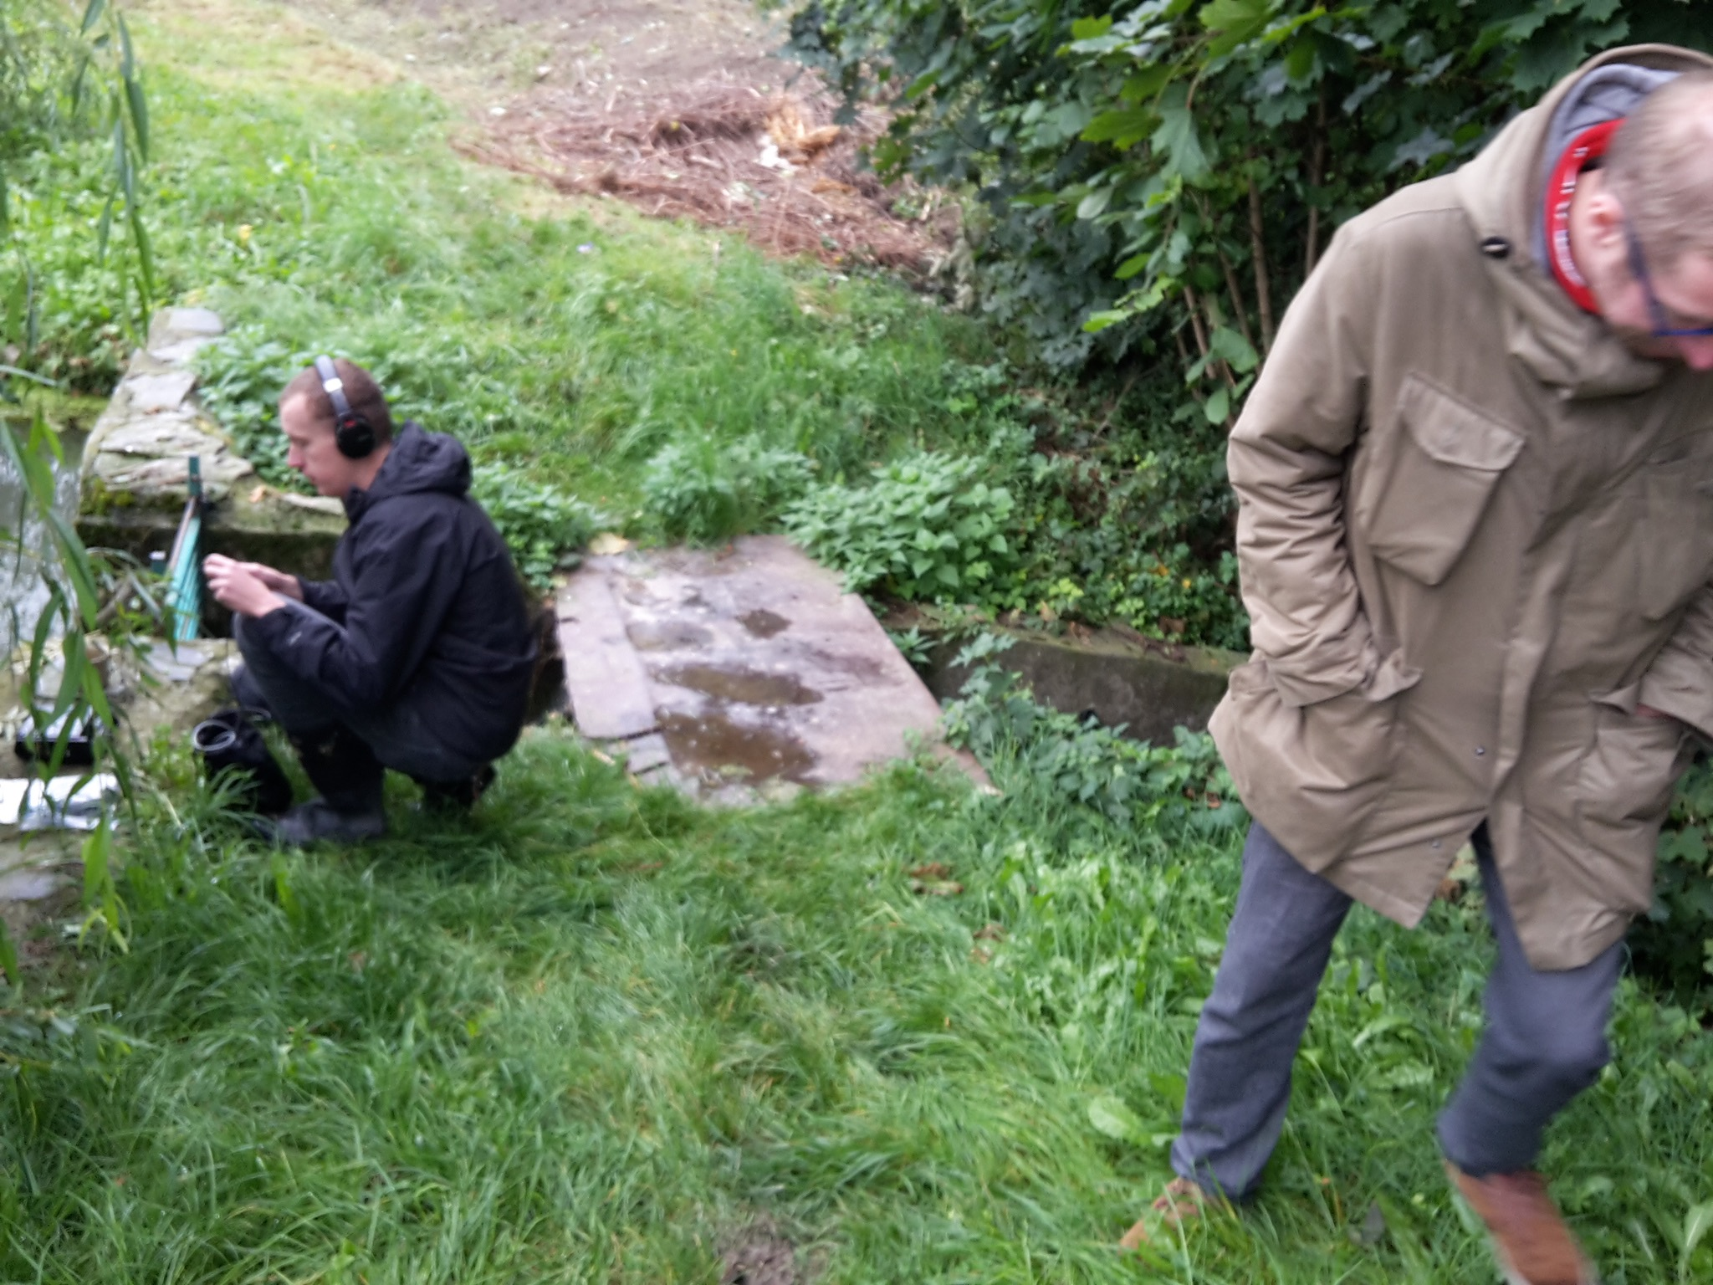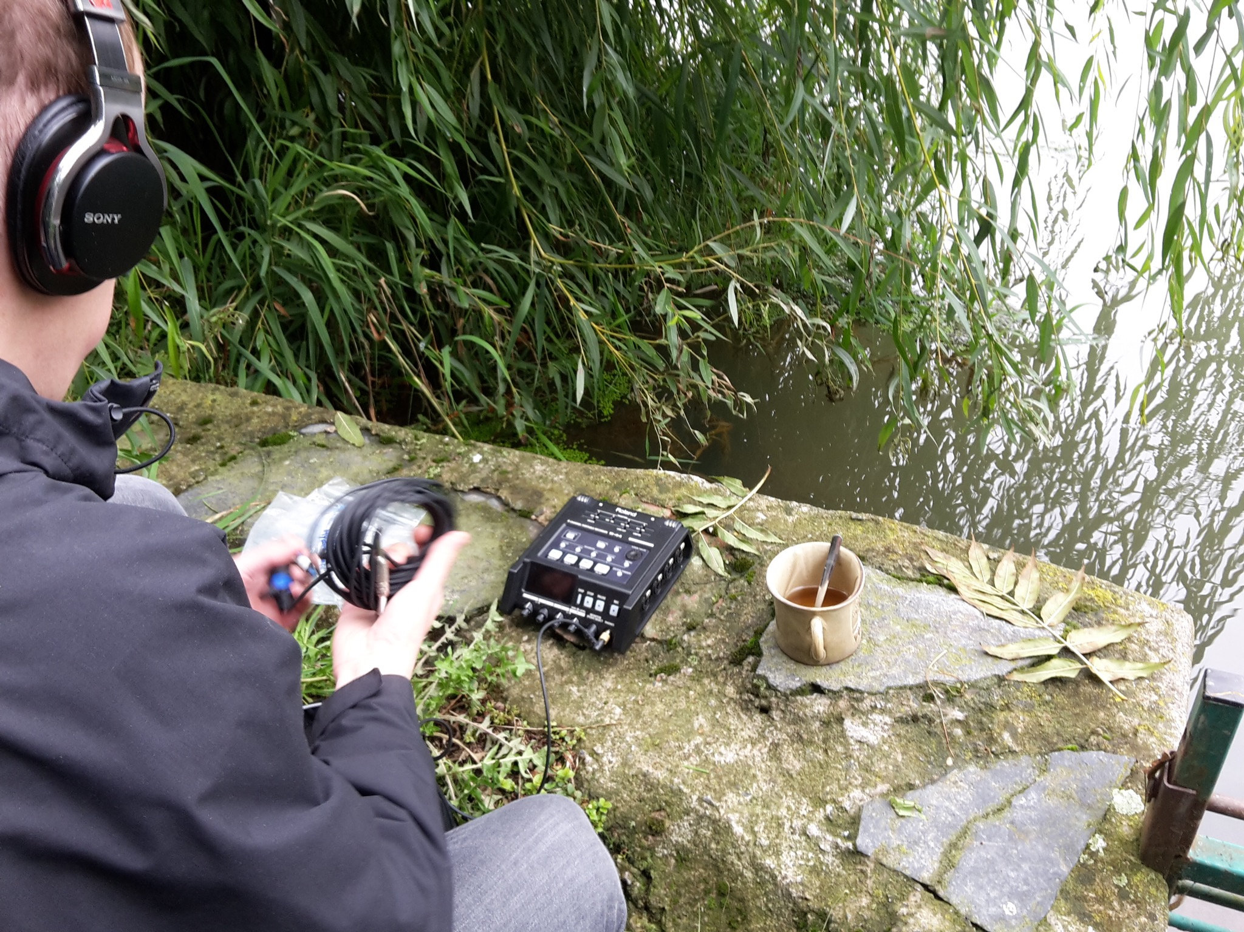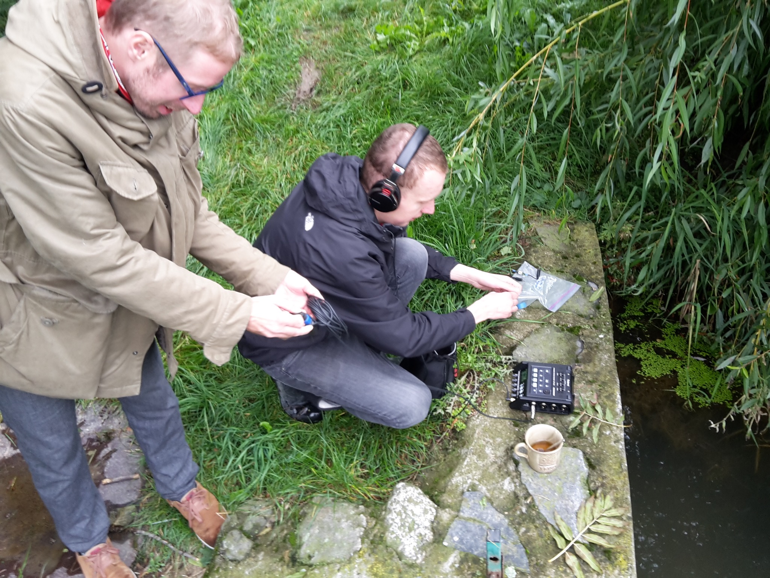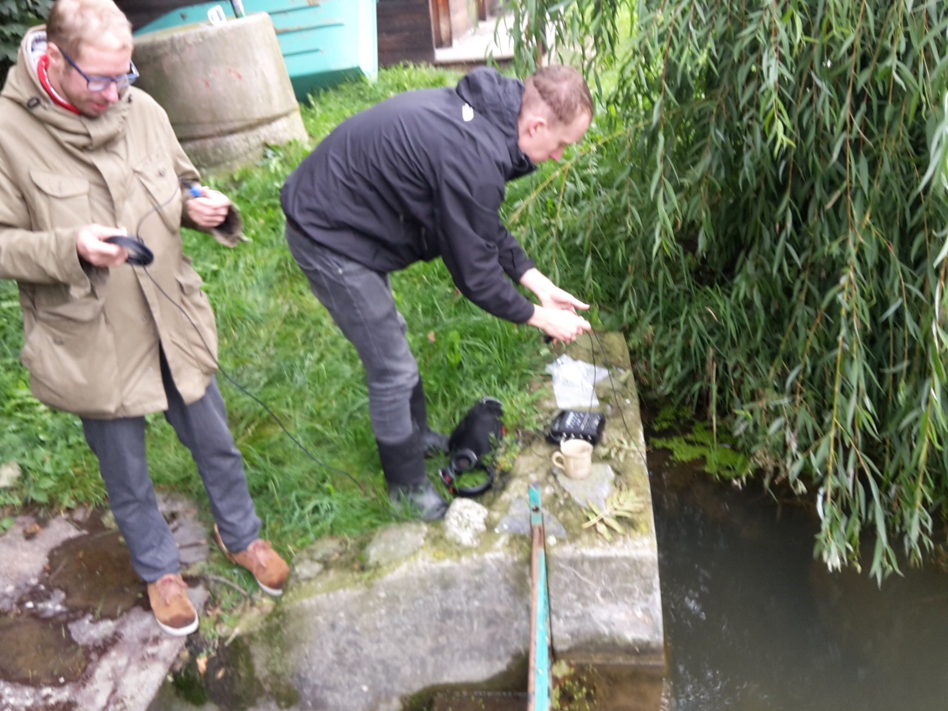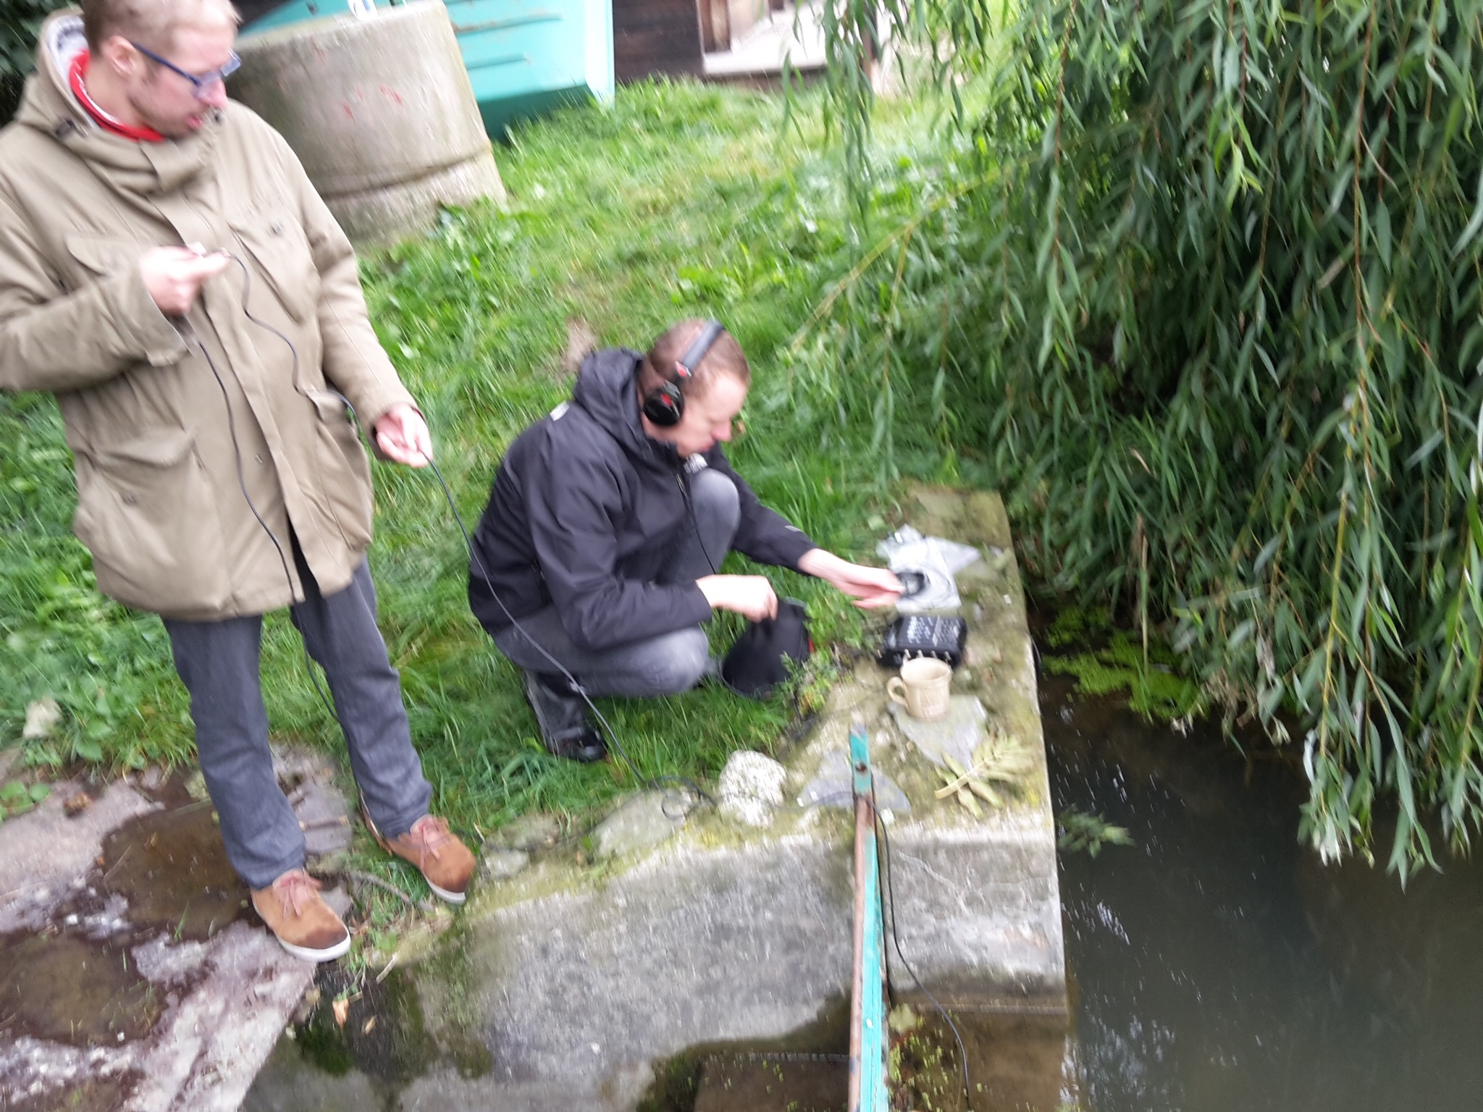
Excerpt of a recording in Kravín Hranice.
September 2017.
skupina-kra-fragment.wav

Attic Talks I
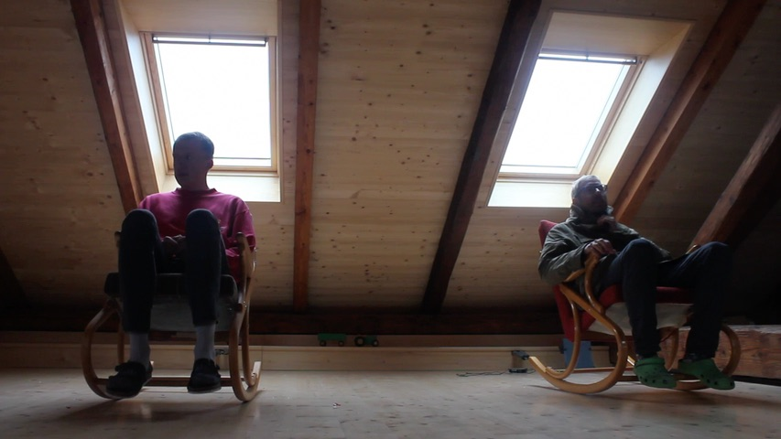 skupina-1-interview.wav

Attic Talks II
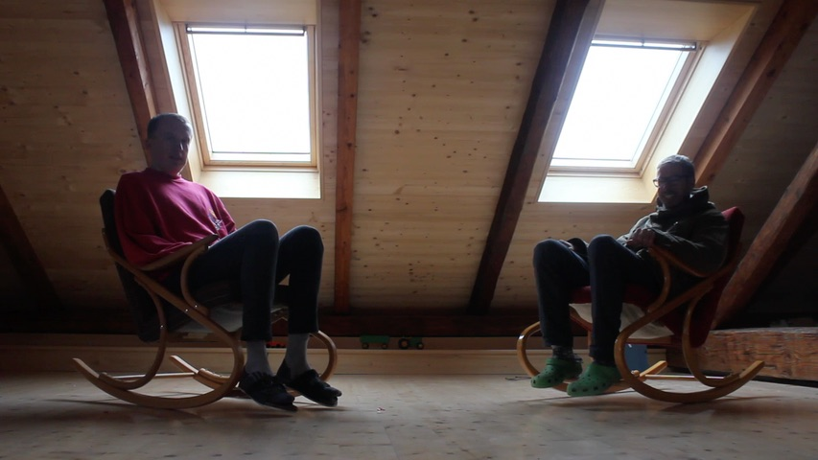 skupina-2-interview.wav

Attic Talks III
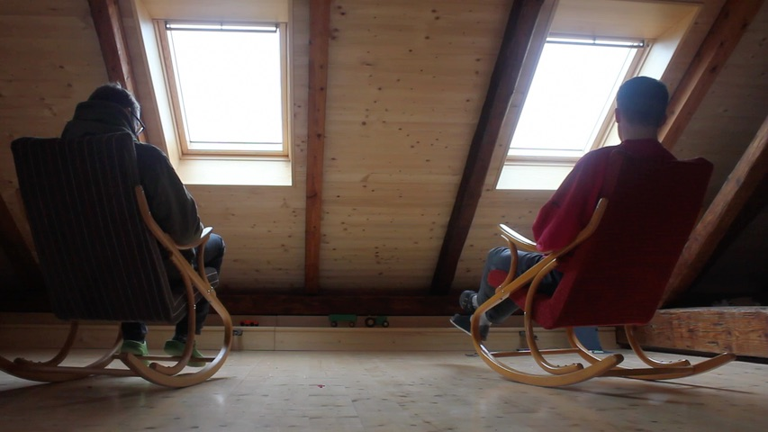 skupina-3-interview.wav

Attic Talks IV
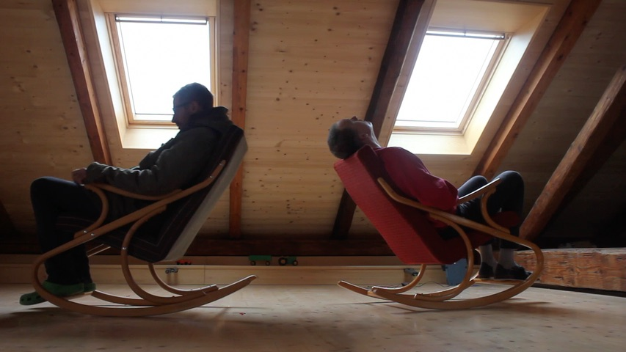 skupina-4-interview.wav

