DVA[2]METRI
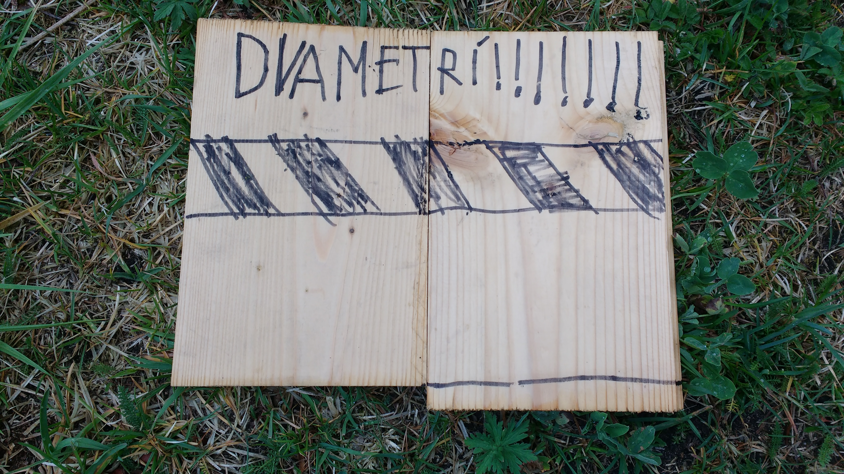
We combine 2 models.
model 1: the fullerene spiral (with failing face) in which each have an individual distance of 2 meters: musicians, singers, audience, instruments, electronics (treating the physical and non-physical people or non-people the same).
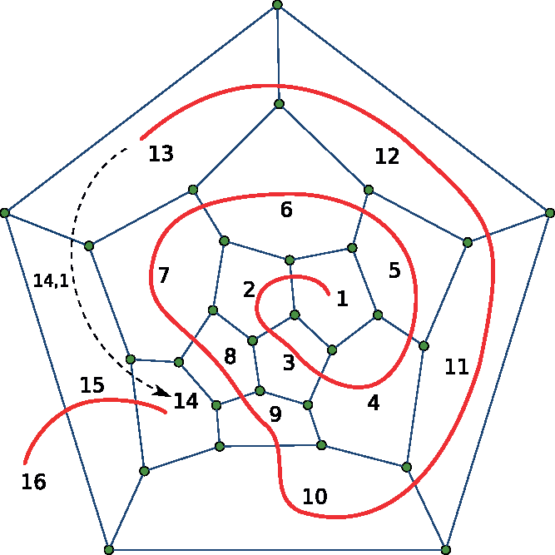
model 2: the sliding puzzle, or: within the spiral, the constant internal movements are regulated with this principle, in 2×2, 3×3 or 4×4 matrices, depending on the magnitude of internal movement.
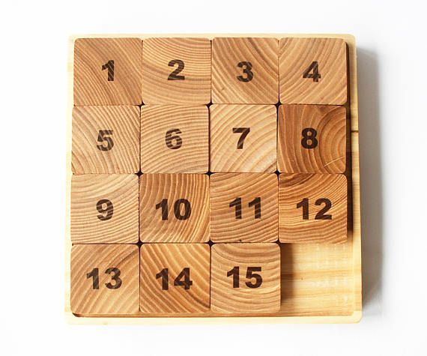
a life-resembling description:
If you know the area of the field you want to perform on, with this algorithm (a spiral) it would be easy to calculate how many people can fit optimally, when standing 2m separated. The first problem occurs when one has to go to the toilet or fetch a drink at the bar. For that reason, a second algorithm is introduced that works on partial collections of people (the sliding puzzle). For the general break though, the spiral unfolds backwards and all people pass in a row the bar and move back in with the same speed, not giving up the required 2m of distance. Interestingly, first in last out and after the break last out first in, so late visitors have a better position towards the middle. If the musicians are part of the spiral set-up, this does not matter, but then it provides, together with the slide puzzle algorithm, a constantly changing spatial sound during the performance and break. A break can better be used for its creative and sonic uniqueness. This is reminiscent of the so-called 'breakdown sessions' at the origin of skiffle music in the early till mid XXth century.
Solutions:
Joeri B. suggested to integrate it into Voronoi diagrams, https://www.openprocessing.org/sketch/399213/
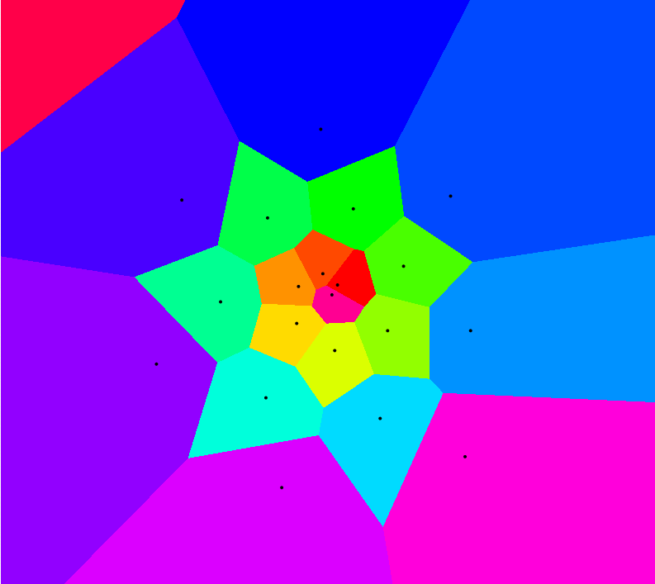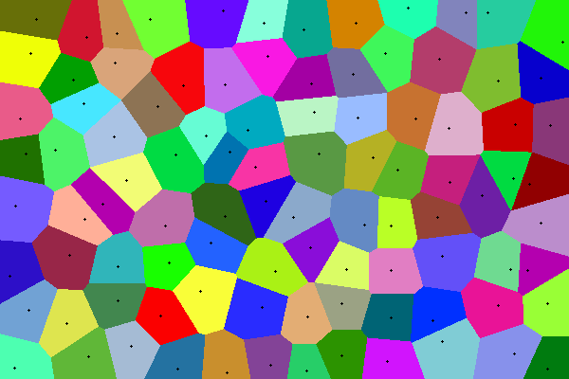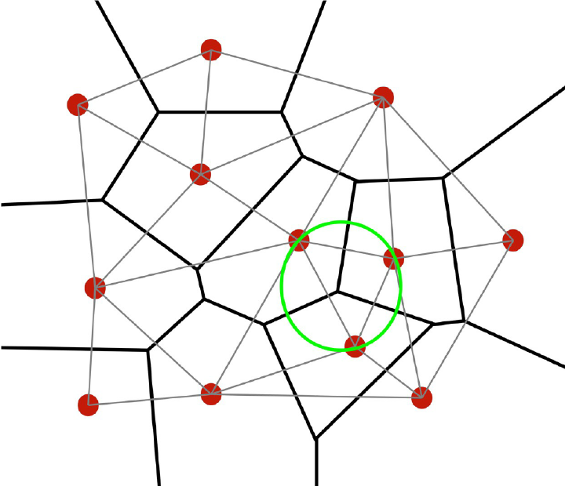
With this choreography, we can additionally provide a solution to any 'crowding' problem:
“... het is vandaag dat we -jah- vragen aan de verschillende kustgemeentes om een strandplan te maken, een strandcirculatieplan, een dijkenplan, dat dat allemaal ingeschakeld wordt in een gemeentelijk circulatieplan en dat zal de grote uitdaging zijn!” (Gouverneur W-Vlaanderen Carl Decaluwé in gesprek met VRT journalist Willem Van Mullem, Terzake 20200511)
Translation:
it is today that we -jah- ask the different coastal municipalities to make a beach plan, a beach circulation plan, a dyke plan, all of which will be used in a municipal circulation plan and that will be the big challenge! ” (Governor W-Flanders Carl Decaluwé in conversation with VRT journalist Willem Van Mullem, Terzake 20200511)
An interesting example: Hajj 2020


