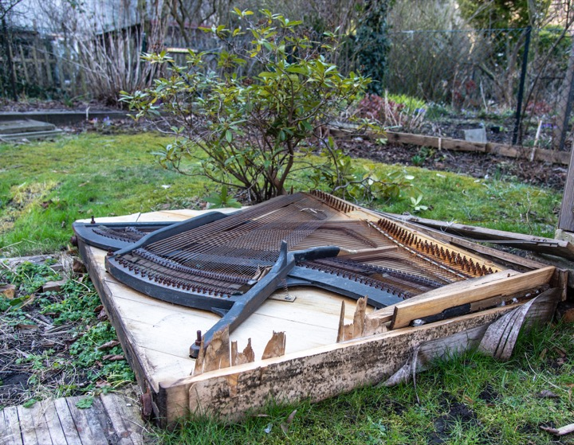
Geza Bobb does research on sound art, contemporary music, audio media and the aesthetics of radio and is a freelance radio and audio producer. Did radio at savvy funk and co-curated Dystopie Sound Art Festival. Phd in musicology on networked music, now Professor of Music and Media at University of Halle.

