Gívan Belá
Yes yes here come the ideas, plans, experiments, materials and comments for Rural Development plays Rural Development -- wait and hear here!

Obligatory Bio
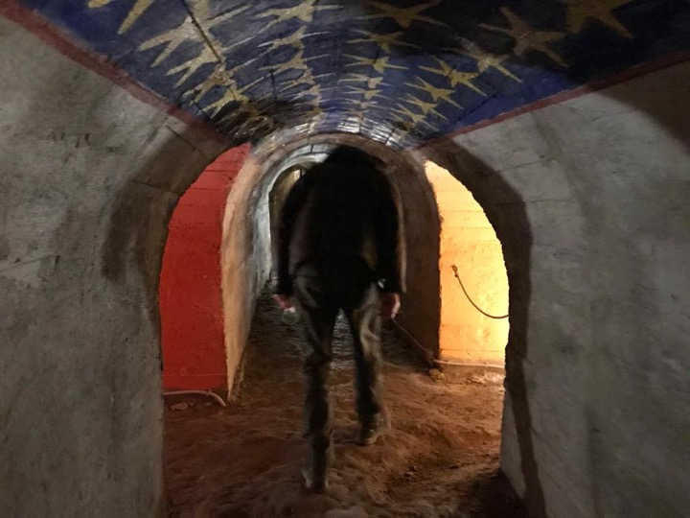
Gívan Belá. FKA Guy Van Belle, rather progressively obsolete. 0 Followers. 0 Following. 0 Like Received. 2 Comments Received. 0 Best Answer. 0 Air miles collected this year. 0 Miles to expire this month. 0 Miles to expire next month. More actions. Rural Development now!
Gívan Belá (b. 1959 in Belgium, a.k.a. Guy van Belle), was an experimental artist living in the Czech Republic. On occasion he would introduce himself as a media data author, on another as a wind time inventor and clockmaker, then at another as a slide and cigar box guitar musician in a skiffle/spasm band, maybe his real passion and phylosophy but in a very mixed technological way. After studying literature and linguistics, philosophy and sculpting, made the switch to computer music at the end of the 1980s. His most important virtual organisations (all collective) have been Stellingname (1984-1989), Young Farmers Claim Future (1990-2000), dBONANZAh! (1998-2002), mXHz.org (2002-?) and Society of Algorithm (2004-?). Then was co-founder and active member of OKNO (2004-15), an artist-run organization in Brussels. Between 2005 and 2009 he lived in Bratislava, where he began to work under the name Gívan Belá. After a short visit to the hamlet Hranice in Vysočina, and seeing an abandoned cowshed, he extended his name to Belá-Kravař. From there he was running an active ecological-artistic program, collaborating with the local cultural/social/educational organizations. Apart from the residency and outdoor performance location KraLand and during the legendary Corona times, he started a DIY digital lab ButtuLab.space, where youngsters of any age came to made sound pieces, FM and netradio, design their own 3D printed instruments and much more. He was founding member of the virtual online band Rural Development, which performed off-grid and in natural environments, integrating birdsongs and human noise. There wasn't much to leave behind than there already is.

Obligatory Timing
- add solar/batteries to the hranice streambox, check for stability, make an online workshop
- field recordings around the clock, edit, delete, keep, share
- take 2-4 local rural people in the fields, woods, mountains and on seasides, play some musical ideas with them and record it well (from mono to binaural and ambisonic), usually on a Sunday afternoon
- build the necky bass box to accompany the oil tin can slide guitar for some skiffle interventions
- patch up MUBU and code RAVE for more intelligent interactions than humans can think about
- add additional materials like pictures, text, sound, movies - that's what radio today is doing, no?
- THEN SUDDENLY IT'S TRANSMISSION DAY!

Example Datafile
- 20220227
- (First) Rural Sunday Walk
- Soundfile Ambix format, ZoomH3-VR
- Description: Cable Zip Line in Libice (60 kg maximum), next to the Rybnik.
- Walking with: Jacek Van Belle z Hranic

