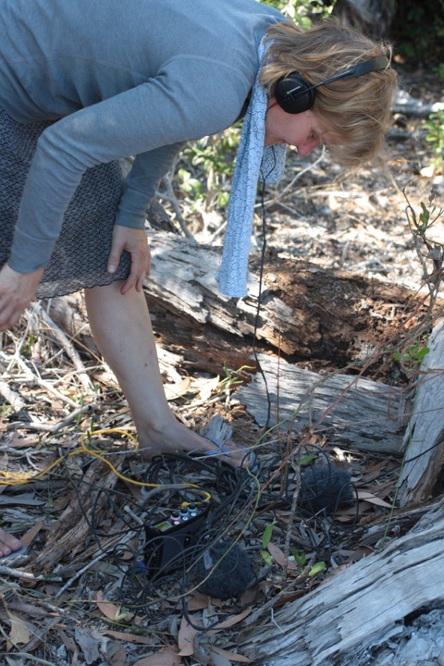
Kirsten Reese, composes for electronic media and unusual perceptual situations, spaces, loudspeaker constellations and performative settings. A focus lies on site-specific compositions, installations and audiowalks for rural and urban landscapes and works concerned with soundscapes and acoustic ecology. Kirsten Reese teaches composition and electronic music at the University of the Arts Berlin and is director of the UNI.K Studio for Klangkunst und Klangforschung at Udk (UNI.K | Studio for Sonic Art and Sound Research).

