Rural Development Plays Rural Development
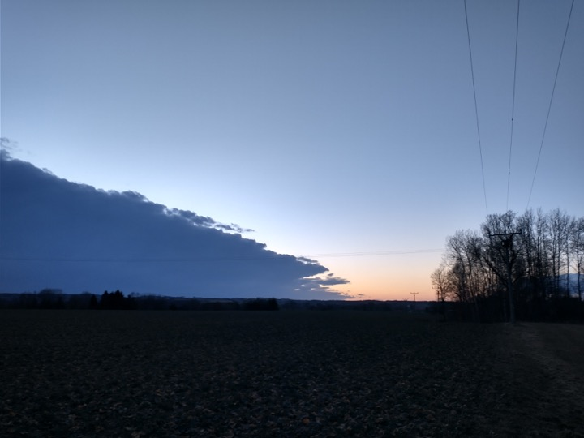
After a couple of meetings with everyone, many preliminary and statements came up. It certainly shows the necessary diversity of the concept of Rural Development and what is worthwhile to pursue, advance and combine. Simultaneously we are thinking of three parallel but overlapping and related streams.
- A 22 hour RuralStreamboxNetwork
- A 22 hour RuralRecombinationMix
- A 22 hour RuralLiveIntervention

Here come some approaches, ideas, texts, statements, materials
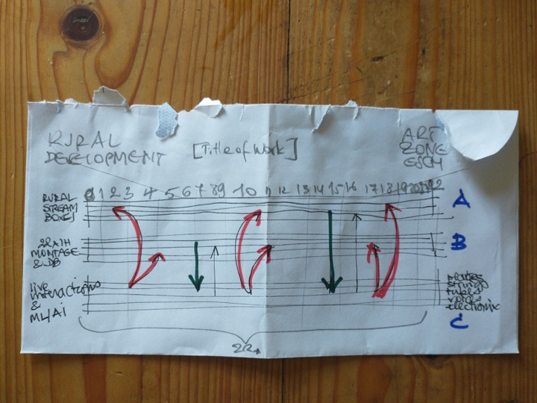
- Some ideas while thinking about 22. or [Title of Work]
- The obligatory Generative Poetika
- Workshop A: setting up an offgrid streambox
- Workshop B: AI/ML for sound (rave, mubu, ...)
- Workshop C: weekly sessions plates, strings, tubes, voices, electronics, code, ...
- Workshop D: P2P synchronisations on&offline
- Workshop E: Planning of musical sections, resource organization, form of the piece
- Outputs = binaural streams, 4.1 local playback (Reaper template available)

