The Rural Open Streams for [Title of Work]
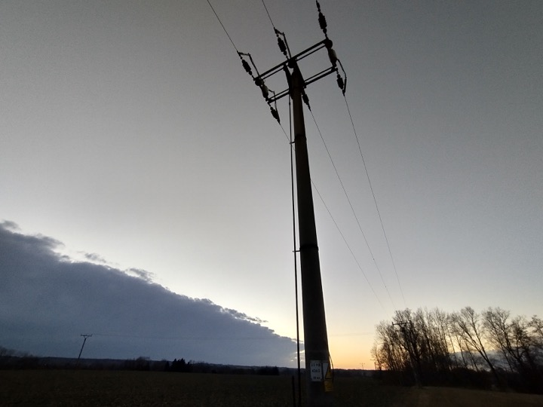
On the day itself 24 August 2022, from all participating Rural Locations, we generate a continuous open mike stream.
This will function as a 22 hour continuous background, and useful for running at anytime within the radio transmission. As Rural Development is playing along with nature, instead of nature playing along with the musicians, it is an essential characteristic anchor point for the band. Also in case of failures, or some additional sonic-sensual needs this could be mixed in and out...
Let's make all our streamboxes, battery operated and stable for the time going.
The last weekend of May we started an online workshop.
By now we have 3 streamboxes operational: Berlin, Hranice, Kerminy. Additionally some local transmissions are planned with the joined Super Radio Rural infrastructyure.

Here come some notes and documentation...

