A Super Radio Rural for [Title of Work]
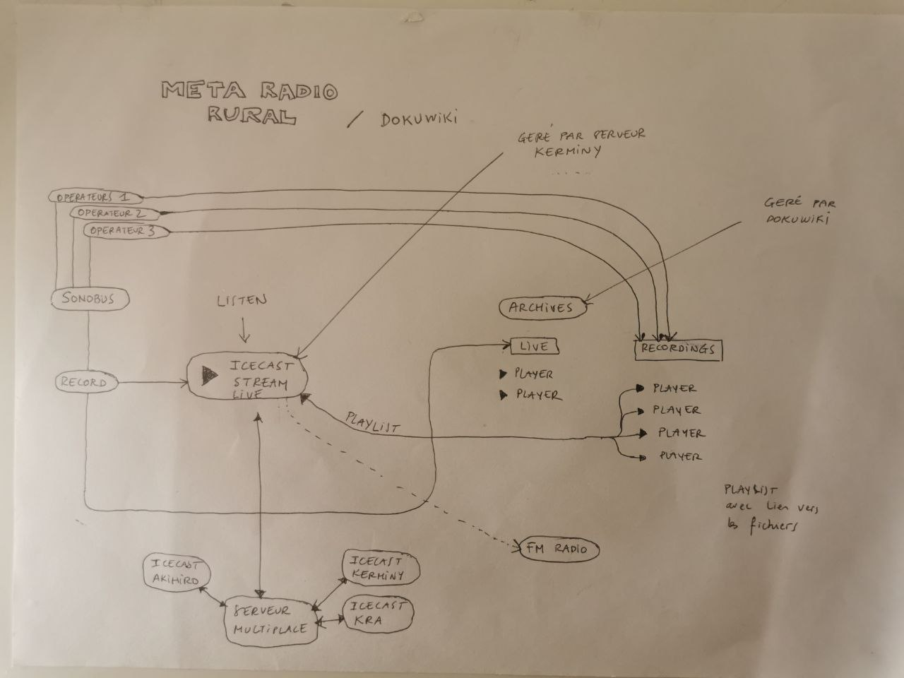
As a kind of sustainable development that we had in mind, across countrysides everywhere in the world, is a double FM/internet radio made and maintained by locals. There exist already preliminary radios like radioK (Kerminy) and Radio Zá (Chotěboř). We invite from now on other rural art radios to join in.
So, the idea is to create a super-radio of all local rural radios, with a shared playlist and soundfiles. Why would we flee from project to project without a more sustainable outcome, something that can be used afterwards for the benefit of our beloved real rural development? Set up so far by: Radio Zá (Chotebor), radioK (Kerminy), but others will join in for sure!
An inspiring talk with Jeff Rolez and Dom Leroy from Kerminy produced a plan! An enigmatig day: 20220211!

