Réveil 2024-05-04

WASR, or: WATER STREAMS AT SUNRISE!
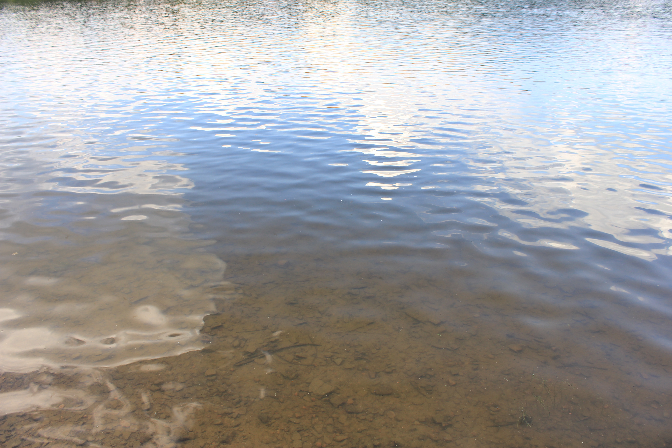
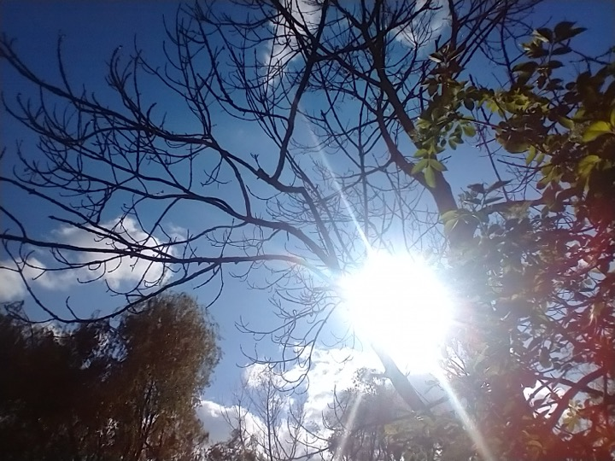

The Stream
Streamer(s): The New Rural Development Broadcast time (your location UTC+2): SUN 04:50 - SUN 05:26 Broadcast time (stream location UTC+2): SUN 04:50 - SUN 05:26 (Civil Twilight - Sunrise) Coordinates: +49.763814°, +15.691920°
Wetlands are vital ecosystems because they regulate the water cycle and prevent floods. They are critical habitats for diverse species, from migratory birds to fish and aquatic plants. At the same time, they provide essential ecosystem services such as water purification and carbon sequestration, significantly contributing to global environmental health. However, despite these critical functions, they are one of the most threatened habitats by human activities: it is estimated that between 64% and 71% of the planet's wetlands have disappeared in the last century.
Climate change, desertification, loss of biodiversity, ... It is daily in the media, EU is proposing new programs for a green approach esp. to the countryside. And it is certainly around us, also about us. In spring near Zastrán farmers were putting new drainage pipes in their fields, while the apples and plums are drying out on the trees. This year we had the warmest September on earth ever recorded (globally +1.5˚C!). Within these changes, water management is playing a crucial role today. One reads about international measures to capture and keep rainwater, protect groundwater, revitalize ponds and rivers by reconnecting them again, of course also reforestation and the return of (green) water energy! Regional history shows that until WW1 the Vysočina region was mainly using waterpower. Elsewhere water turbines have been successfully deployed instead of solar and wind devices, neutralizing the negative environmental impact, empowering small communities, and preserving bio diversity.
Time to bring these things under attention, and to provoke urgent changes.
In the weeks leading up to Réveil, with a small group of (young to old) creative local people, we were preparing different ways of recording sunrise. A workshop on microphones and devices, hydrophones and the different appearances of water, some preliminary walks and recordings. Not only water and the environment, but water is the environment, and we are literally running out of it... but let the sun rise with you! For Réveil we were setting up a combined live stream from 3 locations, each 7 kms apart. With thanks to everyone involved and interested over the last weeks...

Something to see
Chittussi Site Chotěboř
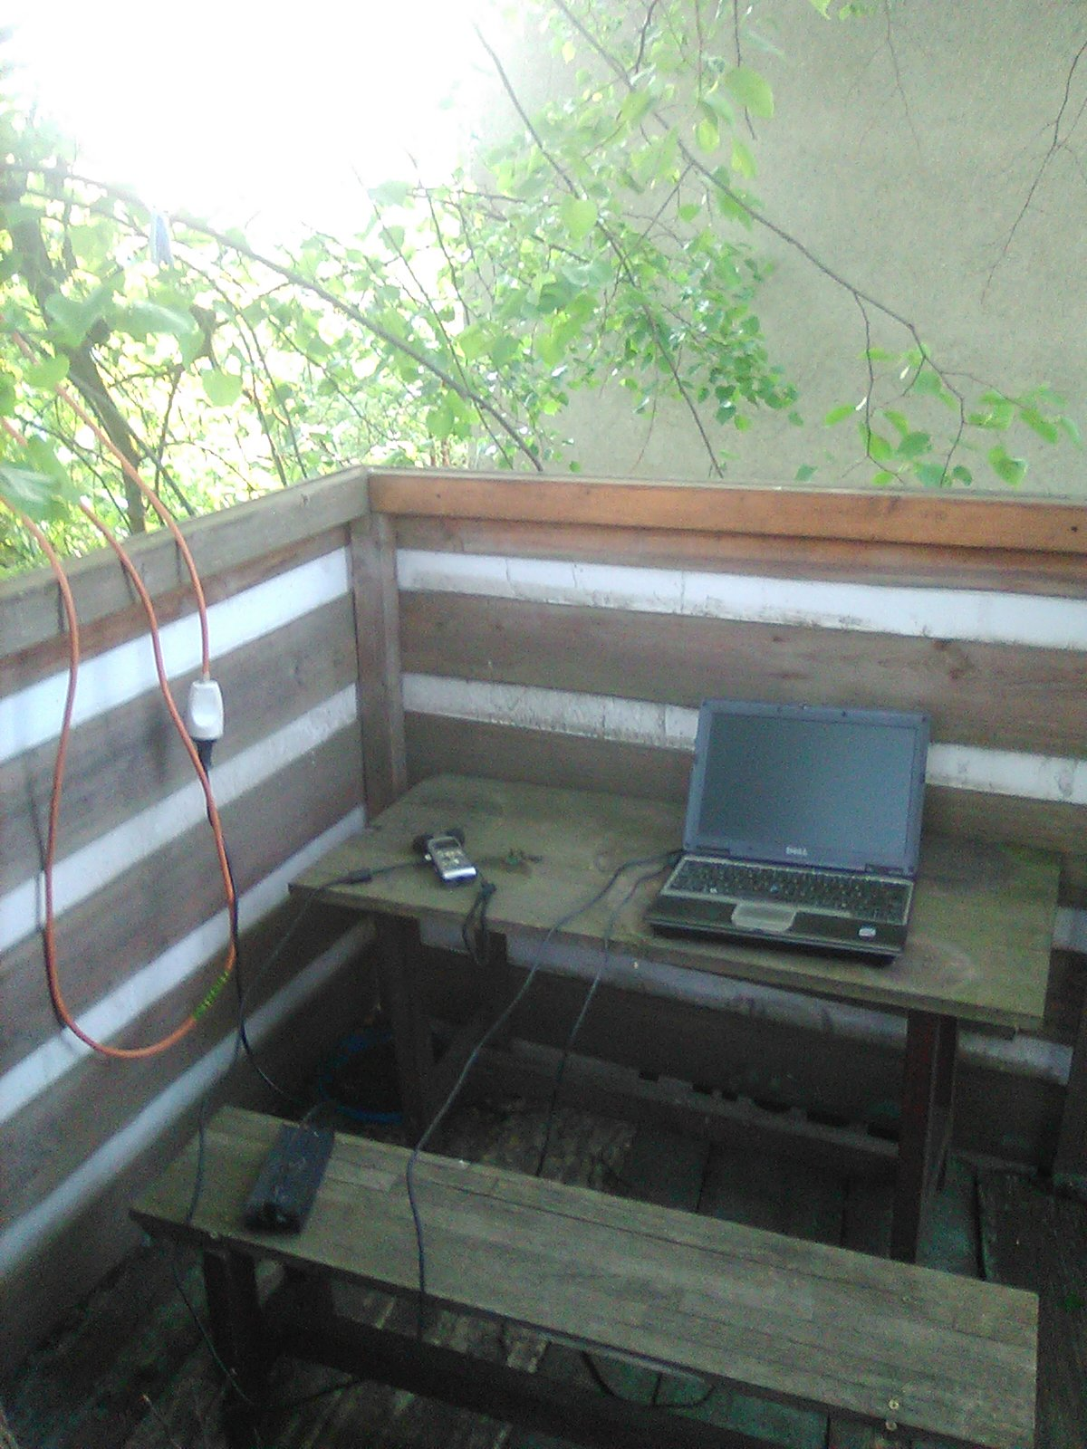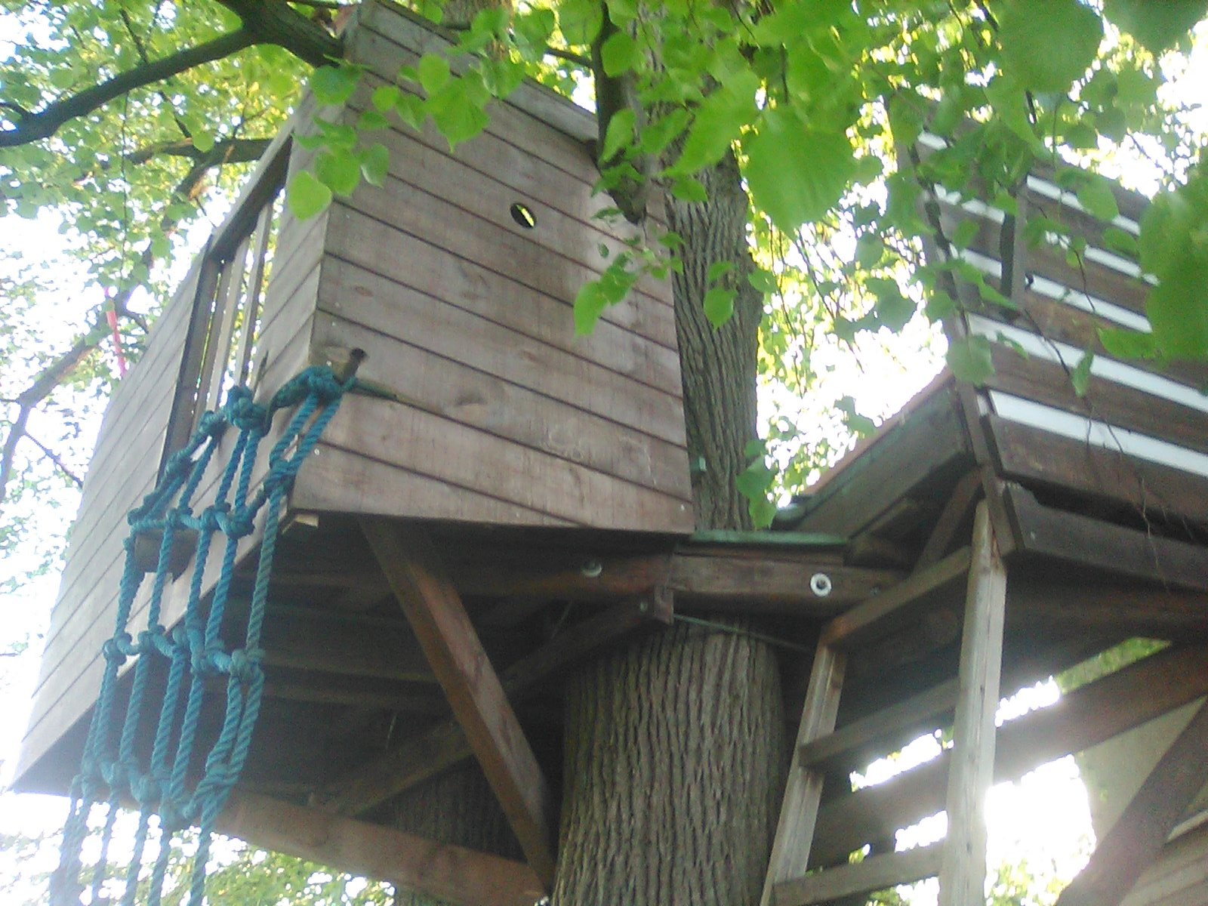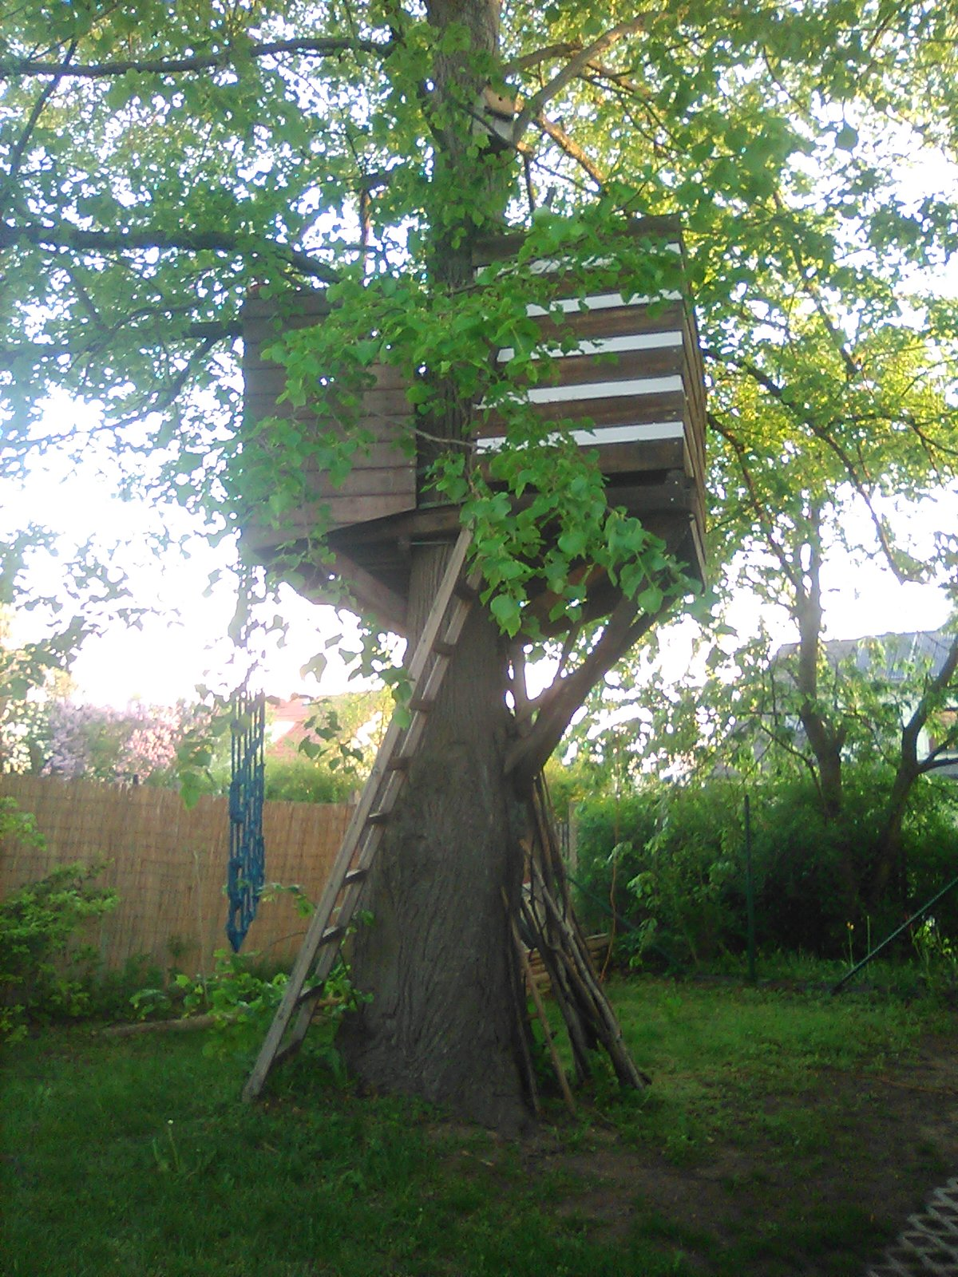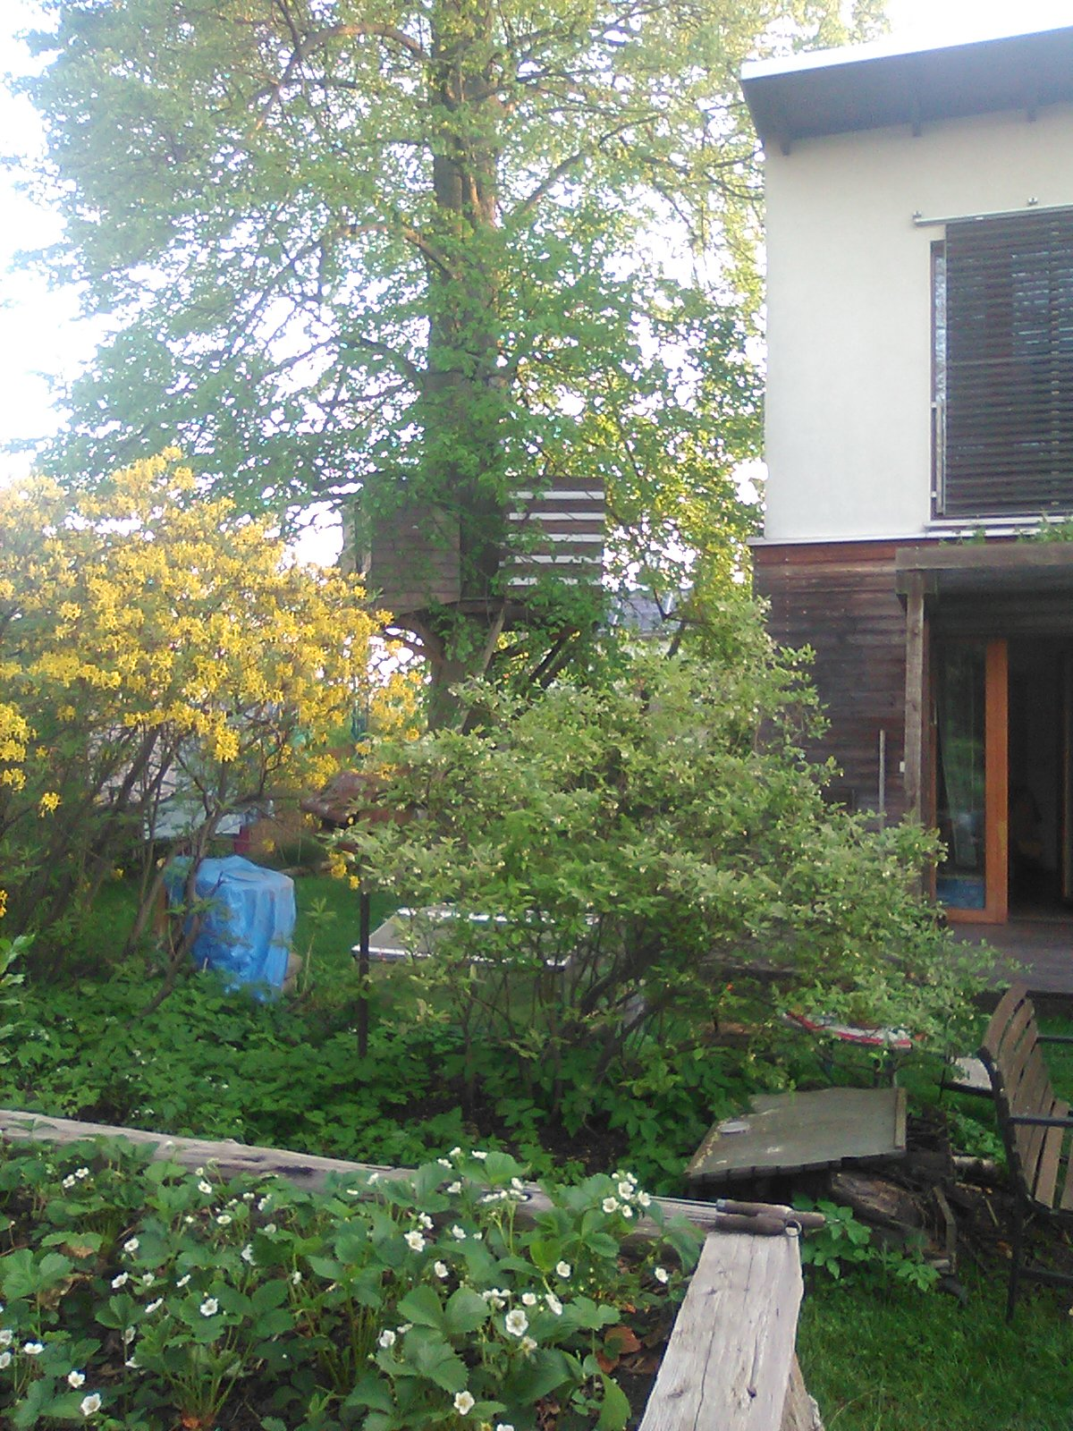
Kra Surroundings Hranice
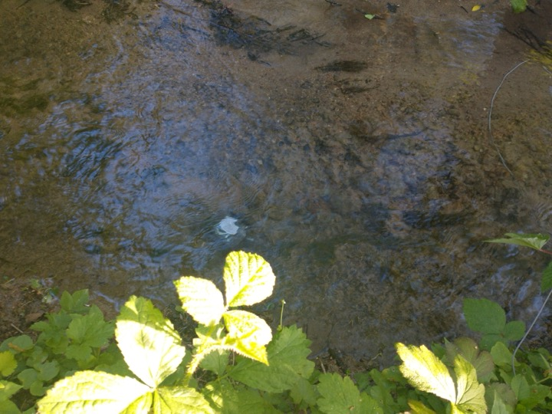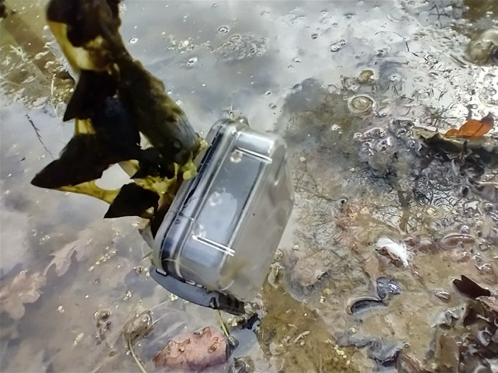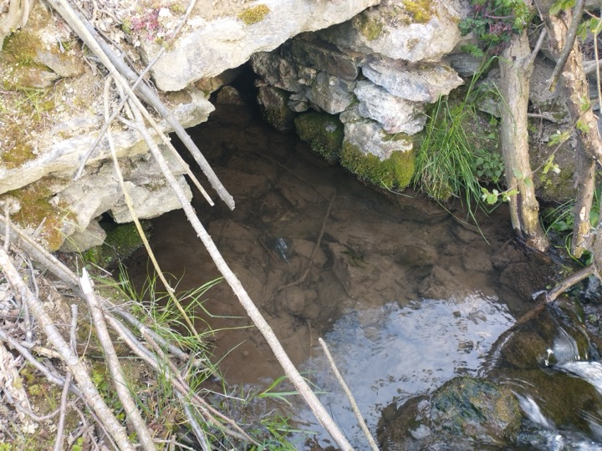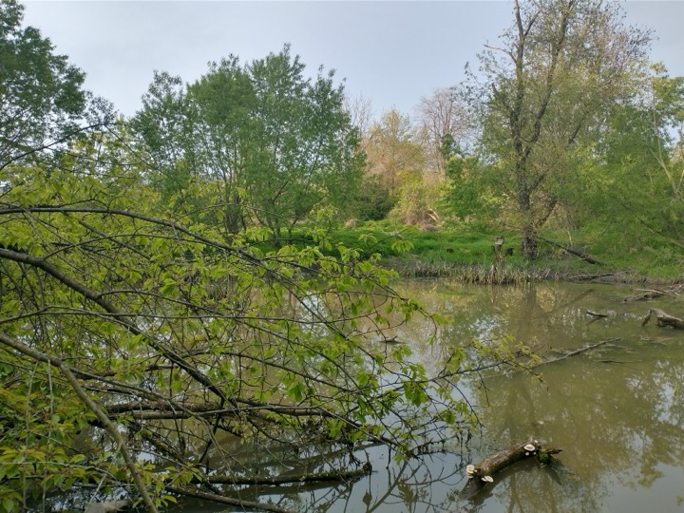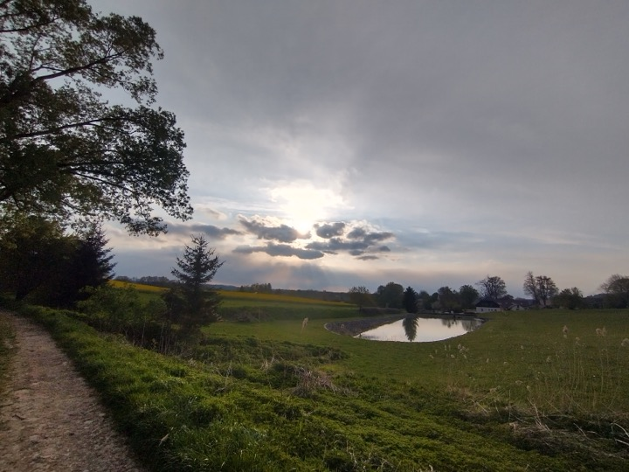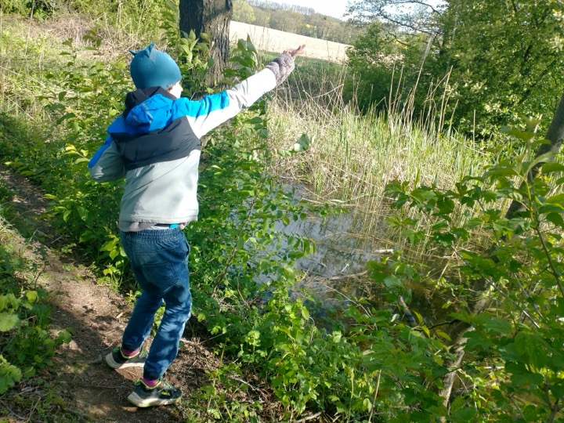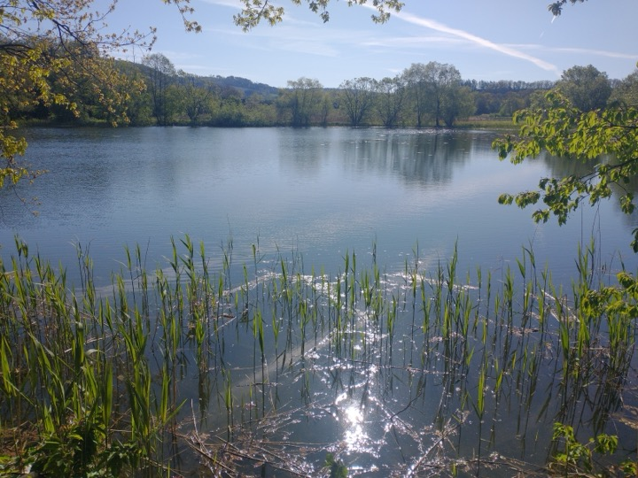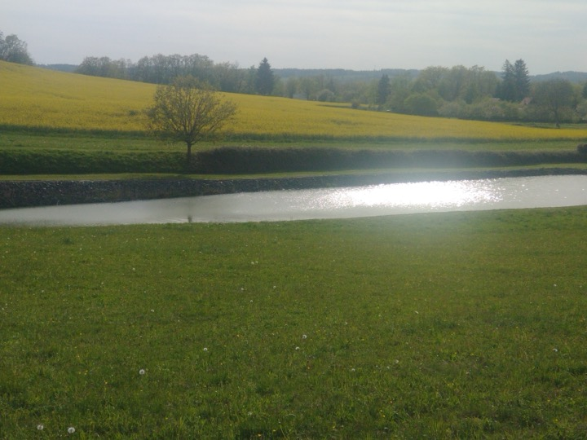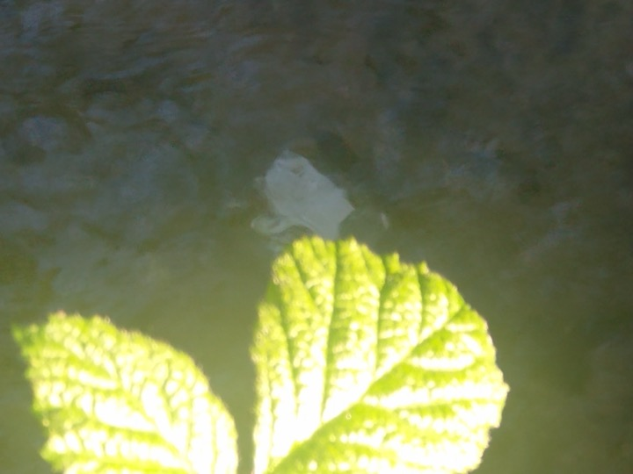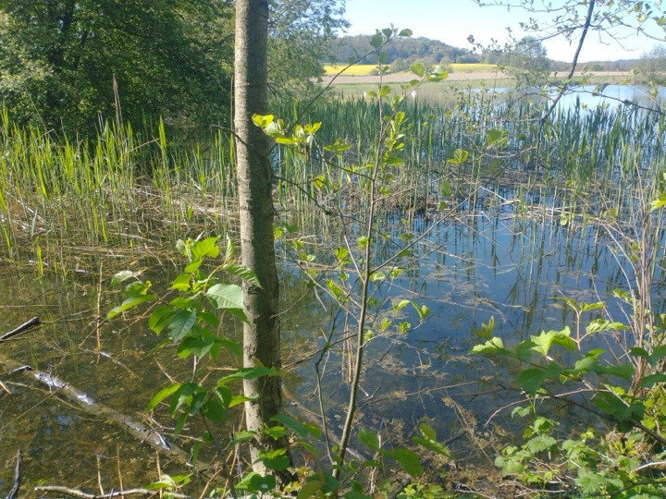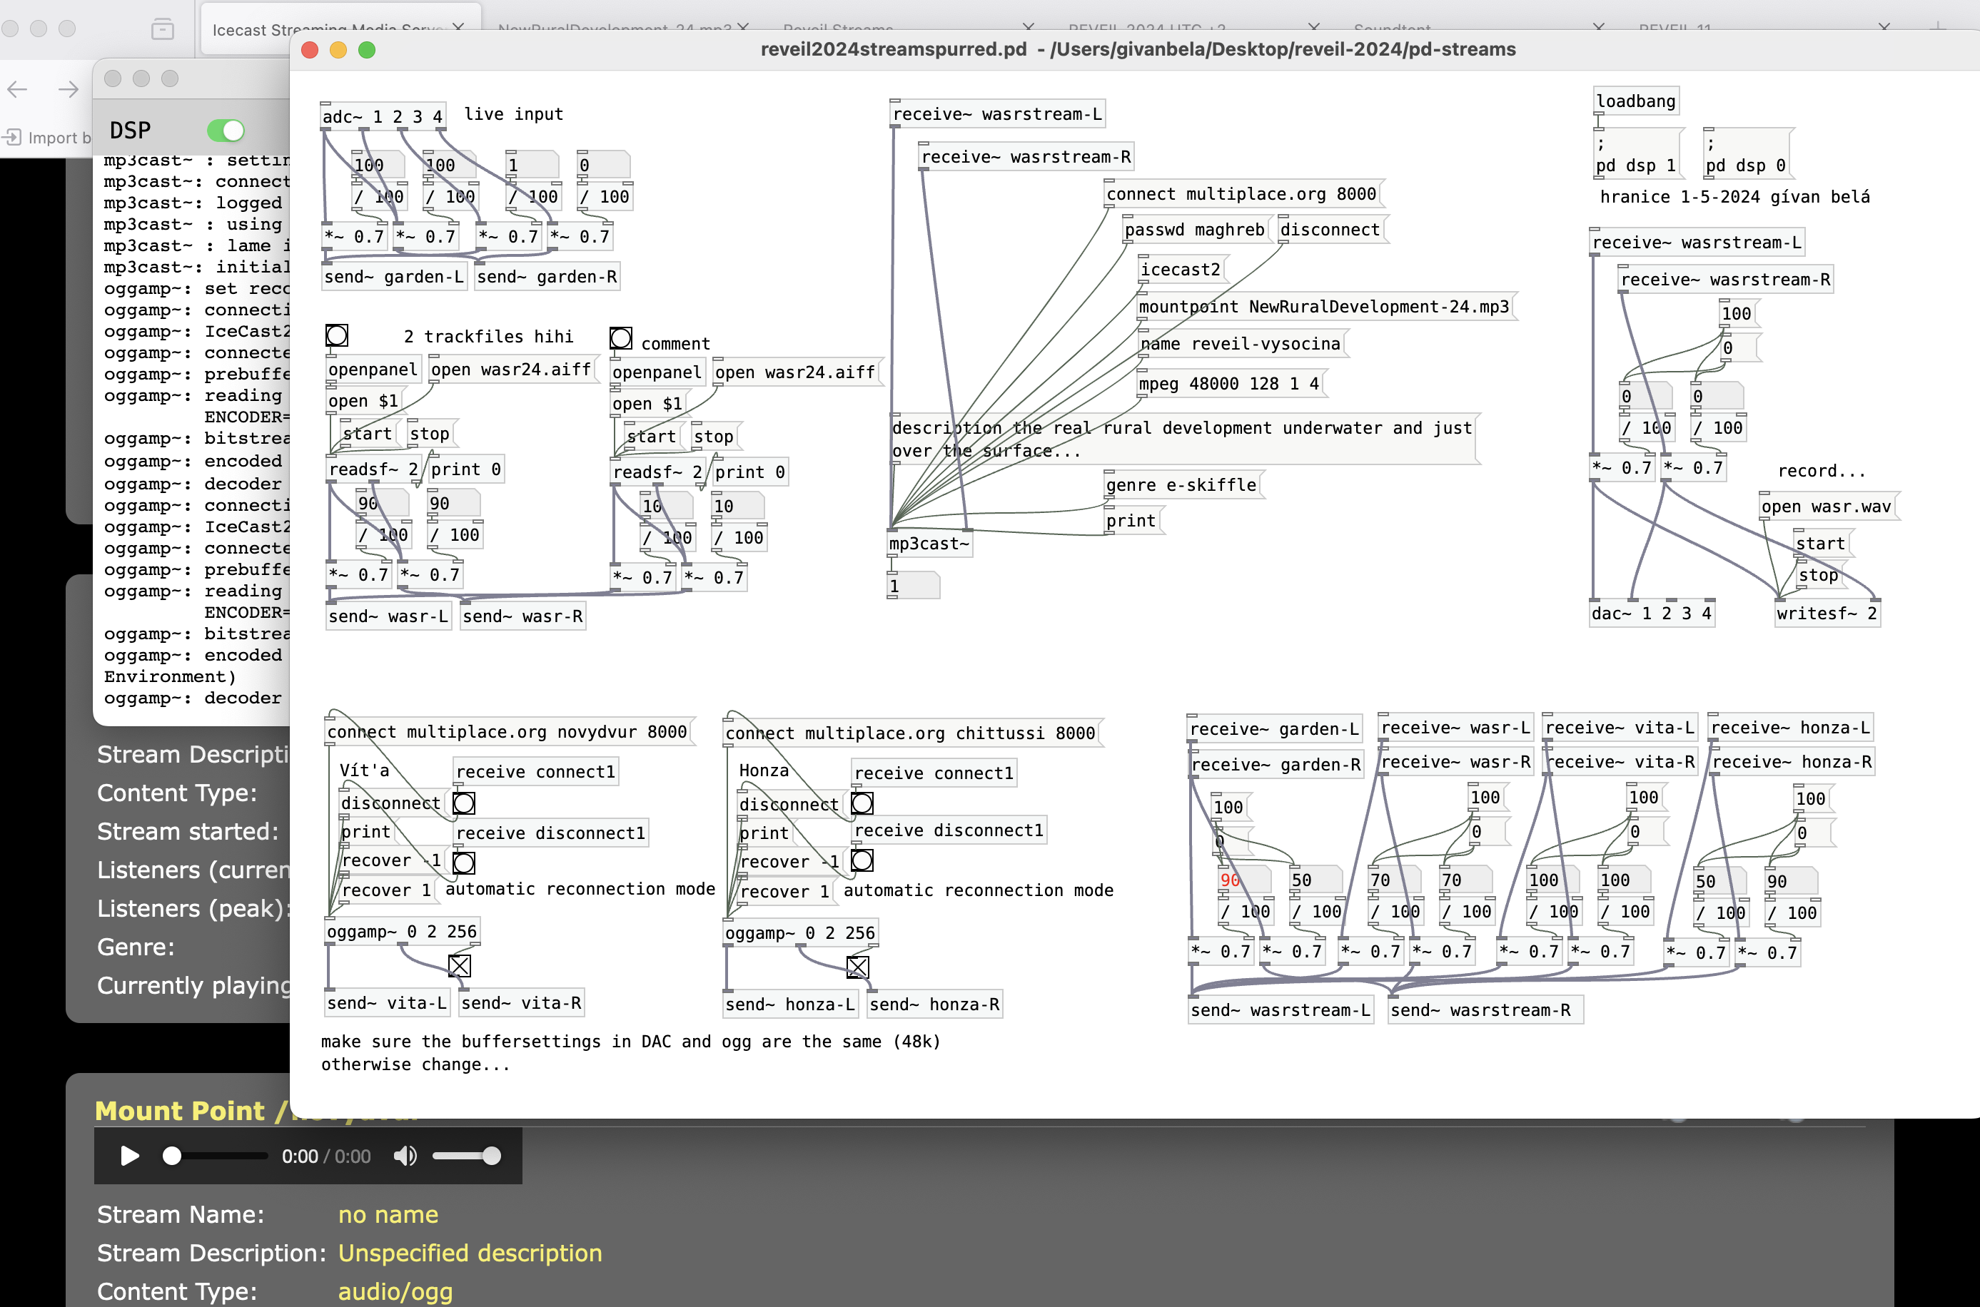
Novy Dvůr Area

Something to hear
This is a local recording of the stream-up for Réveil #11, May 5th 2024
rev11
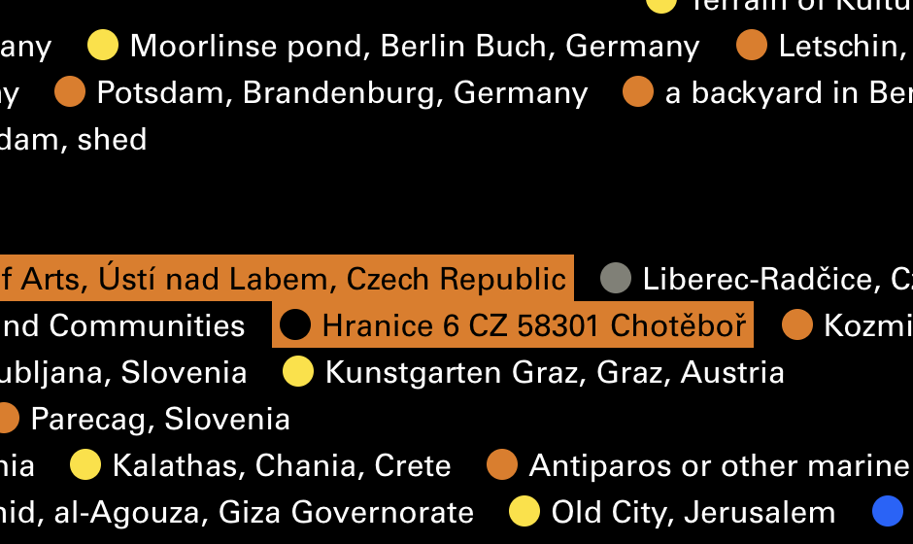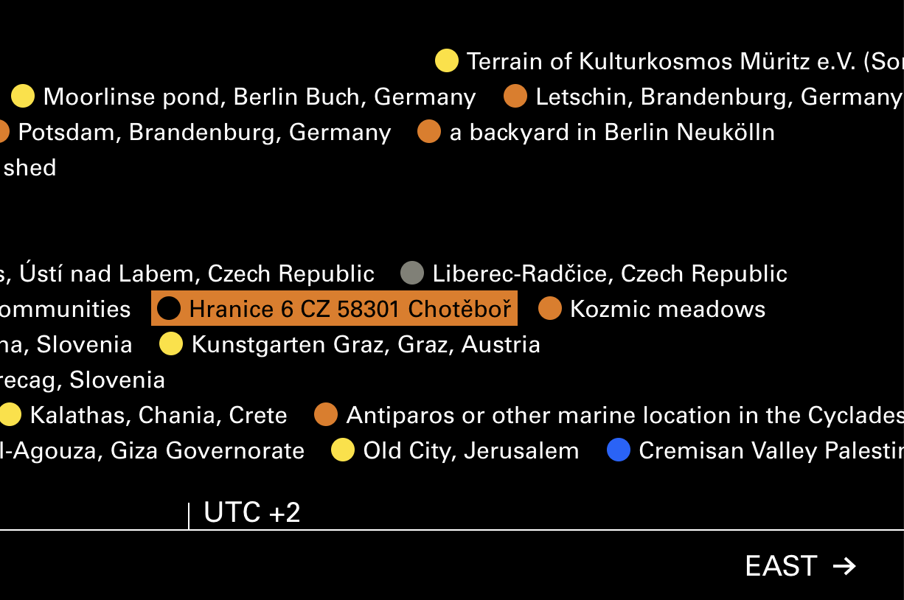

Links
- Date: 4–5 May 2024
- New Rural Development Info Page on Soundtent
- Announce: https://soundtent.org/mail/Reveil_2024_announce.html
- Page builder: http://streams.soundtent.org/manage/
- Example page: http://streams.soundtent.org/2024/streams/utc1_-aa230c3a-bbd5-4b91-b66e-5693ea8ba16e
- How to: https://soundtent.org/stream/
- Webinar / support: http://soundtent.org/mail/Reveil_2024_announce_3.html
- Set up a soundcamp: https://soundtent.org/setup/

The preparations
Address ButtuLab at Zastávka Chotěboř:
1. Every Friday of April 2024
- 2-3h standby online (technical advise for remote DIY artists)
- 3-4h handson onsite WASR! (or: Waterflow@Sunrise)
2. What we wanted to do and somehow did
- 05/04 microphones and devices, edit, mix, play and share
- 06/04 workshops by soundtent London, covering streaming with a phone/laptop/RPIstreambox at 10:00–11:00 UTC+1 and 17:00–18:00 UTC+1
- 12/04 hydrophones, ultra, infra and understanding the spectrum
- 19/04 share and stream and maybe how to set up spatial listening
- 25/04 plans, places, fields, areas, testing setups
- 04/05 RÉVEIL: WASR! water streams at sunrise 5am-6am

