The Rural Streambox Network for 22.
A further further sorry for the in between page: klik
The idea is to create a sonic landscape using live open microphone streams, from the several rural areas where rural artists work. Maybe it is essential to Rural Development, that they don't compose or write music. The natural surroundings of which we are part of are providing the scores and triggers. The combined network is not an absolute one but more of a setting which becomes more or less dominant over time, but never disappears from the music, with human noisemakers as part of nature. Read, listen and enjoy the permanent Rural Open Streams.
B
The second idea is to go beyond the piece for Esch-22, and set up a permanent exchanges of soundfiles that were recorded in rural communities, for transmitting over local FM radio and internet. Jef and Dom from Kerminy are developing the open source hard and software for this Super Radio Rural.
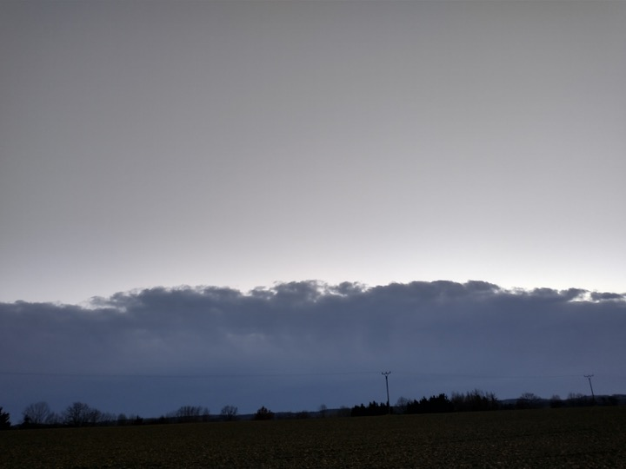
Here come some further descriptions and notes, thoughts ...

