Art's Birthday 17 January 2022 -- 20H (Greenwich + 1)
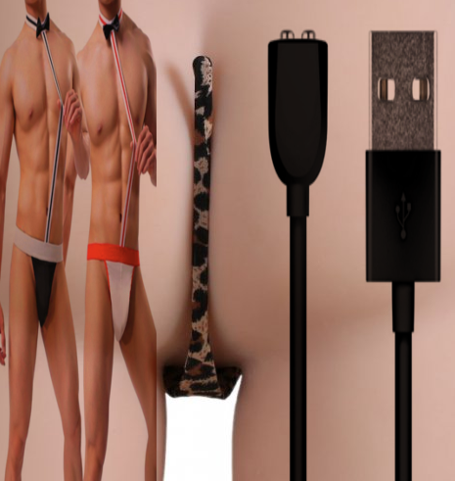
play peer-to-peer in a festive but fitting birthday outfit
wondering where all the string music from past to whatever
like now has gone to... groups of six musicians on long to
short strings (de)tuned and (un)sync'd staccatos slides
drones and everything in between till new birthday songs
can be heard/imagined or ignored...
art's birthday 2022

