Dmitrov (Moscow province)
21 December, 1920
Respected Vladimir Illich,
An announcement has been placed in Izvestiia and in Pravda which makes known the decision of the Soviet government to seize as hostages SRs [Social Revolutionary party members] from the Savinkov groups, White Guards of the nationalist and tactical center, and Wrangel officers; and, in case of an [assassination] attempt on the leaders of the soviets, to “mercilessly exterminate” these hostages.
Is there really no one around you to remind your comrades and to persuade them that such measures represent a return to the worst period of the Middle Ages and religious wars, and are undeserving of people who have taken it upon themselves to create a future society on communist principles? Whoever holds dear the future of communism cannot embark upon such measures.
It is possible that no one has explained what a hostage really is? A hostage is imprisoned not as punishment for some crime. He is held in order to blackmail the enemy with his death. “If you kill one of ours, we will kill one of yours.” But is this not the same thing as leading a man to the scaffold each morning and taking him back, saying: “Wait awhile, not today...”
And don’t your comrades understand that this is tantamount to a restoration of torture for the hostages and their families.
I hope no one will tell me that people in power also do not lead easy lives. Nowadays even among kings there are those who regard the possibility of assassination as an “occupational hazard.”
And revolutionaries assume the responsibility of defending themselves before a court which threatens their lives. Louise Michele chose this way. Or they refuse to be persecuted, as did Malatesta and Voltairine de Cleyre.
Even kings and popes have rejected such barbaric means of self-defense as the taking of hostages. How can apostles of a new life and architects of a new social order have recourse to such means of defense against enemies?
Won’t this be regarded as a sign that you consider your communist experiment unsuccessful, and [that] you are not saving the system that is so dear to you but only [saving] yourselves?
Don’t your comrades realize that you, communists (despite the errors you have committed), are working for the future? And that therefore you must in no case stain your work by acts so close to primitive terror? [You must know] that precisely these acts performed by revolutionaries in the past make the new communist endeavors so difficult.
I believe that for the best of you, the future of communism is more precious than your own lives. And thoughts about this future must compel you to renounce such measures.
With all of its serious deficiencies (and I, as you know, see them well), the October Revolution brought about enormous progress. It has demonstrated that social revolution is not impossible, as people in Western Europe had begun to think. And, for all its defects, it is bringing about progress in the direction of equality, which will not be corroded by attempts to return to the past.
Why, then, push the revolution on a path leading to its destruction, primarily because of defects which are not at all inherent in socialism or communism, but represent the survival of the old order and old disturbances, of an unlimited, omnivorous authority?
P. Kropotkin
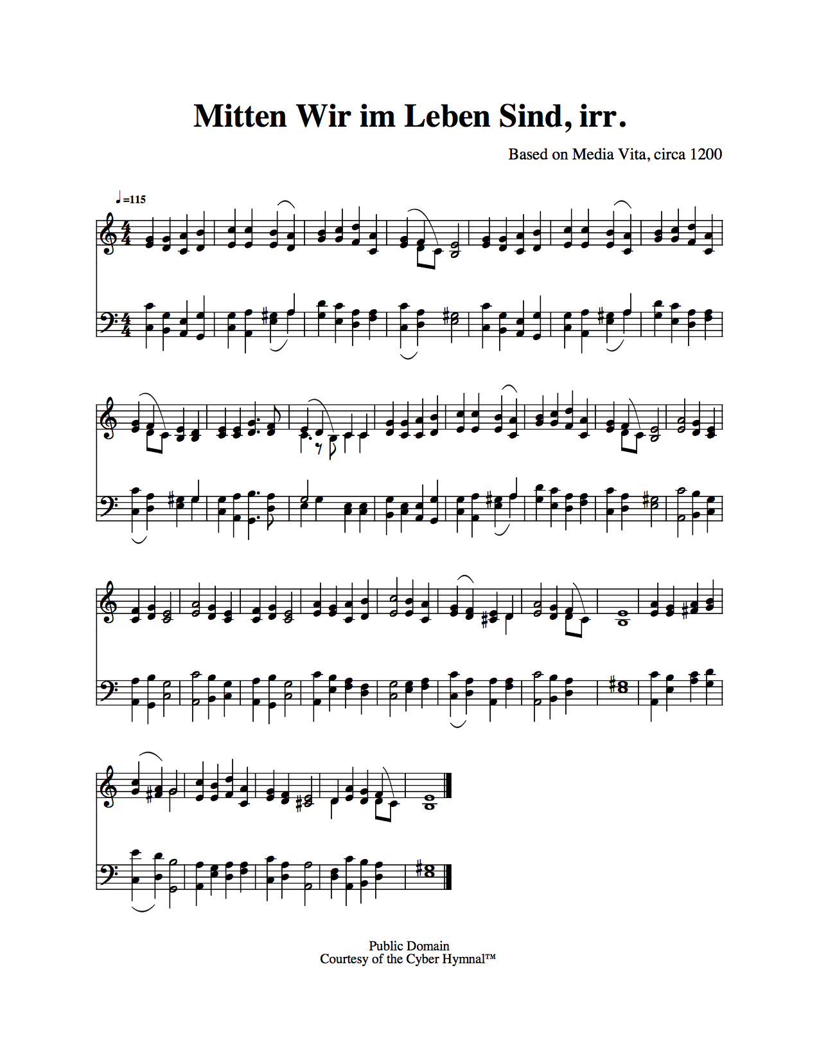
Succour /‘sʌkə/ (or: 'Kropotkin to Lenin but what about Luther?', and also: Materials for U- and Dystopia)
Succour is an experimental sound work based on historical material, with a temporary eko-political setting, and an unpredictable u- or dys-topian outcome.
Brought to you by The All-Weather Experts (Gesa Roman Bobb, Gívan Belá and invited local artists),
20171108-09.
Scenario and composition:
Hooray. The Russian Revolution happened a 100 years ago. It started out as a dream for a new democracy and against all authority and oppression. The rationale was to give a new life to the oppressed, poor, starving, cold, and the ones without any real direction or hope. The revolutionaries acted out against authority and imperialism, local to international. The ideals of Equality of everyone, reflected by the possibility of… [continue] Also 500 years ago in Wittenberg, Martin Luther published his Ninety-five Theses or Disputation on the Power of Indulgences (somehow titled Disputatio pro declaratione virtutis indulgentiarum, but Luther himself called it frequently “meine Propositiones”) which started the reformation. They were heavily based on the writings of Jan Hus, who 100 years earlier had been burnt on the stake in Konstanz, which at that time also … [continue] Petr Alexeyevich Kropotkin is remembered for his writings on biology about collaboration in nature, and his belief in a decentralist society based on voluntary associations of self-governing communities and worker-run enterprises. His “Mutual Aid: A factor of Evolution” starts with a foreword in which he corrects fundamentalist Darwinist followers believing in competition and the struggle for life. To him, exiled in Siberia, he only finds… [continue] On the 24th October 2017 Christine Lagarde, managing director of the International Monetary Fund (IMF), said during a panel discussion on at the Future Investment Initiative in Riyadh, Saudi Arabia: “As I've said before, if we don't do anything about climate change now, in 50 years' time we will be toasted, roasted and grilled (..) Decisions are needed at this point in time...” She called the two key issues both climate change… [continue]
Keywords: barrels, herring, fire, (in)equality, simplicity, death, letters, propositions, gun, authority, fundamentalism, hope, destruction, climate change, utopia, dystopia, 100+500=600, Russian Revolution, Reformation, Neue Sachlichkeit, Hussite Wars, Peasant Wars, IMF, Lenin, Kaplan, Luther, Bora, Hus, Kropotkin, Lagarde.
Succour /'sʌkə/
(or: 'Kropotkin to Lenin but what about Luther?', and also: Materials for U- and Dystopia)
Hooray. The Russian Revolution happened a 100 years ago. It started out as a dream for a new democracy and against all authority and oppression. The rationale was to give a new life to the oppressed, poor, starving, cold, and the ones without any real direction or hope. The revolutionaries acted out against authority and imperialism, local to international. The ideals of Equality of everyone, reflected by the possibility of a classless society and the opportunity for everyone to be educated and at least be able to read and write, or to participate in culture and art, were at the basis of a complete social, creative and industrial reinvention of society from bottom to ... (ok the) top (was either eliminated or had emigrated). Soon it was clear that the Bolsheviks had their own interpretations and involvement. In 1918 Fanya Yefimovna Kaplan (though her real name was maybe Feiga Haimovna Roytblat or Roytman/Reutemann, Dora for the friends) fired three shots with a Browning pistol at Vladimir Ilyich Ulyanov (Lenin). Afterwards she declared: “I consider him a traitor to the Revolution. I was exiled to Akatui for participating in an assassination attempt against a Tsarist official in Kiev. I spent 11 years at hard labour. After the Revolution, I was freed. I favoured the Constituent Assembly and am still for it.” Her corpse was bundled into a barrel, and set alight, by Yakov Sverdlov who half a year earlier had ordered the execution of the tsar and his family. Fanya Kaplan was an SR (or Party of Socialists-Revolutionaries).
Also 500 years ago in Wittenberg, Martin Luther published his Ninety-five Theses or Disputation on the Power of Indulgences (somehow titled Disputatio pro declaratione virtutis indulgentiarum, but Luther himself called it frequently “meine Propositiones”) which started the reformation. They were heavily based on the writings of Jan Hus, who 100 years earlier had been burnt on the stake in Konstanz, which at that time also started the Hussite Wars. Jan Hus his whose last words were: Sancta Simplicitas! (transl. Svatá prostoto! or Holy simplicity!) while wearing a tall paper hat with the inscription Haeresiarcha. Luther was also a composer, of sacred music. His poetics may be described as rather dry and practically inspired, and fitting a puritan paradigm. Maybe he was the predecessor for a kind of Neue Sachlichkeit (which the rest of the world identifies now as Weimar German, but the German artists at the time thought of as all-businesslike in attitude, and intrinsically American), though not as a practical engagement with the world but with divine matters. Maybe it is the fate of leaders, to act gradually against all ideals, hopes and poetics. About the barrels, it is known that in 1523 Katharina von Bora (die Lutherin, or Luther's later wife) helped Luther to escape from a convent acting as his prison, hiding him in a herring barrel. Something fishy would remain. On his return to Wittenberg and in the middle of the Peasant Wars (in which the peasants revolted against suppression, supported by the reformation ideals), Luther wrote the infamous 'Against the Murderous, Thieving Hordes of Peasants', switching over to the ruling side and nobility, and advocating execution for the 100000s of former supporters. In 1526 Luther wrote: “I, Martin Luther, have during the rebellion slain all the peasants, for it was I who ordered them to be struck dead.“ Maybe this is tainting the single beauty of the antifon Media Vita In Morte Summus which he rewrote and adapted to 'Mytten wir ym leben synd' with a cruel aftertaste. Sancta Simplicitas?
Petr Alexeyevich Kropotkin is remembered for his writings on biology about collaboration in nature, and his belief in a decentralist society based on voluntary associations of self-governing communities and worker-run enterprises. His “Mutual Aid: A factor of Evolution” starts with a foreword in which he corrects fundamentalist Darwinist followers believing in competition and the struggle for life. To him, exiled in Siberia, he only finds collaboration within and between species. In 1917, after 40 years of exile, Kropotkin returned to Russia, full of hope for the ideal new society prepared by the Russian revolutionaries. Soon he became disillusioned by the Bolshevik way and wrote in 1919 a Letter to the Workers of Western Europe in which he said: “We are learning to know in Russia how not to introduce communism, even with a people tired of the old regime and opposing no active resistance to the experiments of the new rulers.” In 1920 he ended a critical letter to Lenin with the words: “Why, then, push the revolution on a path leading to its destruction, primarily because of defects which are not at all inherent in socialism or communism, but represent the survival of the old order and old disturbances, of an unlimited, omnivorous authority?”. This time, no barrels, no herring, no fires, Petr Kropotkin died in 2021 of pneumonia.
On the 24th October 2017 Christine Lagarde, managing director of the International Monetary Fund (IMF), said during a panel discussion on at the Future Investment Initiative in Riyadh, Saudi Arabia: “As I've said before, if we don't do anything about climate change now, in 50 years' time we will be toasted, roasted and grilled (..) Decisions are needed at this point in time...” She called the two key issues both climate change and inequality that could drive us “to either utopia or dystopia”. “If we don't address those two issues — of climate change and growing inequalities — we will be moving towards a dark 50 years from now,” she said.
Succour /‘sʌkə/ (Proposal and Materials for U- and Dystopia)
Succour is an experimental sound work based on historical material, with a temporary eko-political setting, and an unpredictable u- or dys-topian outcome. Brought to you by The All-Weather Experts (Gesa Roman Bobb, Gívan Belá and invited local artists), 20171108-09.
Page 2.
The piece is set between 2059-64. Somewhere in a borderzone near the Danube. it is where the Ottoman and Habsburger empires clashed, or where for centuries in the past the Slavic and Germanic wandering tribes left their marks on a uniform sedimentary culture. The world has come to terms with political diversity and conflict. The local language has assimilated the particular ways in which a totally mixed population has been communicating and expressing itself in a highly poetic expressivity. Society is completely organised by selfsustainable groups, providing events and workshops for creativity, learning, relaxing, healing and sports. A very small group of politicians, only available through media, seems to only be there as managers maintaining the DIY structure of the state. There is nothing else (possible) but DIY activities. Everything has to take place in fablabs, community gardens, living rooms and parks. There are a lot of local currencies, which seem to be coordinated via this piramidal and oligarchic structure, but no one knows what the real value of anything seems to be, neither who is really in control. But everything has a nano-value and is bargaining with it for personal benefit. There is no exchange, and everyone is in a kind of debt to one another. Maybe that is the idea of equality. On the other hand, everyone is very stimulating, positive and helpful. Each politician is - like everyone else - the perfect mix of former left and right, of populism and elitarianism, in a style mixed with eloquence and brutality at the same time. A politician does not really intervene in anything. Any common activity needs funding, and if not, will be suppressed. But then again, similar events are allowed at other times, maybe just to prove that diversity is good, who knows. There is not so much food available, nor animals, natural ones I mean. There is no hunger, no war, no conflict. Everyone joins in with anyone else. The living areas are divided in dry places or deserts on hills, and wet places like hot swamps near oceans and seas, with nothing in between. There is gradually less land and more water. Only a couple of places are habitable, or in a sense usable for survival. Summerized, there are clean and polluted lands, wet and dry places. According to where people are, in the end everyone is either toasted, roasted, grilled or drowned. In herring barrels.
Those are the 4 modes that define the 4 different parts of the composition, by generating different mutations of the Luther composition 'Mytten wir ym leben synd'/Media Vita In Morte Summus, evolving along 4 different algorithms. The rhythms and timings are set in realtime by the prosody of one of the musicians reading Kropotkin's Letter to Lenin from 1920. Maybe it is barely heard, but it is driving the musical score, 4 times in a different way. Visually 4 different sceneries flow into one another, following the sound output during the performance. We are working on a libretto composed in a future language, please read the samples below. The main musicians may be (TBC): Gesa Roman Bobb (DE), Gívan Belá (BE/CZ), and someone other people (TR). Guest performers will be invited during the making of the piece, maximum 4. The piece will be worked out collaboratively by the main musicians and guests in Berlin and Istanbul. Where the performances occur is not so important for now, but presumably they will be in a fablab, a community garden, a living room and a park, streamed and recorded before a live audience. Instrumentation: many, including computers and voices.
Please read the score by Martin Luther and the letter by Petr Kropotkin.
Draft for the first 6 parts of the Libretto for the 1st movement:
1.
pikitia(s)
rompita, gbajiri
super ljepilo?
anda salah!
okusno: sed ĝi sentas bone.
2.
draga
koreň
belysa
abyss
samee gorputz
kudzokera kumakumbo avo: oinak
3.
Ffoi i'r a la pista lateral
Arsylwi oddi lapho / turing
Kusursuz slipa obolonka kabuk
Aromat pheìm rs̄chāti
I tyst orom
durbhara vāḻkkai muṟa
Poštena igra adil keur sensitipitas
Hakuna sababu att prata
Voda se nastavené
Vylúčenie skladnosti
taramak sa kývajú
V rovnováhe, samatulitatāva
Muti pedyo / haufi
Ho oa hugwa
Sranje zhuzhzhaniye
Aveese le 'chòrr
Itiiti lava i / Destul de puțin pentru
Le manatu yego
4.
Sakalapa aumentam, sammenfall øker
No campo de vizual extern
blackbird sips na stawie
Pije trochu, xorb ftit
waatpuuhcenan
sānō barpha
Khailsany daraa
yō lāgi
endelig fri: Śulka!
Fără vîrful
self-set pāya
Trouxe trilha mill-binarji
Kawehia me te mana
image koshuharsuu exhausts
Observasjonen snakker, titkellem
O hábito habita
Borma, ika pighalaṇa czajnik
Untuk satu dan perkara yang sama
5.
Gerai sinn
Se smiruva
Mora vidy
grainy raw žaliava
Daktilograf şexsê sêyem de
Granuliuoti geriausiu
lack of purpose jok
ad artis sooda
Magični kvaliteti
Onıñ formasın sïpattañız
Bei Wandmaart
tartipti dialogdun oynoyt
pinkhun stairs nai songkaisid
Fir d'Plafong while renovating
underlying affectu crescente
Opgeholl hunn
Eik prie kilimo
Ho fampiharana
6.
Gallalaus dagur
Upplýst vel
Nemandinn menyembur
Langit-ward
Egy slap az arcban
hārḍ mattu saṇṇa
Mara oke mma
Ua tau zoo ntxiv

