Water Strings Dawn or: From Theory and Planning to Prototype and Instrument

0. Some Ideas
Briefly, we are worried about water, how we use and destroy it, how it is being reduced also in the arts to a theme, or project, or material. Around us we see the highlands drying out, agriculture neglecting and polluting it, people wasting it. Maybe a deeper understanding of water as a necessary environmental thing and a creative approach can make us care more in our daily life as well.
For years, we have been listening underwater to fish, insects, streams/waves, and more unidentifyable noises using hydrophones. When we were discussing how to make a new kind of soundboard based on new ecological and technological possibilities, one of the things that came to mind were the use of strings and their natural resonances in the light of environmental sensing. Strings that resonate with the chaotic waterstreams might provide interesting sounds and time-based variations. Combined with a low consumption but far reaching transmitter from remote areas to receivers for network distribution may open possibilities for spatial representations as well.
Below is a kind of travelogue through theory and practice, hypothesis and proof, failure and surprise.
A quest for creativity: immersed and submerged!

1. Just an idea and some references
Around 1976 I bought a black record at my favourite musicstore Musicman, in Ghent(BE) where I was growing up at that time. It was labeled “Obscure no.4: New and Rediscovered Musical Instruments” by Max Eastley and David Toop on Brian Eno's Obscure Records series. On the back there was a picture of Max Eastley's 'Hydrophone' design (no photographs). I liked the haunting sound a lot at that time, but of course the minimal drawing doesn't much explain the instrument... There was also a different 2-CD release (2010) with a compilation of Eastley's string instruments, but unfortunately the Hydrophone is not included for listening to...
https://en.wikipedia.org/wiki/New_and_Rediscovered_Musical_Instruments
https://www.ubuweb.com/sound/obscure_04.html
https://maxeastley.bandcamp.com/track/hydrophone-string-installation
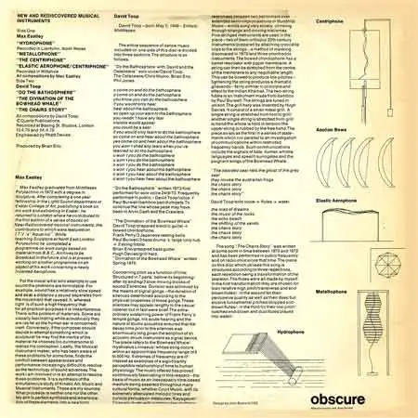
As far as I remember, I did not encounter much strings & water installations afterwards. There were a lot of artists that inspired me though, like Glenn Branca's guitarboxes, which were extensively described in Bart Hopkin's Experimental Music Instruments magazine year 1 issue 3, unfortunately no archived or accessible online. The guitarboxes followed an ingenious resonance design, I saw/heard them in somewhere in the 1980s in Brussels, and they had the same mysterious sound. The interesting thing was that they pickups were situated behind the bridge so that you couldn't hear much of attacks and plucking on the strings. OK, but no water yet...
Another inspiration for sure came from meeting Paul Panhuysen at the Apollohuis, Eindhoven in the 1990s. He made very particular long string installations, based on triangular principles. If I remember it well, he was using steel wire 0.3-0.6mm. Of course for the long strings you need to cope with quite some tensions and forces. And he was using special tunings. At the ZKM site you can also find a beautiful picture of the piezo attachment by Hélène Panhuysen. Just to give you an idea. Most of his fantastic work you can find on his original website (click work, then long strings and sound art). Still no water, I know...
https://www.paulpanhuysen.nl/
https://zkm.de/en/event/2018/06/paul-panhuysen-long-string-installations
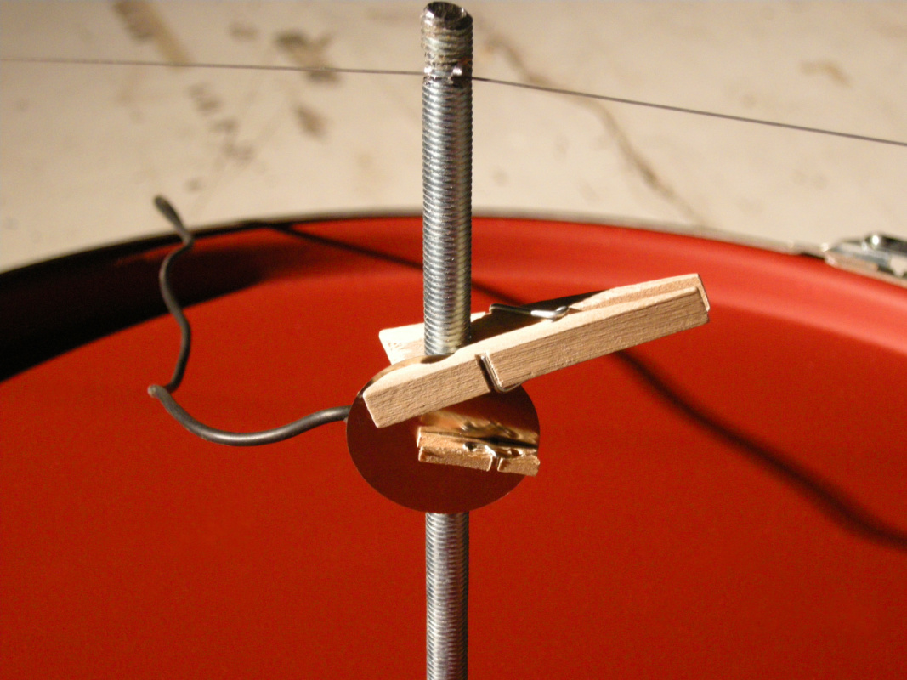

2. The Theory
In physics, a string resonating at its natural frequency, is calculated by the following formula:
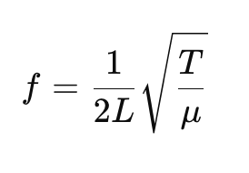
Fundamental frequency (f)
Length (L) in meters
Tension (T) in Newton (1 Newton = 0.102 kg)
Linear Density (μ) or the mass per unit length of the string in kg/m
(simply weigh 1m string, like fishing wire would be approx. 0.005 kg/m)
One needs a kind of driving force, which in our case will be unknown and variable, provided by the water streams.
As an example, when using a 2m piano string weighing 0.01kg/m, with a 10N tension, one could hear 1580Hz (if my maths are right olala!)... and with a lighter string, lower...
Remark: just found out that 1m of 0.6mm diameter piano wire = 0.22grams; will re-calculate it all later sorry... I estimate with 6kg tension we would get approx 150Hz...
Using only natural materials what are the basic principles for making the prototype:
- the right stick (wood, metal,...)
- the right string (piano, guitar, fishing wire, ukelele bass string, ...)
- the right fixing on both ends to allow standing waves to occur
- the right flow rate and perpendular angle (90˚?) of the water stream are important to create oscillations in the string
If we get it right, the string will start to resonate with increasing amplitude and standing wave patterns will form along the string. Probably to us not visible underwater, normally one can see nodes (points of no motion) and antinodes (points of maximum motion) on the string.
An interesting reference here are the experiments by Pythagoras. An interesting text we found online describes this so-called kanon, though now we really don't know much about it for sure...
https://digitalheritagelab.eu/portfolio/the-kanon-of-pythagoras-a-single-string-sonometer-7th-b-c/
A natural water stream is per definition unstable, so we will get only chaotic oscillations occuring. That might prove a difficulty and will probably require dynamical tuning of the string, increasing and decreasing its tension.
There are some easy tricks to find out the general speed of the stream, depth and width. Maybe they can be useful, and certainly nice to play with, for instance (but you will find a lot more online):
https://www.fao.org/fishery/static/FAO_Training/FAO_Training/General/x6705e/x6705e03.htm
https://wildearthlab.com/2023/04/19/river-measurements/
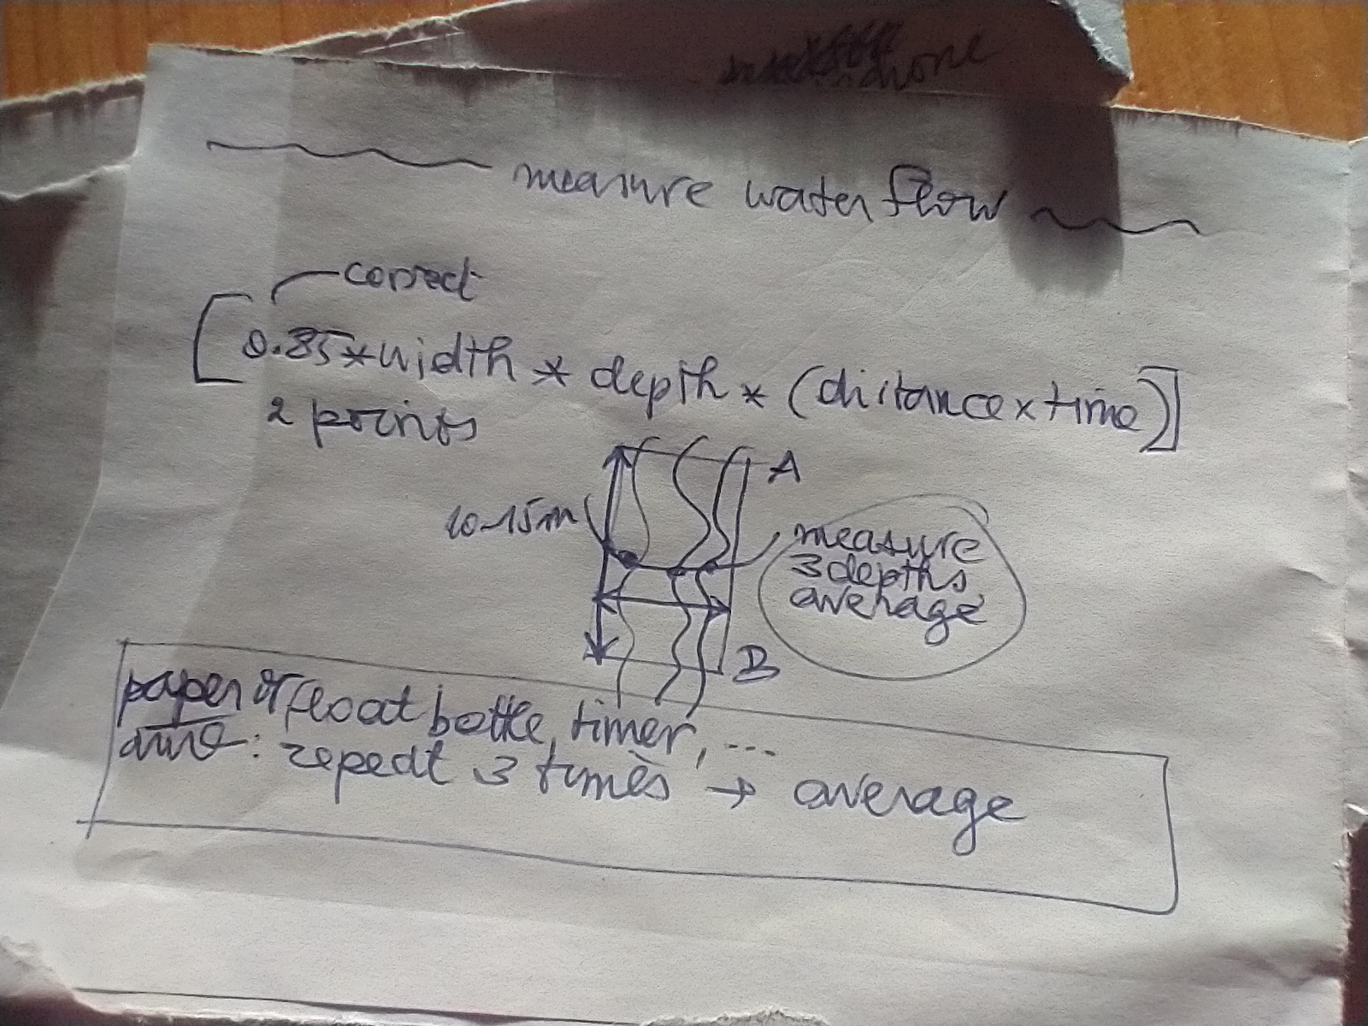

3. The Prototypes
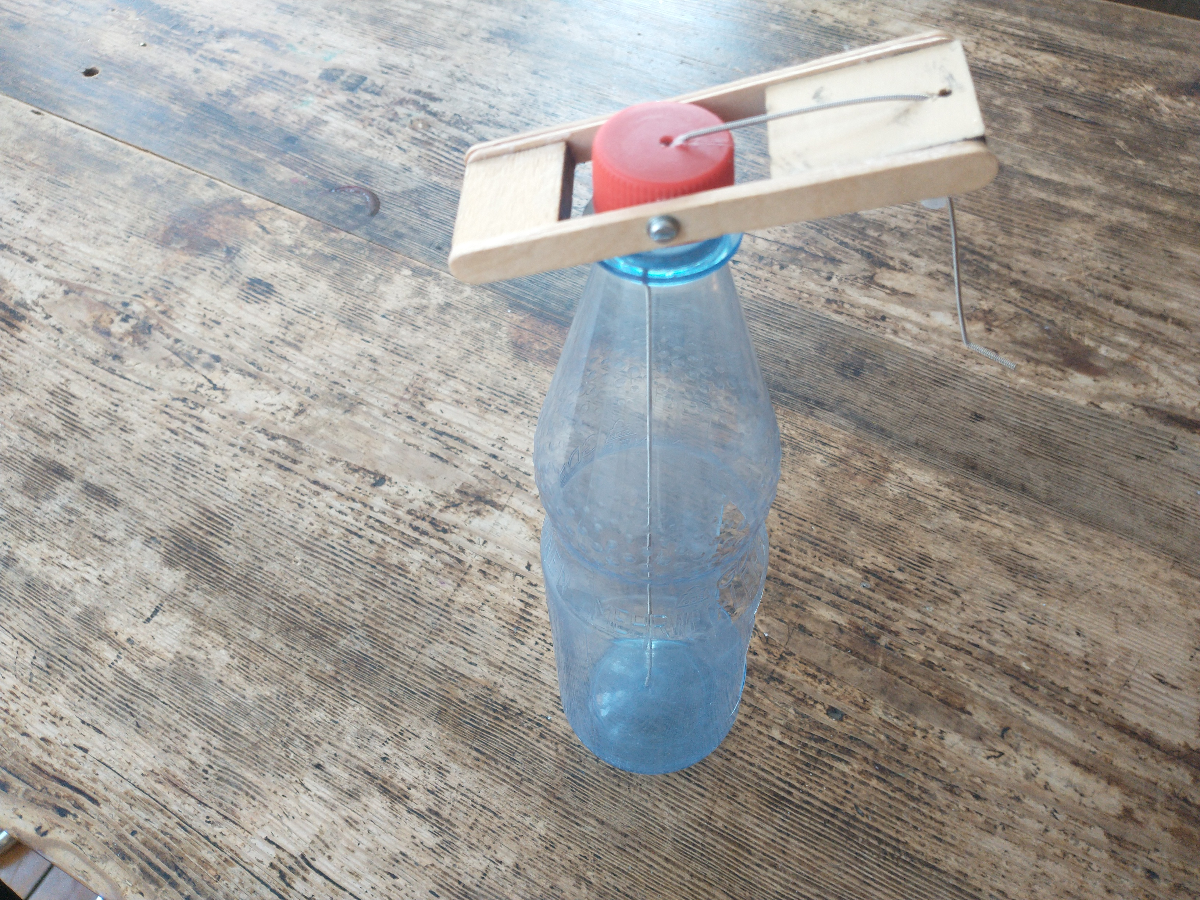
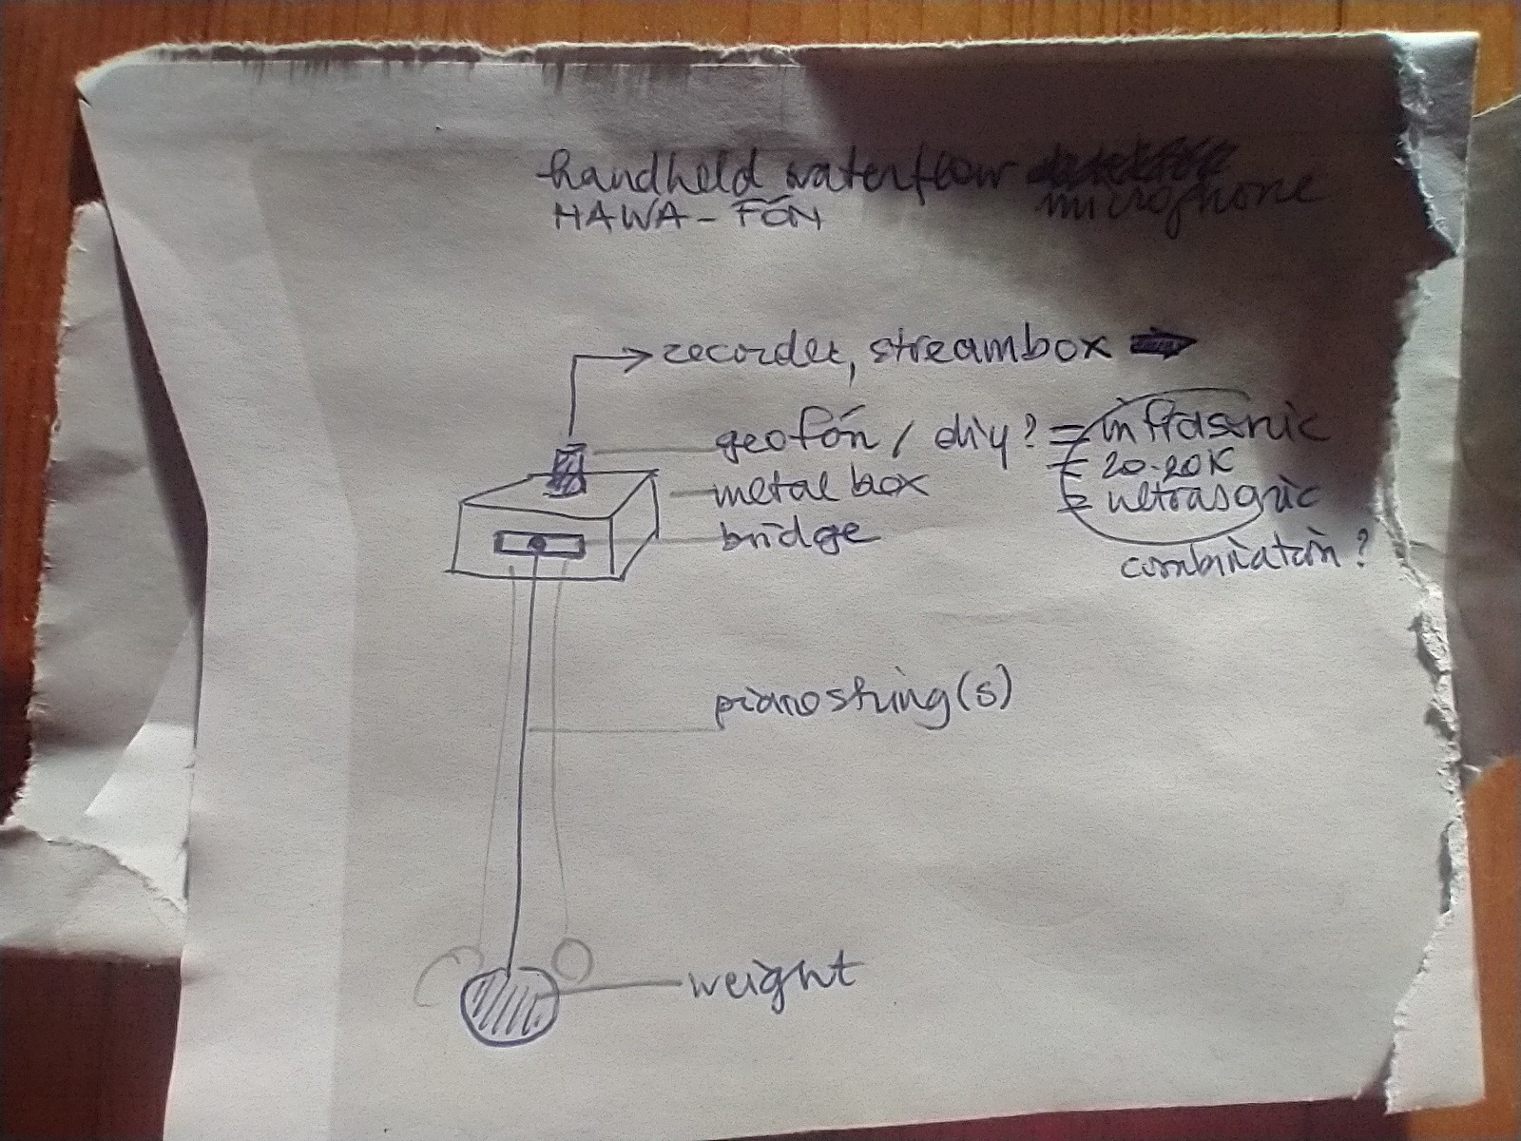
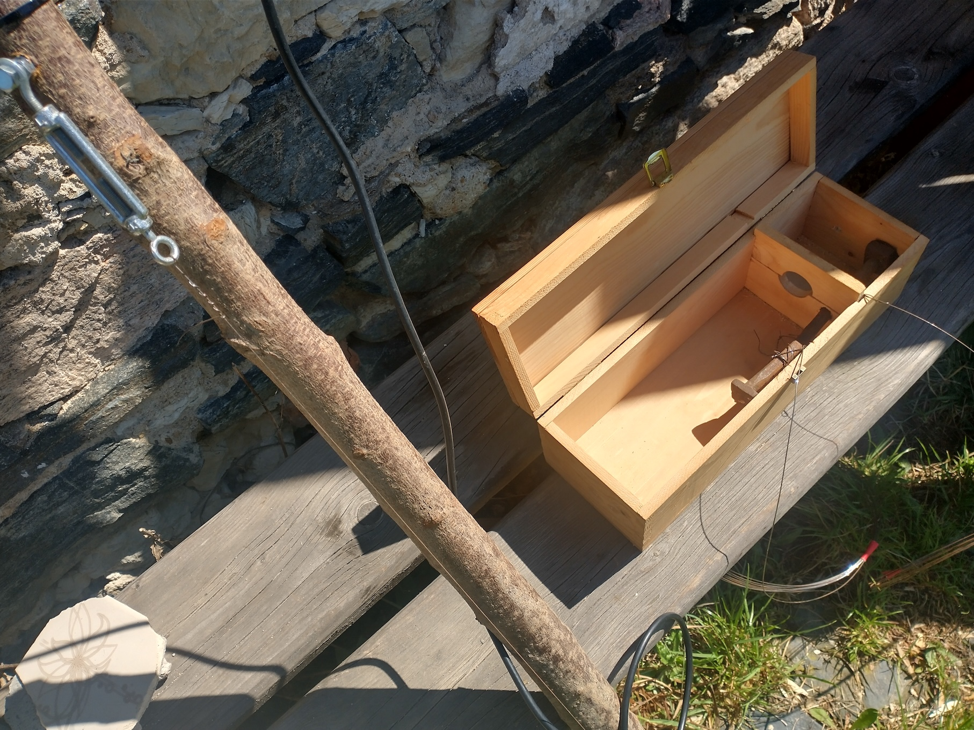

4. The Réveil 2025 Performance at Dawn
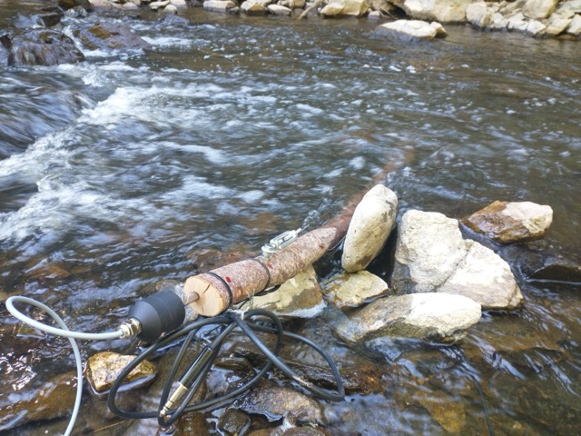
waterstringstick-sample.wav vid_20250501_162325157.mp4

5. The Réveil 2025 Live Stream Recording
20250504-reveil-waterstreamsdawn_usb-c-livestream.wav

6. Some Obligate Links
https://soundtent.org/soundcamp_reveil.html
https://streams.soundtent.org/2025/streams
https://streams.soundtent.org/2025/streams/utc0_-9a9ae85f-c866-45a5-8d44-7f9ca3dd990f

