Welcome to the weather collection page, for a description go to the landing area

Thinking about the weather
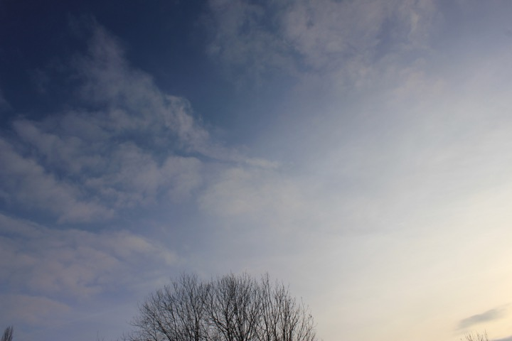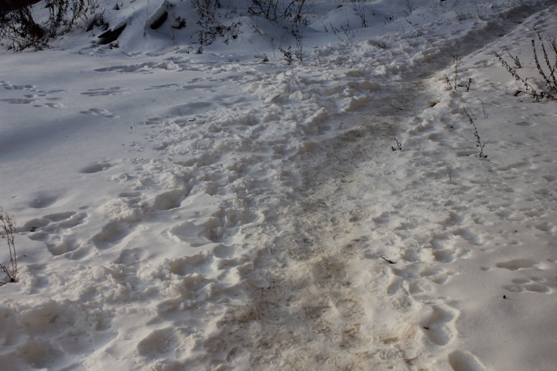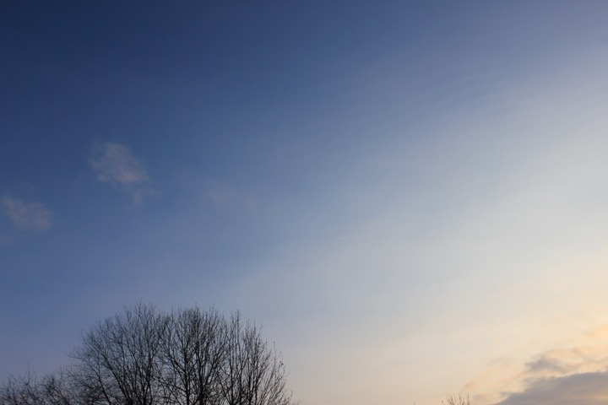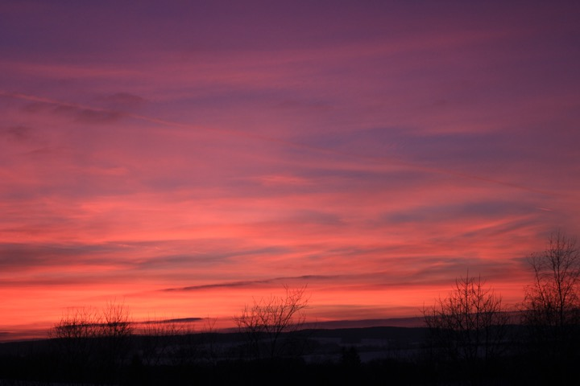
This morning found the neighbour's car in a ditch, on its side, the roads are quite slippery, and over the last weeks layers after layers of ice were getting frozen into the road, it is not snowing anymore, so a hard crust of 20 cm of snow is covering the soil for the rest of the month at least, maybe we should try an igloo tomorrow, now it is approximately -6˚C open skies, going down to -8˚C in the night, the wind is blowing from the north-east at 8-9 km/h, and pressure keeps dropping from 1031 to tomorrow 1024 and humidity is hovering around 70%. Wondering how it is elsewhere. Then suddenly, around midnight a stronger gale from the east came in.
20170126-2334-7x.wav
Hranice, http://www.openstreetmap.org/note/157043#map=17/49.76400/15.69060&layers=N

The Weather Today!
(working on the electronics and gps annotated maps, one moment, catching up with the recording data the following weeks, have to convert and edit them, upload and describe)
- 20170610
- 20170609
- 20170608
- 20170607
- 20170606
- 20170604

- 20170531
- 20170530
- 20170529
- 20170528
- 20170527
- 20170526
- 20170525
- 20170524
- 20170520
- 20170519
- 20170518
- 20170517
- 20170516
- 20170515
- 20170514
- 20170513
- 20170511
- 20170510
- 20170509
- 20170508
- 20170506
- 20170505
- 20170504

- 20170430
- 20170427
- 20170426
- 20170425
- 20170424
- 20170423
- 20170416
- 20170415
- 20170414
- 20170413
- 20170412
- 20170411
- 20170410
- 20170409
- 20170408
- 20170407
- 20170406
- 20170405
- 20170404
- 20170403
- 20170402
- 20170401

- 20170329
- 20170328
- 20170327
- 20170326
- 20170325
- 20170323
- 20170322
- 20170321
- 20170320
- 20170316
- 20170315
- 20170314
- 20170313
- 20170312
- 20170311
- 20170310
- 20170309
- 20170308
- 20170307
- 20170306
- 20170304
- 20170302
- 20170301

- 20170227
- 20170224
- 20170222
- 20170221
- 20170220
- 20170219
- 20170218
- 20170217
- 20170216
- 20170215
- 20170213
- 20170212
- 20170210
- 20170207
- 20170206
- 20170205
- 20170203
- 20170202
- 20170201

- 20170129
- 20170127
- 20170126
- 20170122
- 20170121
- 20170119
- 20170118
- 20170117
- 20170116
- 20170115
- 20170114
- 20170111
- 20170106
- 20170104
- 20170103
- 20170102
- 20170101

- 20161229
- 20161228
- 20161226
- 20161224
- 20161220

Some news:
- TaskList, or what we are working on now
- Our WeatherCorrespondents abroad
- The Weather literary page

Also visit:
- technical description WindClock III and WindClock IV (prototypes)
- some ideas, some approaches, some strategies

