WEATHER REPORTS
A fragemnted radio piece (separated by jingles)
Commissioned by Documenta 14 Radio 'Every Time A Ear di Soun'
June-July 2017.
Weather Reports is making you all-weather-ready by providing world class weather breaking news plus your up to the minute weather reports about the accurate future conditions of your environment, local to international, wherever you want to be. Including imperative disaster coverage. Just listen to this radio and get a taste of walking the windy shores barefoot in the burning sand, running through the fields on top of the hill during a hot summer thunder storm, or sitting in the park getting dripping wet under a leafless tree. Get your daily Weather Reports now: undocumented, raw, but unpredictably vital!

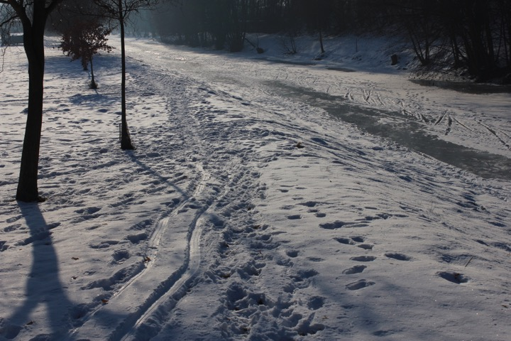
Some news:
- TaskList, or what we are working on now
- Our WeatherCorrespondents abroad
- Below: the ideas, to be narrowed, but expanded till then, and the current Weather Collection!

0. Making Weather Reports
- The Weather Collection
- The Template for entering material
- Links to the finished snippets and pieces (after Easter presumably)...

1. Observing the weather (ears and eyes from elsewhere)
Note 3 of 'Four more notes on the concept of a WindClock'
Maybe an interest that shifted, while working with wind-sensitive devices over the years, to the phenomenon of wind itself, the play with different materials, generating a variable resistance. Relating it to our senses, how we all experience weather, with our body here and now, walking, running, sitting in the grass or snow. Feeling the difference on your skin while it rains as well, when the directions of the streams of cold air are suddenly turning. The first warm winds between spring and summer. Seasons and years pass. Abandoning gradually city life for staying out there. Watching the tops of trees from the window. Setting up yet another lab on the open field. But for different reasons... (Full Notes)
Merely a technical issue.
The sentences above are embedded in a series of questions, investigating nowadays media instruments for perception and expressivity. It will always be a purely technical issue. WindClock-III is going a step further than the previous designs, and wants to come up with an easy-to-handle DIY weather station, to set up anywhere and quickly share relevant data from remote locations. These can be rudimentary sonified and visualized on the object itself, for verification of exactness, feedback to the user. It can be used instantly, but also for keeping track for longer periods of time. It can communicate with a WIFI router, and used in connection with other WindClock-III devices elsewhere in the world. It is sensing the wind speed and directions, the amount of rain, day and night, frost and heat, show barometer values, and all the changes over time. It can leave traces for interpreting catastrophes and disasters, always after the fact. It will be used to predict the coming weather, in a moment, tomorrow and a couple of days later, in the long run. (Technical sheet)

2. Talking about the weather (three groups)
A -- For neighbours, families, friends...
When people are meeting outside, sometimes spontaneously they start to talk about the weather. From a description of the conditions now, to predictions for the coming days and longer, to statements about seasonal, and even longer time climate change, including socio-cultural issues. Yes maybe it will spill over in economical, social and cultural statements packaged as weather descriptions and predictions. Usually people start mixing it up with what they saw on tv. Together with informants and collaborators, let's collect interviews, field recordings, observations, and other audiovisual materials. Later these can be live processed and streamed during the broadcasting days. Though the radio weather descriptions and forecasts, are as much as possible real-time interventions.
Important to keep in mind when recording, are the following advises:
- keep it casual, among friends and family, when meeting in the street or on the field
- add a distributed aspect, while people are moving, looking around and are naturally observing nature
- don't try to make a perfect recording, the environment and how it is sounding can be important too
- describe the real weather in front of your eyes as much as possible
- lure the others into a prediction of the coming days, or compare to official reports
- let them explain why the weather is (not) normal
- ask them if they believe themselves, what else could happen - remember it is like reading horoscopes
- does the weather make the people? there was a correlation in the past between bad harvests, great famines and revolutions, is it still like that?
- try but don't force to turn it slowly into a real world topic (social, cultural, economical, industrial, but avoid the explicit political)
- if possible make a picture, and a soundstamp of 1 minute without talking afterwards and before
- to prepare, read weather descriptions and forecasts and verify them while talking together
- you can plant a flag, look at it and talk to your neighbour about what you both see and think
B -- For artificial people...
A second bulk of information is to be obtained from contacts online. People write a lot, send pictures and recordings, chit-chat freely about almost everything. Usually when sending a picture of the weather outside others reply by sending a picture back, or describing the weather where they are. For instance, here it was freezing -15˚C and when mailing to friends in Brussels, Berlin, Bratislava, Barcelona, most of them replied with small descriptions of the weather there. Maybe, when you are bored, also ask them if they know any weather jokes? Remember Armand Pien, his whole career was full of bad weather jokes, he told one every day! Armand Pien (1920 – 2003) was a Belgian weatherman for 37 years. He was popular because his weather predictions were funny and somewhat cryptic. After he retired from national television he had a daily (Monday – Friday) weather talk on the East Flanders department of Belgium national radio. He did this until the Friday before his death; he died the following Monday.
C -- For experts, ignorant or not...
There is too much information available online, and for now let's concentrate on the previously mentioned things, but when bored, it would be interesting to see how to access data from online weather balloons high up in the stratosphere, use data from online long-term forecast sites, explain strange weather phenomena, describe George Kuchar's Weather Diary Series, Joris Ivens' Histoire du vent, or cite from Andrzej Stasiuk's Dukla (a book about light). Or yes, talk about the Armand Piens elsewhere in this world.

3. Rendering the weather (making a radio without making a mess)
All agents involved should get together and discuss, from now on from time to time:
- how to use the streaming components (transceiving data/images/sound in realtime)
- how to bring in the prerecorded sounds, interviews, situations
- how to fine tune the processed parts
- sonification with physical models of wind/rain/heat in max/pd/sc
- machine learning for interpreting disasters / catastrophes, and other complex interactions
- how to critically assemble the collected other media and ideas in between
- how to deal with diversity (who said: who likes one language likes them all? ok. All languages welcome, and when in doubt, invent your own language! )
The timing, schedule for bringing in radio can be inspired by the Traffic Message Channel (TMC), which interrupts fm-transmissions, and bring urgent news about disasters (let's call it the 'KatastrofeMessageChannel (KMC)' for now). A new radio should try to come up with new time concepts and scheduling structures, based on the environmental conditions, whatever they are. The weather and climate conditions have to be an integrated part of this. (Isn't the weather an essential thing that we all share in this world, for living and communicating, for making art and all other things we feel good with?)
A question not to forget: can Tub0tech streams be actively used by then? (will sort it out soon with Dom/Jeff)

4. Reporting the weather (about the aesthetics of new radio)
to be extended --> time space and the weather!
Content differences [how to approach the weather]:
- atmospheric condition, weather condition
- brave, brave out, endure, resist, survive, withstand
- climate
- harden, season
- meteorologic, meteorological
Stylistics and forms [everyday time on air, take another style]:
- account
- advertise/advertize
- advise
- announce/announcement
- article
- bit of news
- broadcast bulletin
- call
- cite
- communicate/communication
- composition
- coverage
- declare
- describe/description
- document
- give notice
- gossip/hearsay
- intelligence
- mention
- instant message
- minutes
- name
- narrate
- news/news item
- special news report
- notice / notification / notify
- read a paper
- proceedings
- proclamation
- publicise/publicize/publish
- recital
- record/records
- recount
- registration
- relate/relation
- reportage/reporting
- reputation/rumour
- statement
- story
- just talk
- tell
- a theme
- tidings
- another version
- word/writen-up/written-out
Timings, ranges:
- today, now
- tomorrow, +24h
- the coming 5 days
- long term forecasts
Places (not more than 10, to be decided later):
- Developing:
- * hranice cz (kralab)
- * berlin, weimar, kassel
- * athens gr
- See if they can be added:
- * gent, brussels be
- * saint-nazaire fr
- * bratislava sk
- * bergen no

