Zero Times
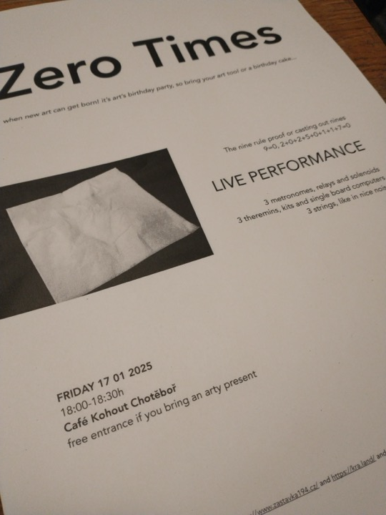

when new art can get born!
For Art's Birthday on 2025/01/17
Live at Café Kohout, Chotěboř 18.00h
The nine rule proof
or casting out nines
when 9=0; 2+0+2+5+0+1+1+7=0
An open performance with local rural art-loving friends
- 3 metronomes, relays and solenoids
- 3 theremins, kits and SBC's
- 3 nice noisy strings

Just like a birthday party should be! Free entrance with cake, presents and music
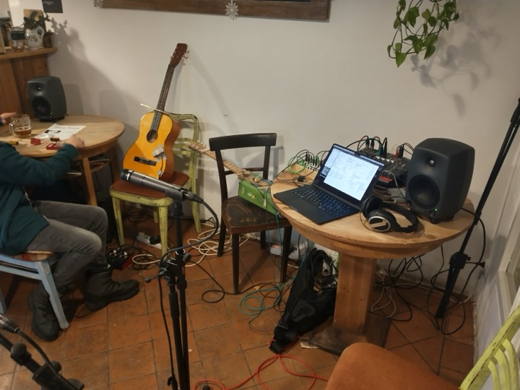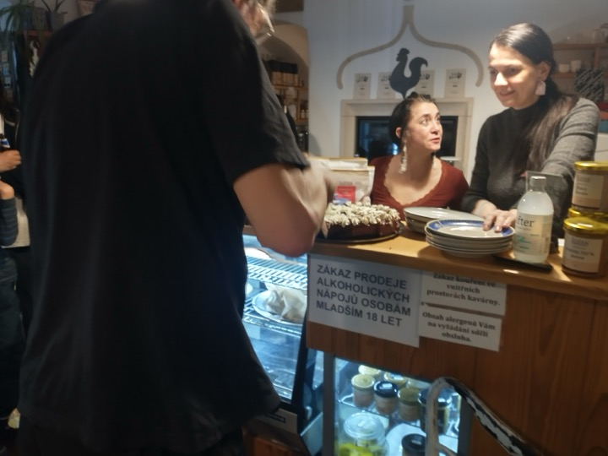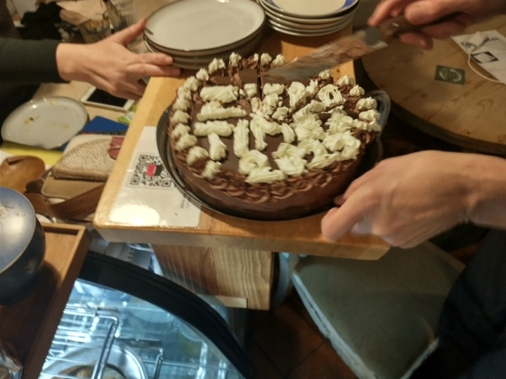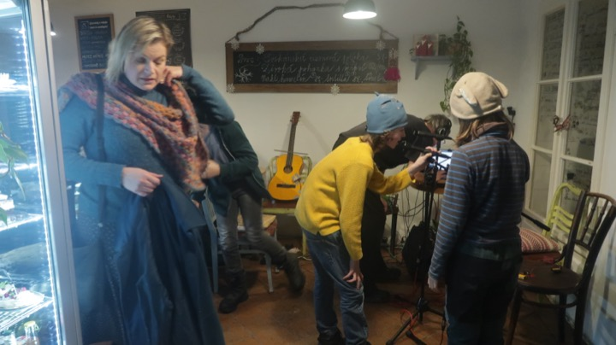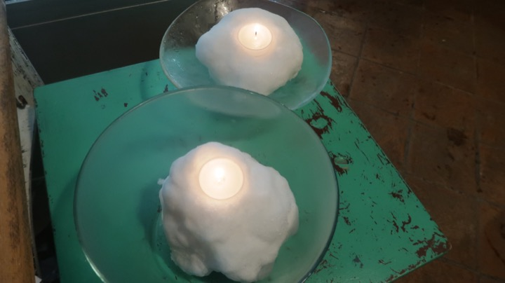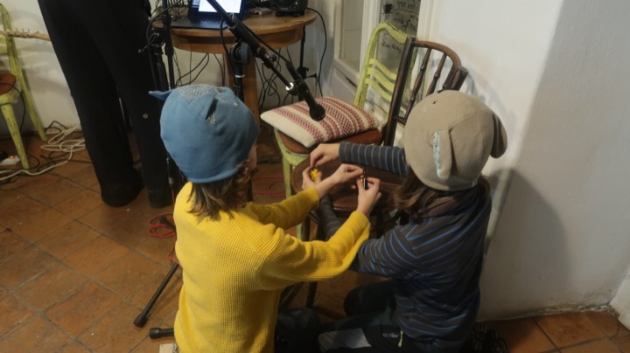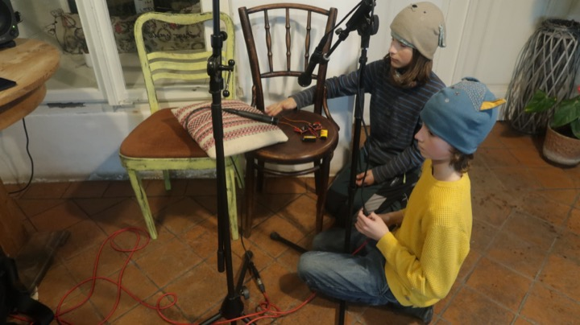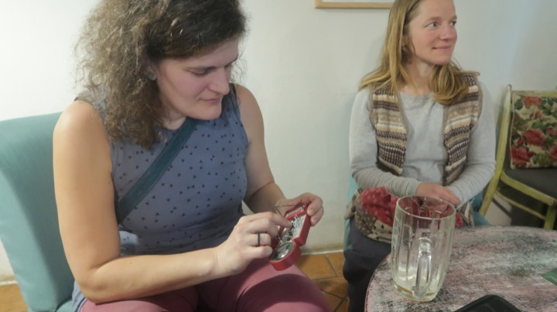
ab25-zerotimes-lenkadvid-01.mp4 ab25-zerotimes-lenkadvid-02.mp4 ab25-zerotimes-lenkadvid-03.mp4 ab25-zerotimes-lenkadvid-04.mp4

The stream
ab25-zerotimes-stream.mp3
also see https://www.artsbirthday.net/2025
org. KraLand + ButtuLab + https://Zastávka194.cz

